# **[Chapter 5. Getting Started with Entity Framework using MVC](http://www.asp.net/mvc/tutorials/getting-started-with-ef-using-mvc)**

# 1 Creating an Entity Framework Data Model for an ASP.NET MVC Application

The Contoso University sample web application demonstrates how to create ASP.NET MVC 3 applications using the Entity Framework. The sample application is a website for a fictional Contoso University. It includes functionality such as student admission, course creation, and instructor assignments.

This tutorial series explains the steps taken to build the Contoso University sample application. You can [download the completed application](http://go.microsoft.com/fwlink/?LinkId=215669) or create it by following the steps in the tutorial. The tutorial shows examples in C#. The downloadable sample contains code in both C# and Visual Basic. If you have questions that are not directly related to the tutorial, you can post them to the [ASP.NET Entity Framework forum](http://forums.asp.net/1227.aspx) or the [Entity Framework and LINQ to Entities forum](http://social.msdn.microsoft.com/forums/en-US/adodotnetentityframework/threads/).

This tutorial series assumes you know how to work with ASP.NET MVC in Visual Studio. If you don’t, a good place to start is a [basic ASP.NET MVC Tutorial](http://www.asp.net/mvc/tutorials/getting-started-with-MVC3-part1-cs). If you prefer to work with the ASP.NET Web Forms model, see the [Getting Started with the Entity Framework](http://www.asp.net/entity-framework/tutorials#Getting Started) and [Continuing with the Entity Framework](http://www.asp.net/entity-framework/tutorials#Continuing) tutorials.

Before you start, make sure you have the following software installed on your computer:

* [Visual Studio 2010 SP1](http://www.microsoft.com/web/gallery/install.aspx?appsxml=&appid=VS2010SP1Pack) or [Visual Web Developer Express 2010 SP1](http://www.microsoft.com/web/gallery/install.aspx?appsxml=&appid=VWD2010SP1Pack) (If you use one of these links, the following items will be installed automatically.)
* [ASP.NET MVC 3 Tools Update](http://www.microsoft.com/web/gallery/install.aspx?appid=MVC3)
* [Microsoft SQL Server Compact 4.0](http://www.microsoft.com/web/gallery/install.aspx?appid=SQLCE)
* [Microsoft Visual Studio 2010 SP1 Tools for SQL Server Compact 4.0](http://www.microsoft.com/web/gallery/install.aspx?appid=SQLCEVSTools)

**Note:** These tutorials were written for ASP.NET 4.1. The Code First Migrations feature was introduced in ASP.NET 4.3, so it isn't covered in these tutorials. Migrations solves the problem of what to do about data model changes after you have deployed your database to production. For a more recent tutorial that includes coverage of Code First Migrations, see [Introduction to ASP.NET MVC 4 - Adding a New Field to the Movie Model and Table](http://www.asp.net/mvc/tutorials/mvc-4/getting-started-with-aspnet-mvc4/adding-a-new-field-to-the-movie-model-and-table).

In the tutorial you run the application in Visual Studio. You can also make the application available over the Internet by deploying it to a hosting provider. Microsoft offers free web hosting for up to 10 web sites in a [free Windows Azure trial account](http://www.windowsazure.com/en-us/pricing/free-trial/?WT.mc_id=A443DD604). For information about how to deploy a Visual Studio web project to a Windows Azure Web Site, see [Create and deploy an ASP.NET web site and SQL Database with Visual Studio](http://www.windowsazure.com/en-us/develop/net/compute/). That tutorial also shows how to use Entity Framework Code First Migrations to deploy your SQL Server database to Windows Azure SQL Database (formerly SQL Azure).

## The Contoso University Web Application

The application you'll be building in these tutorials is a simple university website.

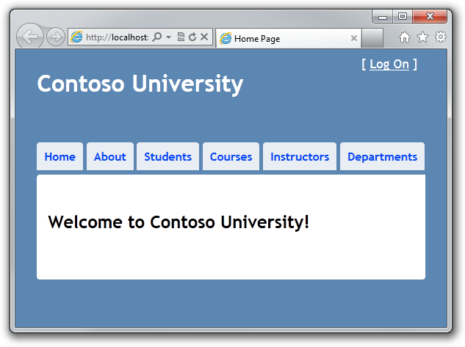

Users can view and update student, course, and instructor information. A few of the screens you'll create are shown below.

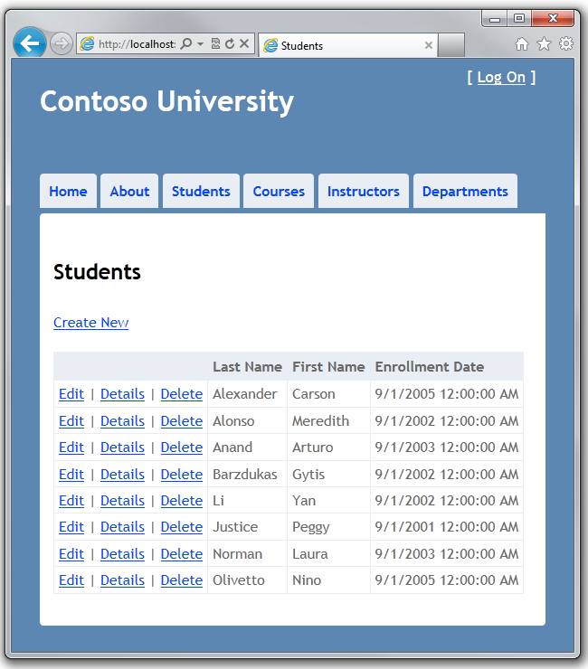

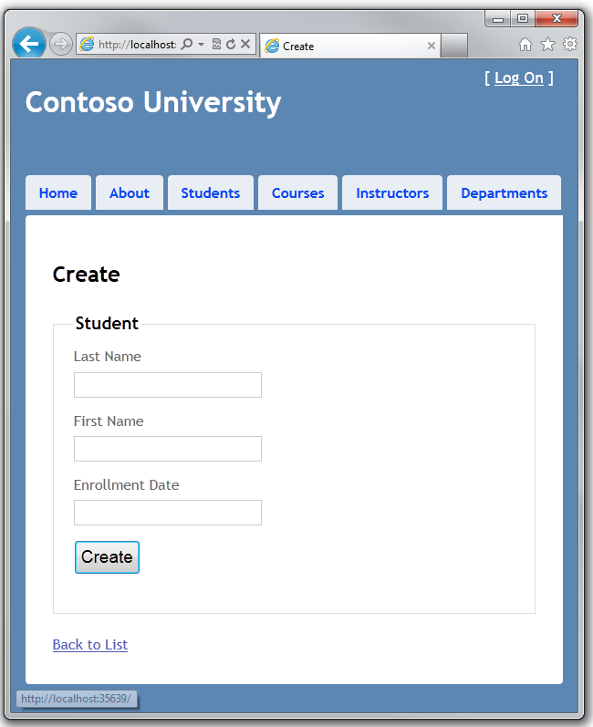

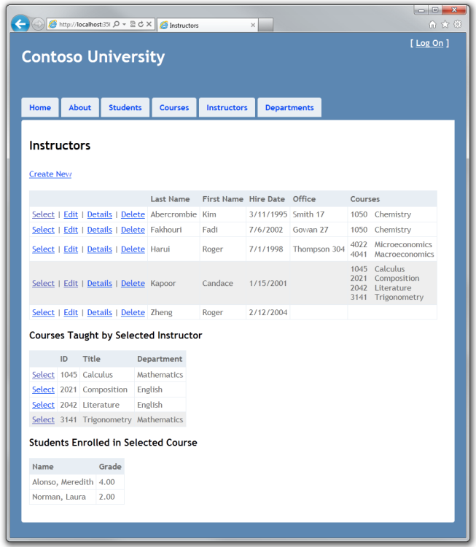

The UI style of this site has been kept close to what's generated by the built-in templates, so that the tutorial can focus mainly on how to use the Entity Framework.

## Entity Framework Development Approaches

As shown in the following diagram, there are three ways you can work with data in the Entity Framework: *Database First*, *Model First*, and *Code First.*

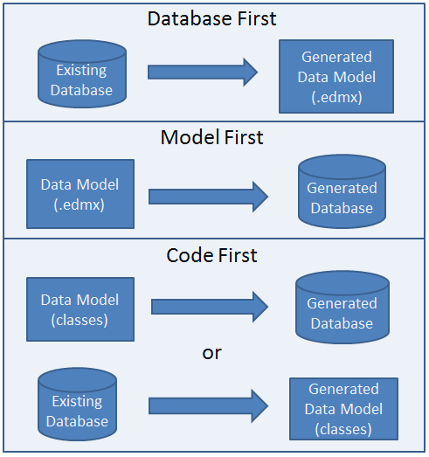

## Database First

If you already have a database, the Entity Framework can automatically generate a data model that consists of classes and properties that correspond to existing database objects such as tables and columns. The information about your database structure (*store schema*), your data model (*conceptual model*), and the mapping between them is stored in XML in an *.edmx* file. Visual Studio provides the Entity Framework designer, which is a graphical designer that you can use to display and edit the *.edmx* file. The sections [Getting Started With the Entity Framework](http://www.asp.net/entity-framework/tutorials#Getting Started) and [Continuing With the Entity Framework](http://www.asp.net/entity-framework/tutorials#Continuing) in the Web Forms tutorial series use Database First development.

## Model First

If you don't yet have a database, you can begin by creating a model using the Entity Framework designer in Visual Studio. When the model is finished, the designer can generate DDL (*data definition language*) statements to create the database. This approach also uses an *.edmx* file to store model and mapping information. The [What's New in the Entity Framework 4](http://www.asp.net/entity-framework/tutorials/what-s-new-in-the-entity-framework-4) tutorial includes a brief example of Model First development.

## Code First

Whether you have an existing database or not, you can code your own classes and properties that correspond to tables and columns and use them with the Entity Framework without an *.edmx* file. That's why you sometimes see this approach called *code only*, although the official name is Code First. The mapping between the store schema and the conceptual model represented by your code is handled by convention and by a special mapping API. If you don't yet have a database, the Entity Framework can automatically create the database for you, or drop and re-create it if the model changes. This tutorial series uses Code First development.

The data access API that was developed for Code First is based on the DbContext class. This API can also be used with the Database First and Model First development workflows. For more information, see [When is Code First not code first?](http://blogs.msdn.com/b/adonet/archive/2011/03/07/when-is-code-first-not-code-first.aspx) on the Entity Framework team blog.

## POCO (Plain Old CLR Objects)

By default, when you use the Database First or Model First development approaches, the entity classes in your data model inherit from the [EntityObject](http://msdn.microsoft.com/en-us/library/system.data.objects.dataclasses.entityobject.aspx) class, which provides them with Entity Framework functionality. This means that these classes technically aren't [persistence ignorant](http://msdn.microsoft.com/en-us/magazine/dd882510.aspx#id0420053) and so don't conform fully to one of the requirements of [domain-driven design](http://msdn.microsoft.com/en-us/magazine/dd419654.aspx). All development approaches of the Entity Framework can also work with POCO (*plain old CLR objects*) classes, which essentially means that they are persistence-ignorant because they don't inherit from the EntityObject class. In this tutorial you'll use POCO classes.

## Creating an MVC Web Application

Before you start, make sure you have the following installed on your computer:

* [Visual Studio 2010 SP1](http://www.microsoft.com/web/gallery/install.aspx?appsxml=&appid=VS2010SP1Pack) or [Visual Web Developer Express 2010 SP1](http://www.microsoft.com/web/gallery/install.aspx?appsxml=&appid=VWD2010SP1Pack) (If you use one of these links, the following items will be installed automatically.)
* [ASP.NET MVC 3 Tools Update](http://www.microsoft.com/web/gallery/install.aspx?appid=MVC3)
* [Microsoft SQL Server Compact 4.0](http://www.microsoft.com/web/gallery/install.aspx?appid=SQLCE)
* [Microsoft Visual Studio 2010 SP1 Tools for SQL Server Compact 4.0](http://www.microsoft.com/web/gallery/install.aspx?appid=SQLCEVSTools)

Open Visual Studio and create a new project named "ContosoUniversity" using the **ASP.NET MVC 3 Web Application** template:

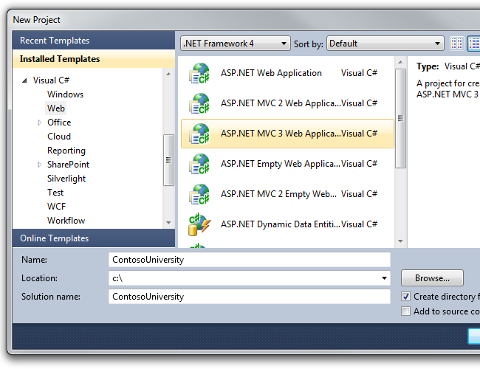

In the **New ASP.NET MVC 3 Project** dialog box select the **Internet Application** template and the **Razor** view engine, clear the **Create a unit test project** check box, and then click **OK**.

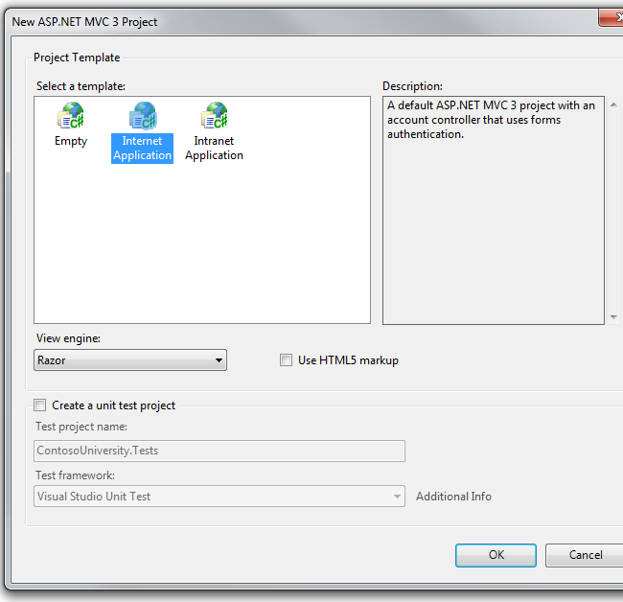

## Setting Up the Site Style

A few simple changes will set up the site menu, layout, and home page.

In order to set up the Contoso University menu, in the *Views\Shared\_Layout.cshtml* file, replace the existing h1 heading text and the menu links, as shown in the following example:

<!DOCTYPE html>

<html>

<head>

<title>@ViewBag.Title</title>

<link href="@Url.Content("~/Content/Site.css")" rel="stylesheet" type="text/css" />

<script src="@Url.Content("~/Scripts/jquery-1.5.1.min.js")" type="text/javascript"></script>

</head>

<body>

<div class="page">

<div id="header">

<div id="title">

<h1>Contoso University</h1>

</div>

<div id="logindisplay">

@Html.Partial("_LogOnPartial")

</div>

<div id="menucontainer">

<ul id="menu">

<li>@Html.ActionLink("Home", "Index", "Home")</li>

<li>@Html.ActionLink("About", "About", "Home")</li>

<li>@Html.ActionLink("Students", "Index", "Student")</li>

<li>@Html.ActionLink("Courses", "Index", "Course")</li>

<li>@Html.ActionLink("Instructors", "Index", "Instructor")</li>

<li>@Html.ActionLink("Departments", "Index", "Department")</li>

</ul>

</div>

</div>

<div id="main">

@RenderBody()

</div>

<div id="footer">

</div>

</div>

</body>

</html>

In the *Views\Home\Index.cshtml* file, delete everything under the h2 heading.

In the *Controllers\HomeController.cs* file, replace "Welcome to ASP.NET MVC!" with "Welcome to Contoso University!"

In the *Content\Site.css* file, make the following changes in order to move the menu tabs to the left:

* In the definition for #main, add clear: both;, as shown in the following example:
* #main
* {
* clear: both;
* padding: 30px 30px 15px 30px;
* background-color: #fff;
* border-radius: 4px 0 0 0;
* -webkit-border-radius: 4px 0 0 0;
* -moz-border-radius: 4px 0 0 0;

}

* In the definition for nav and #menucontainer, add clear: both; float: left;, as shown in the following example:
* nav,
* #menucontainer {
* margin-top: 40px;
* clear: both;
* float: left;

}

Run the site. You see the home page with the main menu.



## Creating the Data Model

Next you'll create your first entity classes for the Contoso University application. You'll start with the following three entities:

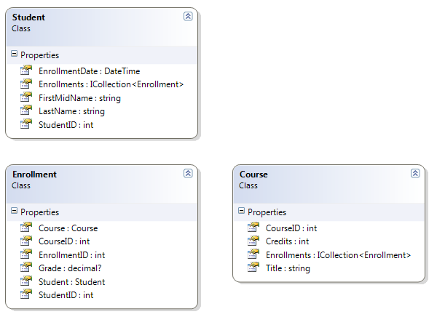

There's a one-to-many relationship between Student and Enrollment entities, and there's a one-to-many relationship between Course and Enrollment entities. In other words, a student can be enrolled in any number of courses, and a course can have any number of students enrolled in it.

In the following sections you'll create a class for each one of these entities.

**Note** If you try to compile the project before you finish creating all of these entity classes, you'll get compiler errors.

## The Student Entity

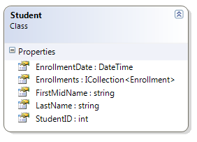

In the *Models* folder, create *Student.cs* and replace the existing code with the following code:

using System;

using System.Collections.Generic;

namespace ContosoUniversity.Models

{

public class Student

{

public int StudentID { get; set; }

public string LastName { get; set; }

public string FirstMidName { get; set; }

public DateTime EnrollmentDate { get; set; }

public virtual ICollection<Enrollment> Enrollments { get; set; }

}

}

The StudentID property will become the primary key column of the database table that corresponds to this class. By default, the Entity Framework interprets a property that's named ID or *classname*ID as the primary key.

The Enrollments property is a *navigation property*. Navigation properties hold other entities that are related to this entity. In this case, the Enrollments property of a Student entity will hold all of the Enrollment entities that are related to that Student entity. In other words, if a given Student row in the database has two related Enrollment rows (rows that contain that student's primary key value in their StudentID foreign key column), that Student entity's Enrollments navigation property will contain those two Enrollment entities.

Navigation properties are typically defined as virtual so that they can take advantage of an Entity Framework function called *lazy loading*. (Lazy loading will be explained later, in the [Reading Related Data](http://www.asp.net/entity-framework/tutorials/reading-related-data-with-the-entity-framework-in-an-asp-net-mvc-application) tutorial later in this series.) If a navigation property can hold multiple entities (as in many-to-many or one-to-many relationships), its type must be ICollection.

## The Enrollment Entity

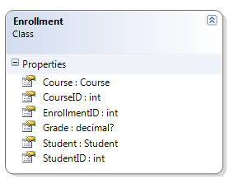

In the *Models* folder, create *Enrollment.cs* and replace the existing code with the following code:

using System;

using System.Collections.Generic;

namespace ContosoUniversity.Models

{

public class Enrollment

{

public int EnrollmentID { get; set; }

public int CourseID { get; set; }

public int StudentID { get; set; }

public decimal? Grade { get; set; }

public virtual Course Course { get; set; }

public virtual Student Student { get; set; }

}

}

The question mark after the decimal type declaration indicates that the Grade property is nullable. A grade that's null is different from a zero grade — null means a grade hasn't been assigned yet, while zero means a zero grade has been assigned.

The StudentID property is a foreign key, and the corresponding navigation property is Student. An Enrollment entity is associated with one Student entity, so the property can only hold a single Student entity (unlike the Student.Enrollments navigation property you saw earlier, which can hold multiple Enrollment entities).

The CourseID property is a foreign key, and the corresponding navigation property is Course. An Enrollment entity is associated with one Course entity.

## The Course Entity

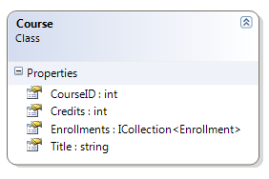

In the *Models* folder, create *Course.cs*, replacing the existing code with the following code:

using System;

using System.Collections.Generic;

namespace ContosoUniversity.Models

{

public class Course

{

public int CourseID { get; set; }

public string Title { get; set; }

public int Credits { get; set; }

public virtual ICollection<Enrollment> Enrollments { get; set; }

}

}

The Enrollments property is a navigation property. A Course entity can be related to any number of Enrollment entities.

## Creating the Database Context

The main class that coordinates Entity Framework functionality for a given data model is the *database context* class. You create this class by deriving from the System.Data.Entity.DbContext class. In your code you specify which entities are included in the data model. You can also customize certain Entity Framework behavior. In the code for this project, the class is named SchoolContext.

Create a *DAL* folder. In that folder create a new class file named *SchoolContext.cs*, and replace the existing code with the following code:

using System;

using System.Collections.Generic;

using System.Data.Entity;

using ContosoUniversity.Models;

using System.Data.Entity.ModelConfiguration.Conventions;

namespace ContosoUniversity.Models

{

public class SchoolContext : DbContext

{

public DbSet<Student> Students { get; set; }

public DbSet<Enrollment> Enrollments { get; set; }

public DbSet<Course> Courses { get; set; }

protected override void OnModelCreating(DbModelBuilder modelBuilder)

{

modelBuilder.Conventions.Remove<PluralizingTableNameConvention>();

}

}

}

This code creates a DbSet property for each entity set. In Entity Framework terminology, an *entity set* typically corresponds to a database table, and an *entity* corresponds to a row in the table.

The statement in the OnModelCreating method prevents table names from being pluralized. If you didn't do this, the generated tables would be named Students, Courses, and Enrollments. Instead, the table names will be Student, Course, and Enrollment. Developers disagree about whether table names should be pluralized or not. This tutorial uses the singular form, but the important point is that you can select whichever form you prefer by including or omitting this line of code.

(This class is in the Models namespace, because in some situations Code First assumes that the entity classes and the context class are in the same namespace.)

## Setting the Connection String

You don't have to create a connection string. If you don't create one, the Entity Framework will automatically create a SQL Server Express database for you. In this tutorial, however, you'll work with SQL Server Compact, so you need to create a connection string to specify that.

Open the project *Web.config* file and add a new connection string to the connectionStrings collection, as shown in the following example. (Make sure you update the *Web.config* file in the root project folder. There's also a *Web.config* file is in the *Views* subfolder that you don't need to update. )

<add name="SchoolContext" connectionString="Data Source=|DataDirectory|School.sdf" providerName="System.Data.SqlServerCe.4.0"/>

By default, the Entity Framework looks for a connection string named the same as the object context class. The connection string you've added specifies a SQL Server Compact database named *School.sdf* located in the *App_Data* folder.

## Initializing the Database with Test Data

The Entity Framework can automatically create (or drop and re-create) a database for you when the application runs. You can specify that this should be done every time your application runs or only when the model is out of sync with the existing database. You can also write a class that includes a method that the Entity Framework automatically calls after creating the database in order to populate it with test data. In this section you'll specify that the database should be dropped and re-created whenever the model changes.

In the *DAL* folder, create a new class file named *SchoolInitializer.cs* and replace the existing code with the following code, which causes a database to be created when needed and loads test data into the new database.

using System;

using System.Collections.Generic;

using System.Linq;

using System.Web;

using System.Data.Entity;

using ContosoUniversity.Models;

namespace ContosoUniversity.DAL

{

public class SchoolInitializer : DropCreateDatabaseIfModelChanges<SchoolContext>

{

protected override void Seed(SchoolContext context)

{

var students = new List<Student>

{

new Student { FirstMidName = "Carson", LastName = "Alexander", EnrollmentDate = DateTime.Parse("2005-09-01") },

new Student { FirstMidName = "Meredith", LastName = "Alonso", EnrollmentDate = DateTime.Parse("2002-09-01") },

new Student { FirstMidName = "Arturo", LastName = "Anand", EnrollmentDate = DateTime.Parse("2003-09-01") },

new Student { FirstMidName = "Gytis", LastName = "Barzdukas", EnrollmentDate = DateTime.Parse("2002-09-01") },

new Student { FirstMidName = "Yan", LastName = "Li", EnrollmentDate = DateTime.Parse("2002-09-01") },

new Student { FirstMidName = "Peggy", LastName = "Justice", EnrollmentDate = DateTime.Parse("2001-09-01") },

new Student { FirstMidName = "Laura", LastName = "Norman", EnrollmentDate = DateTime.Parse("2003-09-01") },

new Student { FirstMidName = "Nino", LastName = "Olivetto", EnrollmentDate = DateTime.Parse("2005-09-01") }

};

students.ForEach(s => context.Students.Add(s));

context.SaveChanges();

var courses = new List<Course>

{

new Course { Title = "Chemistry", Credits = 3, },

new Course { Title = "Microeconomics", Credits = 3, },

new Course { Title = "Macroeconomics", Credits = 3, },

new Course { Title = "Calculus", Credits = 4, },

new Course { Title = "Trigonometry", Credits = 4, },

new Course { Title = "Composition", Credits = 3, },

new Course { Title = "Literature", Credits = 4, }

};

courses.ForEach(s => context.Courses.Add(s));

context.SaveChanges();

var enrollments = new List<Enrollment>

{

new Enrollment { StudentID = 1, CourseID = 1, Grade = 1 },

new Enrollment { StudentID = 1, CourseID = 2, Grade = 3 },

new Enrollment { StudentID = 1, CourseID = 3, Grade = 1 },

new Enrollment { StudentID = 2, CourseID = 4, Grade = 2 },

new Enrollment { StudentID = 2, CourseID = 5, Grade = 4 },

new Enrollment { StudentID = 2, CourseID = 6, Grade = 4 },

new Enrollment { StudentID = 3, CourseID = 1 },

new Enrollment { StudentID = 4, CourseID = 1, },

new Enrollment { StudentID = 4, CourseID = 2, Grade = 4 },

new Enrollment { StudentID = 5, CourseID = 3, Grade = 3 },

new Enrollment { StudentID = 6, CourseID = 4 },

new Enrollment { StudentID = 7, CourseID = 5, Grade = 2 },

};

enrollments.ForEach(s => context.Enrollments.Add(s));

context.SaveChanges();

}

}

}

The Seed method takes the database context object as an input parameter, and the code in the method uses that object to add new entities to the database. For each entity type, the code creates a collection of new entities, adds them to the appropriate DbSet property, and then saves the changes to the database. It isn't necessary to call the SaveChanges method after each group of entities, as is done here, but doing that helps you locate the source of a problem if an exception occurs while the code is writing to the database.

Make the following changes in the *Global.asax.cs* file to cause this initializer code to run when the application begins:

* Add using statements:
* using System.Data.Entity;
* using ContosoUniversity.Models;

using ContosoUniversity.DAL;

* In the Application_Start method, call an Entity Framework method that runs the database initializer code:

Database.SetInitializer<SchoolContext>(new SchoolInitializer());

The application is now set up so that when you access the database for the first time in a given run of the application, the Entity Framework compares the database to the model (your SchoolContext class). If there's a difference, the application drops and re-creates the database.

**Note** When you deploy an application to a production web server, you must remove code that seeds the database.

Now you'll create a web page to display data, and the process of requesting the data will automatically trigger the creation of the database. You'll begin by creating a new controller. But before you do that, build the project to make the model and context classes available to MVC controller scaffolding.

## Creating a Student Controller

To create a Student controller, right-click the **Controllers** folder in **Solution Explorer**, select **Add**, and then click **Controller**. In the **Add Controller** dialog box, make the following selections and then click **Add**:

* Controller name: **StudentController**.
* Template: **Controller with read/write actions and views, using Entity Framework**. (The default.)
* Model class: **Student (ContosoUniversity.Models)**. (If you don't see this option in the drop-down list, build the project and try again.)
* Data context class: **SchoolContext (ContosoUniversity.Models)**.
* Views: **Razor (CSHTML)**. (The default.)

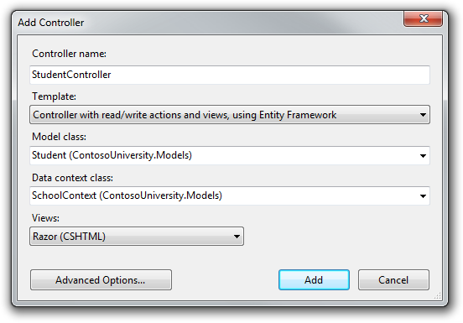

Open the *Controllers\StudentController.cs* file. You see a class variable has been created that instantiates a database context object:

private SchoolContext db = new SchoolContext();

The Index action method gets a list of students from the Students property of the database context instance:

public ViewResult Index()

{

return View(db.Students.ToList());

}

The automatic scaffolding has also created a set of Student views. To customize the default headings and column order in the Index view, open *Views\Student\Index.cshtml* and replace the existing code with the following code:

@model IEnumerable<ContosoUniversity.Models.Student>

@{

ViewBag.Title = "Students";

}

<h2>Students</h2>

<p>

@Html.ActionLink("Create New", "Create")

</p>

<table>

<tr>

<th></th>

<th>Last Name</th>

<th>First Name</th>

<th>Enrollment Date</th>

</tr>

@foreach (var item in Model) {

<tr>

<td>

@Html.ActionLink("Edit", "Edit", new { id=item.StudentID }) |

@Html.ActionLink("Details", "Details", new { id=item.StudentID }) |

@Html.ActionLink("Delete", "Delete", new { id=item.StudentID })

</td>

<td>

@Html.DisplayFor(modelItem => item.LastName)

</td>

<td>

@Html.DisplayFor(modelItem => item.FirstMidName)

</td>

<td>

@Html.DisplayFor(modelItem => item.EnrollmentDate)

</td>

</tr>

}

</table>

Run the site, click the **Students** tab, and you see a list of students.



Close the browser. In **Solution Explorer**, select the **ContosoUniversity** project (make sure the project and not the solution is selected). Click **Show all Files** if you aren't already in that mode. Click **Refresh** and then expand the *App_Data* folder to see the *School.sdf* file.

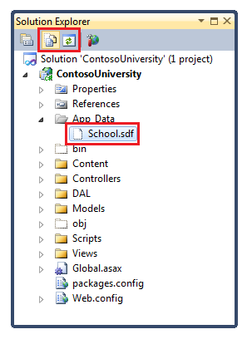

Double-click *School.sdf* to open **Server Explorer**. Then expand the **Tables** folder to see the tables that have been created in the database.

**Note** If you get an error when you double-click *School.sdf*, make sure you have installed **Visual Studio 2010 SP1 Tools for SQL Server Compact 4.0**. (For links to the software, see the list of prerequisites at the top of this page.) If you install the tools now, you'll have to close and re-open Visual Studio.

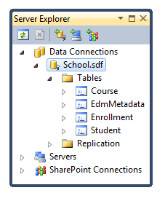

There's one table for each entity set, plus one additional table. The EdmMetadata table is used by the Entity Framework to determine when the model and the database are out of sync.

Right-click one of the tables and select **Show Table Data** to see the data that was loaded in the table by the SchoolInitializer class.

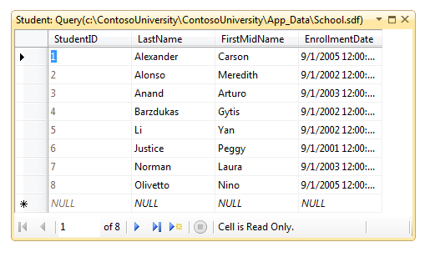

When you're finished, close the connection. (If you don't close the connection, you might get an error the next time you run the project).

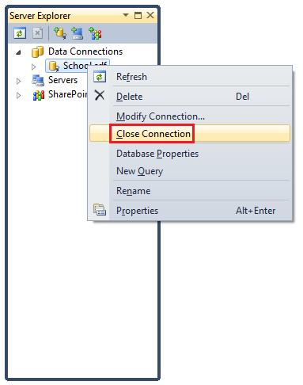

## Conventions

The amount of code you had to write in order for the Entity Framework to be able to create a complete database for you is minimal because of the use of *conventions*, or assumptions that the Entity Framework makes. Some of them have already been noted:

* The pluralized forms of entity class names are used as table names.
* Entity property names are used for column names.
* Entity properties that are named ID or *classname*ID are recognized as primary key properties.
* The Entity Framework connects to your database by looking for a connection string that has the same name as your context class (in this case, SchoolContext).

You've seen that conventions can be overridden (for example, you specified that table names shouldn't be pluralized), and you'll learn more about conventions and how to override them in the [Creating a More Complex Data Model](http://www.asp.net/entity-framework/tutorials/creating-a-more-complex-data-model-for-an-asp-net-mvc-application) tutorial later in this series.

You've now created a simple application that uses the Entity Framework and SQL Server Compact to store and display data. In the following tutorial you'll learn how to perform basic CRUD (create, read, update, delete) operations.

# 2 Implementing Basic CRUD Functionality with the Entity Framework in ASP.NET MVC Application

The Contoso University sample web application demonstrates how to create ASP.NET MVC applications using the Entity Framework. The sample application is a website for a fictional Contoso University. It includes functionality such as student admission, course creation, and instructor assignments.

This tutorial series explains the steps taken to build the Contoso University sample application. You can [download the completed application](http://go.microsoft.com/fwlink/?LinkId=215669) or create it by following the steps in the tutorial. The tutorial shows examples in C#. The downloadable sample contains code in both C# and Visual Basic. If you have questions that are not directly related to the tutorial, you can post them to the [ASP.NET Entity Framework forum](http://forums.asp.net/1227.aspx) or the [Entity Framework and LINQ to Entities forum](http://social.msdn.microsoft.com/forums/en-US/adodotnetentityframework/threads/).

This tutorial series assumes you know how to work with ASP.NET MVC in Visual Studio. If you don’t, a good place to start is a [basic ASP.NET MVC Tutorial](http://www.asp.net/mvc/tutorials/getting-started-with-MVC3-part1-cs). If you prefer to work with the ASP.NET Web Forms model, see the [Getting Started with the Entity Framework](http://www.asp.net/entity-framework/tutorials#Getting Started) and [Continuing with the Entity Framework](http://www.asp.net/entity-framework/tutorials#Continuing) tutorials.

Before you start, make sure you have the following software installed on your computer:

* [Visual Studio 2010 SP1](http://www.microsoft.com/web/gallery/install.aspx?appsxml=&appid=VS2010SP1Pack) or [Visual Web Developer Express 2010 SP1](http://www.microsoft.com/web/gallery/install.aspx?appsxml=&appid=VWD2010SP1Pack) (If you use one of these links, the following items will be installed automatically.)
* [ASP.NET MVC 3 Tools Update](http://www.microsoft.com/web/gallery/install.aspx?appid=MVC3)
* [Microsoft SQL Server Compact 4.0](http://www.microsoft.com/web/gallery/install.aspx?appid=SQLCE)
* [Microsoft Visual Studio 2010 SP1 Tools for SQL Server Compact 4.0](http://www.microsoft.com/web/gallery/install.aspx?appid=SQLCEVSTools)

In the previous tutorial you created an MVC application that stores and displays data using the Entity Framework and SQL Server Compact. In this tutorial you will review and customize the CRUD (create, read, update, delete) code that the MVC scaffolding automatically creates for you in controllers and views.

**Note** It's a common practice to implement the repository pattern in order to create an abstraction layer between your controller and the data access layer. To keep these tutorials simple, you won't implement a repository until a later tutorial in this series ([Implementing the Repository and Unit of Work Patterns](http://www.asp.net/entity-framework/tutorials/implementing-the-repository-and-unit-of-work-patterns-in-an-asp-net-mvc-application)).

In this tutorial, you will create the following web pages:

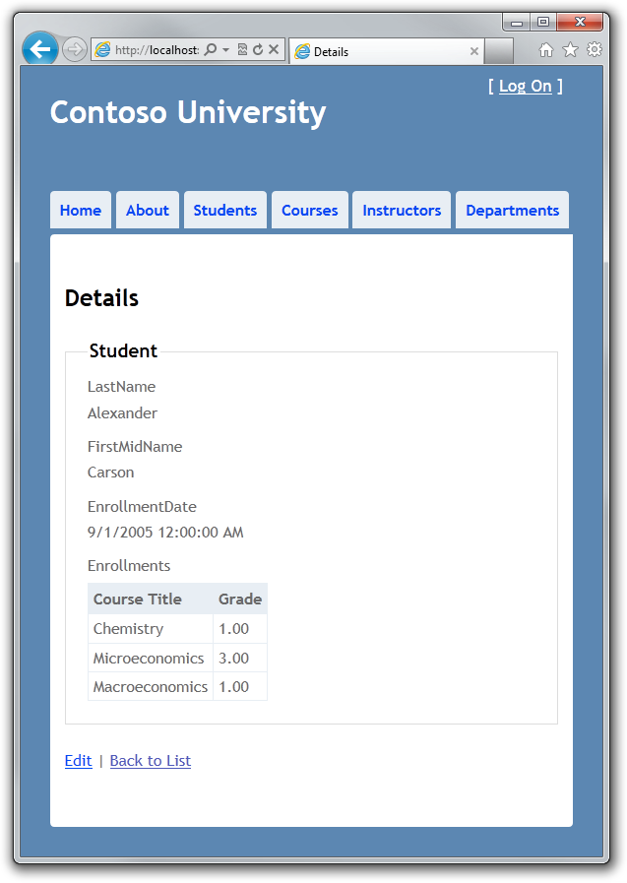

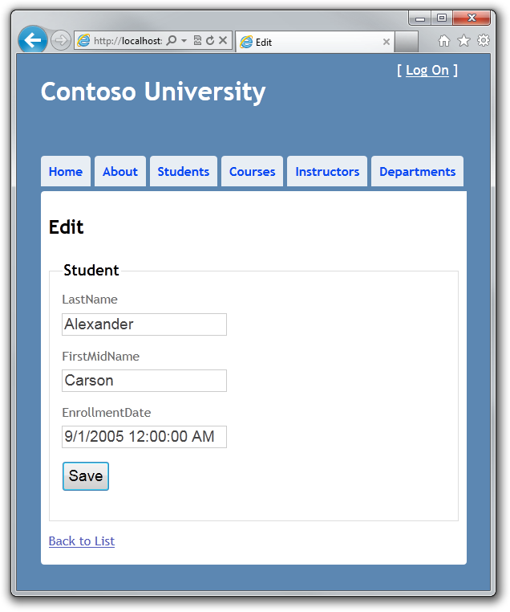

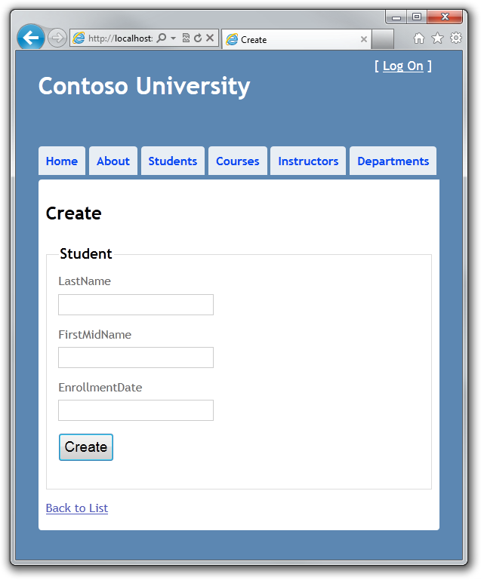

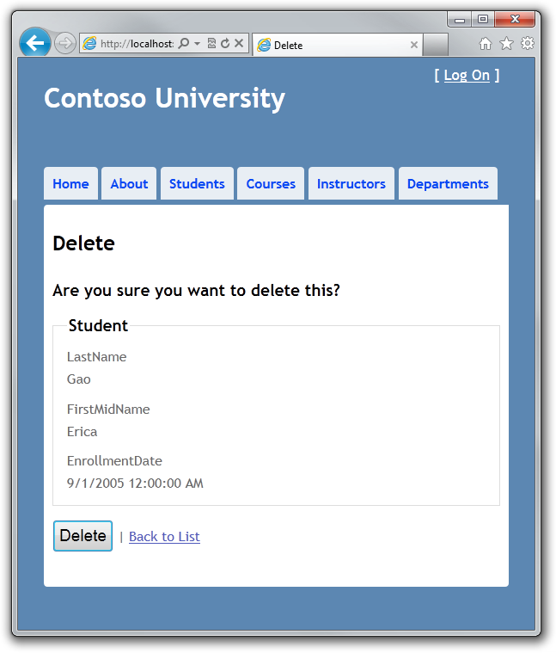

## Creating a Details Page

The scaffolded code for the Index page left out the Enrollments property, because that property holds a collection. In the Details page you will display the contents of the collection in an HTML table.

In Controllers\StudentController.cs, the action method for the Details view resembles the following example:

public ViewResult Details(int id)

{

Student student = db.Students.Find(id);

return View(student);

}

The code uses the Find method to retrieve a single Student entity corresponding to the key value that's passed to the method as the id parameter. The id value comes from a query string in the **Details** hyperlink on the Index page.

Open Views\Student\Details.cshtml. Each field is displayed using a DisplayFor helper, as shown in the following example:

<div class="display-label">LastName</div>

<div class="display-field">

@Html.DisplayFor(model => model.LastName)

</div>

To display a list of enrollments, add the following code after the EnrollmentDate field, immediately before the closing fieldset tag:

<div class="display-label">

@Html.LabelFor(model => model.Enrollments)

</div>

<div class="display-field">

<table>

<tr>

<th>Course Title</th>

<th>Grade</th>

</tr>

@foreach (var item in Model.Enrollments)

{

<tr>

<td>

@Html.DisplayFor(modelItem => item.Course.Title)

</td>

<td>

@Html.DisplayFor(modelItem => item.Grade)

</td>

</tr>

}

</table>

</div>

This code loops through the entities in the Enrollments navigation property. For each Enrollment entity in the property, it displays the course title and the grade. The course title is retrieved from the Course entity that's stored in the Course navigation property of the Enrollments entity. All of this data is retrieved from the database automatically when it's needed. (In other words, you are using lazy loading here. You did not specify eager loading for the Courses navigation property, so the first time you try to access that property, a query is sent to the database to retrieve the data. You can read more about lazy loading and eager loading in the [Reading Related Data](http://www.asp.net/entity-framework/tutorials/reading-related-data-with-the-entity-framework-in-an-asp-net-mvc-application) tutorial later in this series.)

Run the page by selecting the **Students** tab and clicking a **Details** hyperlink. You see the list of courses:



## Creating a Create Page

In Controllers\StudentController.cs, replace the HttpPost Create action method with the following code to add a try-catch block to the scaffolded method:

[HttpPost]

public ActionResult Create(Student student)

{

try

{

if (ModelState.IsValid)

{

db.Students.Add(student);

db.SaveChanges();

return RedirectToAction("Index");

}

}

catch (DataException)

{

//Log the error (add a variable name after DataException)

ModelState.AddModelError("", "Unable to save changes. Try again, and if the problem persists see your system administrator.");

}

return View(student);

}

This code adds the Student entity created by the ASP.NET MVC model binder to the Students entity set and then saves the changes to the database. (Model binder refers to the ASP.NET MVC functionality that makes it easier for you to work with data submitted by a form; a model binder converts posted form values to .NET Framework types and passes them to the action method in parameters. In this case, the model binder instantiates a Student entity for you using property values from the Form collection.)

The try-catch block is the only difference between this code and what the automatic scaffolding created. If an exception that derives from DataException is caught while the changes are being saved, a generic error message is displayed. These kinds of errors are typically caused by something external to the application rather than a programming error, so the user is advised to try again. The code in Views\Student\Create.cshtml is similar to what you saw in Details.cshtml, except that EditorFor and ValidationMessageFor helpers are used for each field instead of DisplayFor. The following example shows the relevant code:

<div class="editor-label">

@Html.LabelFor(model => model.LastName)

</div>

<div class="editor-field">

@Html.EditorFor(model => model.LastName)

@Html.ValidationMessageFor(model => model.LastName)

</div>

No changes are required in Create.cshtml.

Run the page by selecting the **Students** tab and clicking **Create New**.



Data validation works by default. Enter names and an invalid date and click **Create** to see the error message.

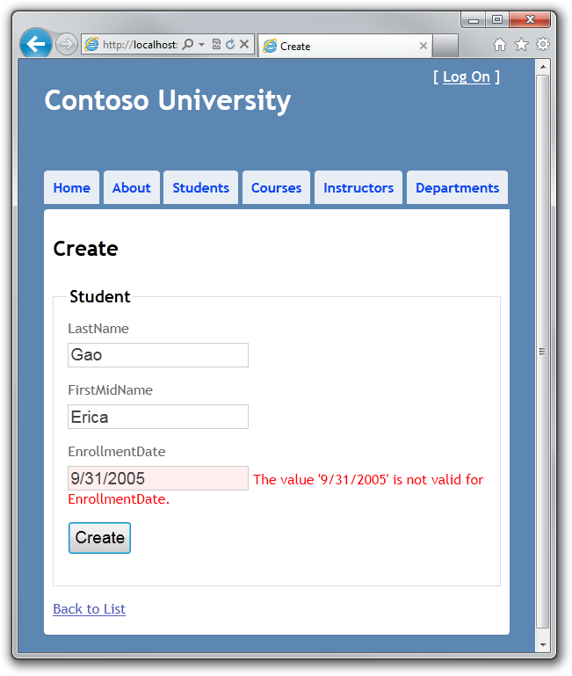

In this case you're seeing client-side validation that's implemented using JavaScript. But server-side validation is also implemented. Even if client validation failed, bad data would be caught and an exception would be thrown in server code.

Change the date to a valid value such as 9/1/2005 and click **Create** to see the new student appear in the **Index** page.

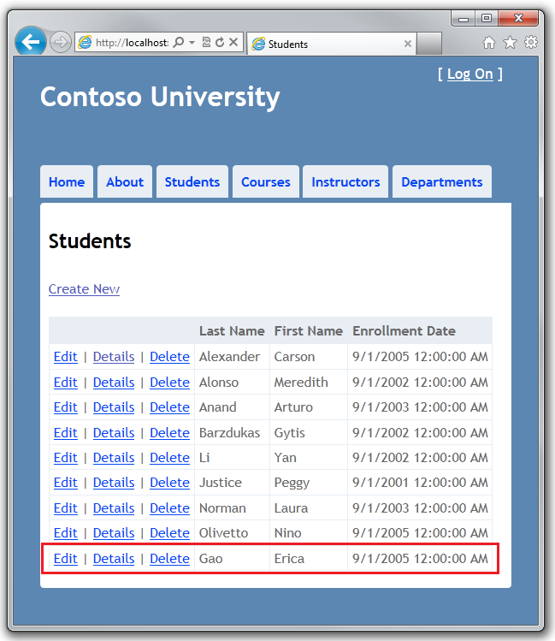

## Creating an Edit Page

In Controllers\StudentController.cs, the HttpGet Edit method (the one without the HttpPost attribute) uses the Find method to retrieve the selected Student entity, as you saw in the Details method. You don't need to change this method.

However, replace the HttpPost Edit action method with the following code to add a try-catch block:

[HttpPost]

public ActionResult Edit(Student student)

{

try

{

if (ModelState.IsValid)

{

db.Entry(student).State = EntityState.Modified;

db.SaveChanges();

return RedirectToAction("Index");

}

}

catch (DataException)

{

//Log the error (add a variable name after DataException)

ModelState.AddModelError("", "Unable to save changes. Try again, and if the problem persists see your system administrator.");

}

return View(student);

}

This code is similar to what you saw in the HttpPost Create method. However, instead of adding the entity created by the model binder to the entity set, this code sets a flag on the entity that indicating it has been changed. When the SaveChanges method is called, the Modified flag causes the Entity Framework to create SQL statements to update the database row. All columns of the database row will be updated, including those that the user didn't change, and concurrency conflicts are ignored. (You will learn how to handle concurrency in the [Handling Concurrency](http://www.asp.net/entity-framework/tutorials/handling-concurrency-with-the-entity-framework-in-an-asp-net-mvc-application) tutorial later in this series.)

## Entity States and the Attach and SaveChanges Methods

The database context keeps track of whether entities in memory are in sync with their corresponding rows in the database, and this information determines what happens when you call the SaveChanges method. For example, when you pass a new entity to the Add method, that entity's state is set to Added. Then when you call the SaveChanges method, the database context issues a SQL INSERT command.

An entity may be in one of the following states:

* Added. The entity does not yet exist in the database. The SaveChanges method must issue an INSERT statement.
* Unchanged. Nothing needs to be done with this entity by the SaveChanges method. When you read an entity from the database, the entity starts out with this status.
* Modified. Some or all of the entity's property values have been modified. The SaveChanges method must issue an UPDATE statement.
* Deleted. The entity has been marked for deletion. The SaveChanges method must issue a DELETE statement.
* Detached. The entity isn't being tracked by the database context.

In a desktop application, state changes are typically set automatically. In this type of application, you read an entity and make changes to some of its property values. This causes its entity state to automatically be changed to Modified. Then when you call SaveChanges, the Entity Framework generates a SQL UPDATE statement that updates only the actual properties that you changed.

However, in a web application this sequence is interrupted, because the database context instance that reads an entity is disposed after a page is rendered. When the HttpPost Edit action method is called, this is the result of a new request and you have a new instance of the context, so you have to manually set the entity state to Modified. Then when you call SaveChanges, the Entity Framework updates all columns of the database row, because the context has no way to know which properties you changed.

If you want the SQL Update statement to update only the fields that the user actually changed, you can save the original values in some way (such as hidden fields) so that they are available when the HttpPost Edit method is called. Then you can create a Student entity using the original values, call the Attach method with that original version of the entity, update the entity's values to the new values, and then call SaveChanges. For more information, see [Add/Attach and Entity States](http://blogs.msdn.com/b/adonet/archive/2011/01/29/using-dbcontext-in-ef-feature-ctp5-part-4-add-attach-and-entity-states.aspx) and [Local Data](http://blogs.msdn.com/b/adonet/archive/2011/02/01/using-dbcontext-in-ef-feature-ctp5-part-7-local-data.aspx) on the Entity Framework team blog.

The code in Views\Student\Edit.cshtml is similar to what you saw in Create.cshtml, and no changes are required.

Run the page by selecting the **Students** tab and then clicking an **Edit** hyperlink.



Change some of the data and click **Save**. You see the changed data in the Index page.

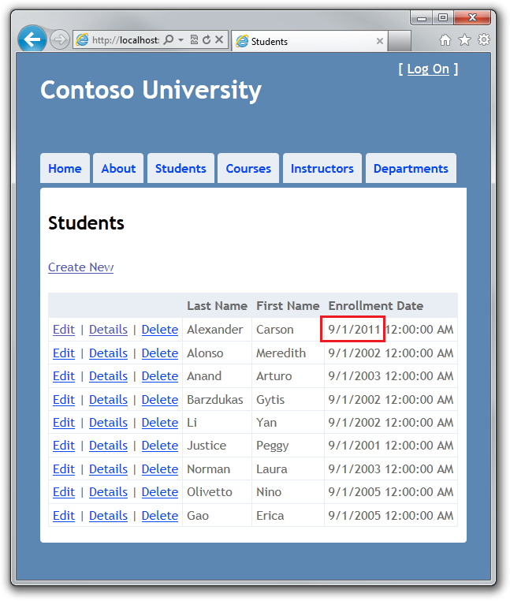

## Creating a Delete Page

In Controllers\StudentController.cs, the template code for the HttpGet Delete method uses the Find method to retrieve the selected Student entity, as you saw in the Details and Edit methods. However, to implement a custom error message when the call to SaveChanges fails, you will add some functionality to this method and its corresponding view.

As you saw for update and create operations, delete operations require two action methods. The method that is called in response to a GET request displays a view that gives the user a chance to approve or cancel the delete operation. If the user approves it, a POST request is created. When that happens, the HttpPost Delete method is called and then that method actually performs the delete operation.

You will add a try-catch block to the HttpPost Delete method to handle any errors that might occur when the database is updated. If an error occurs, the HttpPost Delete method calls the HttpGet Delete method, passing it a parameter that indicates that an error has occurred. The HttpGet Delete method then redisplays the confirmation page along with the error message, giving the user an opportunity to cancel or to try again.

Replace the HttpGet Delete action method with the following code, which manages error reporting:

public ActionResult Delete(int id, bool? saveChangesError)

{

if (saveChangesError.GetValueOrDefault())

{

ViewBag.ErrorMessage = "Unable to save changes. Try again, and if the problem persists see your system administrator.";

}

return View(db.Students.Find(id));

}

This code accepts an optional Boolean parameter that indicates whether it was called after a failure to save changes. This parameter is null (false) when the HttpGet Delete method is called in response to a page request. When it is called by the HttpPost Delete method in response to a database update error, the parameter is true and an error message is passed to the view.

Replace the HttpPost Delete action method (named DeleteConfirmed) with the following code, which performs the actual delete operation and catches any database update errors.

[HttpPost, ActionName("Delete")]

public ActionResult DeleteConfirmed(int id)

{

try

{

Student student = db.Students.Find(id);

db.Students.Remove(student);

db.SaveChanges();

}

catch (DataException)

{

//Log the error (add a variable name after DataException)

return RedirectToAction("Delete",

new System.Web.Routing.RouteValueDictionary {

{ "id", id },

{ "saveChangesError", true } });

}

return RedirectToAction("Index");

}

This code retrieves the selected entity, then calls the Remove method to set the entity's status to Deleted. When SaveChanges is called, a SQL DELETE command is generated.

If improving performance in a high-volume application is a priority, you could avoid an unnecessary SQL query to retrieve the row by replacing the lines of code that call the Find and Remove methods with the following code:

Student studentToDelete = new Student() { StudentID = id };

db.Entry(studentToDelete).State = EntityState.Deleted;

This code instantiates a Student entity using only the primary key value and then sets the entity state to Deleted. That's all that the Entity Framework needs in order to delete the entity.

As noted, the HttpGet Delete method doesn't delete the data. Performing a delete operation in response to a GET request (or for that matter, performing an edit operation, create operation, or any other operation that changes data) creates a security risk. For more information, see [ASP.NET MVC Tip #46 — Don't use Delete Links because they create Security Holes](http://stephenwalther.com/blog/archive/2009/01/21/asp.net-mvc-tip-46-ndash-donrsquot-use-delete-links-because.aspx) on Stephen Walther's blog.

In Views\Student\Delete.cshtml, add the following code between the h2 heading and the h3 heading:

<p class="error">@ViewBag.ErrorMessage</p>

Run the page by selecting the **Students** tab and clicking a **Delete** hyperlink:



Click **Delete**. The Index page is displayed without the deleted student. (You'll see an example of the error handling code in action in the [Handling Concurrency](http://www.asp.net/entity-framework/tutorials/handling-concurrency-with-the-entity-framework-in-an-asp-net-mvc-application) tutorial later in this series.)

## Ensuring that Database Connections Are Not Left Open

To make sure that database connections are properly closed and the resources they hold freed up, you should see to it that the context instance is disposed. That is why you will find a Dispose method at the end of the StudentController class in StudentController.cs, as shown in the following example:

protected override void Dispose(bool disposing)

{

db.Dispose();

base.Dispose(disposing);

}

The base Controller class already implements the IDisposable interface, so this code simply adds an override to the Dispose(bool) method to explicitly dispose the context instance.

You now have a complete set of pages that perform simple CRUD operations for Student entities. In the next tutorial you'll expand the functionality of the Index page by adding sorting and paging.

# 3 Sorting, Filtering, and Paging with the Entity Framework in an ASP.NET MVC Application

The Contoso University sample web application demonstrates how to create ASP.NET MVC applications using the Entity Framework. The sample application is a website for a fictional Contoso University. It includes functionality such as student admission, course creation, and instructor assignments.

This tutorial series explains the steps taken to build the Contoso University sample application. You can [download the completed application](http://go.microsoft.com/fwlink/?LinkId=215669) or create it by following the steps in the tutorial. The tutorial shows examples in C#. The downloadable sample contains code in both C# and Visual Basic. If you have questions that are not directly related to the tutorial, you can post them to the [ASP.NET Entity Framework forum](http://forums.asp.net/1227.aspx) or the [Entity Framework and LINQ to Entities forum](http://social.msdn.microsoft.com/forums/en-US/adodotnetentityframework/threads/).

This tutorial series assumes you know how to work with ASP.NET MVC in Visual Studio. If you don’t, a good place to start is a [basic ASP.NET MVC Tutorial](http://www.asp.net/mvc/tutorials/getting-started-with-MVC3-part1-cs). If you prefer to work with the ASP.NET Web Forms model, see the [Getting Started with the Entity Framework](http://www.asp.net/entity-framework/tutorials#Getting Started) and [Continuing with the Entity Framework](http://www.asp.net/entity-framework/tutorials#Continuing) tutorials.

Before you start, make sure you have the following software installed on your computer:

* [Visual Studio 2010 SP1](http://www.microsoft.com/web/gallery/install.aspx?appsxml=&appid=VS2010SP1Pack) or [Visual Web Developer Express 2010 SP1](http://www.microsoft.com/web/gallery/install.aspx?appsxml=&appid=VWD2010SP1Pack) (If you use one of these links, the following items will be installed automatically.)
* [ASP.NET MVC 3 Tools Update](http://www.microsoft.com/web/gallery/install.aspx?appid=MVC3)
* [Microsoft SQL Server Compact 4.0](http://www.microsoft.com/web/gallery/install.aspx?appid=SQLCE)
* [Microsoft Visual Studio 2010 SP1 Tools for SQL Server Compact 4.0](http://www.microsoft.com/web/gallery/install.aspx?appid=SQLCEVSTools)

In the previous tutorial you implemented a set of web pages for basic CRUD operations for Student entities. In this tutorial you'll add sorting, filtering, and paging functionality to the Students Index page. You'll also create a page that does simple grouping.

The following illustration shows what the page will look like when you're done. The column headings are links that the user can click to sort by that column. Clicking a column heading repeatedly toggles between ascending and descending sort order.

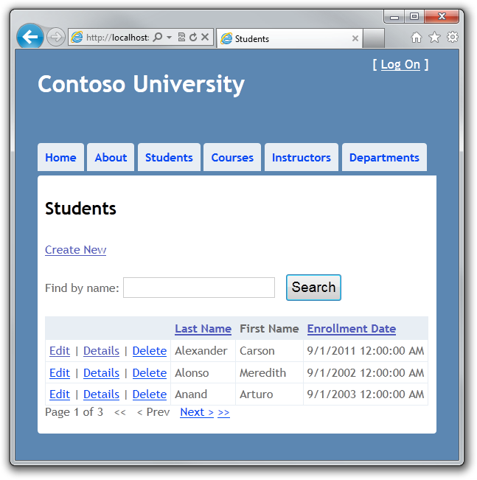

## Adding Column Sort Links to the Students Index Page

To add sorting to the Student Index page, you'll change the Index method of the Student controller and add code to the Student Index view.

## Adding Sorting Functionality to the Index Method

In Controllers\StudentController.cs, replace the Index method with the following code:

public ViewResult Index(string sortOrder)

{

ViewBag.NameSortParm = String.IsNullOrEmpty(sortOrder) ? "Name desc" : "";

ViewBag.DateSortParm = sortOrder == "Date" ? "Date desc" : "Date";

var students = from s in db.Students

select s;

switch (sortOrder)

{

case "Name desc":

students = students.OrderByDescending(s => s.LastName);

break;

case "Date":

students = students.OrderBy(s => s.EnrollmentDate);

break;

case "Date desc":

students = students.OrderByDescending(s => s.EnrollmentDate);

break;

default:

students = students.OrderBy(s => s.LastName);

break;

}

return View(students.ToList());

}

This code receives a sortOrder parameter from the query string in the URL, which is provided by ASP.NET MVC as a parameter to the action method. The parameter will be a string that's either "Name" or "Date", optionally followed by a space and the string "desc" to specify descending order.

The first time the Index page is requested, there's no query string. The students are displayed in ascending order by LastName, which is the default as established by the fall-through case in the switch statement. When the user clicks a column heading hyperlink, the appropriate sortOrder value is provided in the query string.

The two ViewBag variables are used so that the view can configure the column heading hyperlinks with the appropriate query string values:

ViewBag.NameSortParm = String.IsNullOrEmpty(sortOrder) ? "Name desc" : "";

ViewBag.DateSortParm = sortOrder == "Date" ? "Date desc" : "Date";

These are ternary statements. The first one specifies that if the sortOrder parameter is null or empty, ViewBag.NameSortParm should be set to "Name desc"; otherwise, it should be set to an empty string.

There are four possibilities, depending on how the data is currently sorted:

* If the current order is **Last Name** ascending, the **Last Name** link must specify **Last Name** descending, and the **Enrollment Date** link must specify **Date** ascending.
* If the current order is **Last Name** descending, the links must indicate **Last Name** ascending (that is, empty string) and **Date** ascending.
* If the current order is **Date** ascending, the links must indicate **Last Name** ascending and **Date** descending.
* If the current order is **Date** descending, the links must indicate **Last Name** ascending and **Date** ascending.

The method uses LINQ to Entities to specify the column to sort by. The code creates an IQueryable variable before the switch statement, modifies it in the switch statement, and calls the ToList method after the switch statement. When you create and modify IQueryable variables, no query is sent to the database. The query is not executed until you convert the IQueryable object into a collection by calling a method such as ToList. Therefore, this code results in a single query that is not executed until the return View statement.

## Adding Column Heading Hyperlinks to the Student Index View

In Views\Student\Index.cshtml, replace the <tr> and <th> elements for the heading row with the following code:

<tr>

<th></th>

<th>

@Html.ActionLink("Last Name", "Index", new { sortOrder=ViewBag.NameSortParm })

</th>

<th>

First Name

</th>

<th>

@Html.ActionLink("Enrollment Date", "Index", new { sortOrder=ViewBag.DateSortParm })

</th>

</tr>

This code uses the information in the ViewBag properties to set up hyperlinks with the appropriate query string values.

Run the page and click the column headings to verify that sorting works.

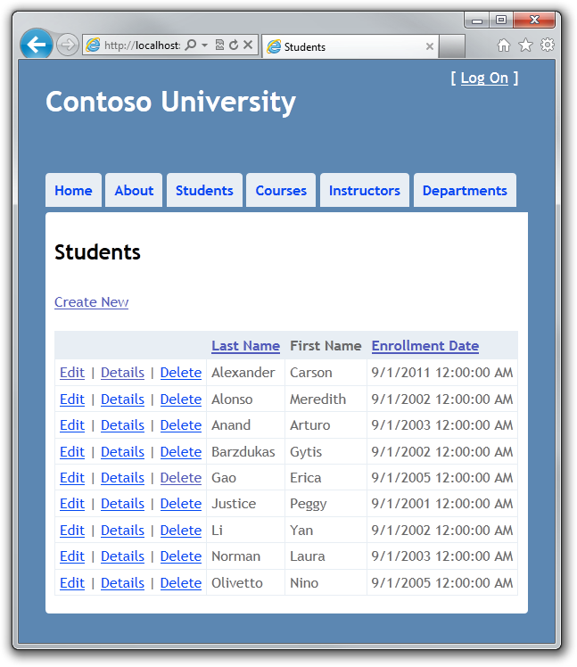

## Adding a Search Box to the Students Index Page

To add filtering to the Student Index page, you'll add a text box and a submit button to the view and make corresponding changes in the Index method. The text box will let you enter a string to search for in the first name and last name fields.

## Adding Filtering Functionality to the Index Method

In Controllers\StudentController.cs, replace the Index method with the following code:

public ViewResult Index(string sortOrder, string searchString)

{

ViewBag.NameSortParm = String.IsNullOrEmpty(sortOrder) ? "Name desc" : "";

ViewBag.DateSortParm = sortOrder == "Date" ? "Date desc" : "Date";

var students = from s in db.Students

select s;

if (!String.IsNullOrEmpty(searchString))

{

students = students.Where(s => s.LastName.ToUpper().Contains(searchString.ToUpper())

|| s.FirstMidName.ToUpper().Contains(searchString.ToUpper()));

}

switch (sortOrder)

{

case "Name desc":

students = students.OrderByDescending(s => s.LastName);

break;

case "Date":

students = students.OrderBy(s => s.EnrollmentDate);

break;

case "Date desc":

students = students.OrderByDescending(s => s.EnrollmentDate);

break;

default:

students = students.OrderBy(s => s.LastName);

break;

}

return View(students.ToList());

}

You've added a searchString parameter to the Index method. You've also added a where clause to the LINQ statement that selects only students whose first name or last name contains the search string. The search string value is received from a text box that you'll add later to the Index view.The statement that adds the where clause is executed only if there's a value to search for:

if (!String.IsNullOrEmpty(searchString))

{

students = students.Where(s => s.LastName.ToUpper().Contains(searchString.ToUpper())

|| s.FirstMidName.ToUpper().Contains(searchString.ToUpper()));

}

**Note** The .NET Framework implementation of the Contains method returns all rows when you pass an empty string to it, but the Entity Framework provider for SQL Server Compact 4.0 returns zero rows for empty strings. Therefore the code in the example (putting the Where statement inside an if statement) makes sure that you get the same results for all versions of SQL Server. Also, the .NET Framework implementation of the Contains method performs a case-sensitive comparison by default, but Entity Framework SQL Server providers perform case-insensitive comparisons by default. Therefore, calling the ToUpper method to make the test explicitly case-insensitive ensures that results do not change when you change the code later to use a repository, which will return an IEnumerable collection instead of an IQueryable object. (When you call the Contains method on an IEnumerable collection, you get the .NET Framework implementation; when you call it on an IQueryable object, you get the database provider implementation.)

## Adding a Search Box to the Student Index View

In Views\Student\Index.cshtml, add a caption, a text box, and a **Search** button immediately before the opening table tag:

@using (Html.BeginForm())

{

<p>

Find by name: @Html.TextBox("SearchString")

<input type="submit" value="Search" /></p>

}

Run the page, enter a search string, and click **Search** to verify that filtering is working.

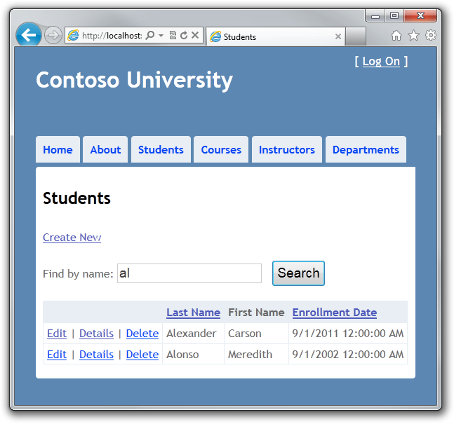

## Adding Paging to the Students Index Page

To add paging to the Student Index page, you'll start by installing the **PagedList** NuGet package. Then you'll make additional changes in the Index method and add paging links to the Index view. The following illustration shows the paging links.



## Installing the PagedList NuGet Package

The NuGet **PagedList** package installs a PagedList collection type. When you put query results in a PagedList collection, several properties and methods are provided that facilitate paging.

In Visual Studio, make sure the project (not the solution) is selected. From the **Tools** menu, select **Library Package Manager** and then **Add Library Package Reference**.

In the **Add Library Package Reference** dialog box, click the **Online** tab on the left and then enter "pagedlist" in the search box. When you see the **PagedList** package, click **Install**.

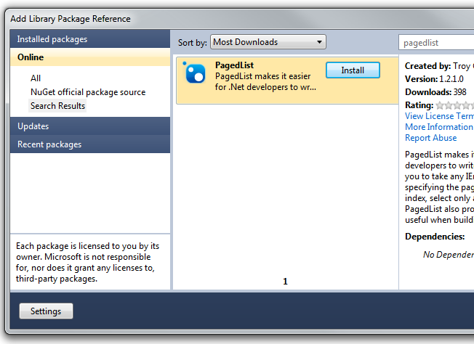

## Adding Paging Functionality to the Index Method

In Controllers\StudentController.cs, add a using statement for the PagedList namespace:

using PagedList;

Replace the Index method with the following code:

public ViewResult Index(string sortOrder, string currentFilter, string searchString, int? page)

{

ViewBag.CurrentSort = sortOrder;

ViewBag.NameSortParm = String.IsNullOrEmpty(sortOrder) ? "Name desc" : "";

ViewBag.DateSortParm = sortOrder == "Date" ? "Date desc" : "Date";

if (Request.HttpMethod == "GET")

{

searchString = currentFilter;

}

else

{

page = 1;

}

ViewBag.CurrentFilter = searchString;

var students = from s in db.Students

select s;

if (!String.IsNullOrEmpty(searchString))

{

students = students.Where(s => s.LastName.ToUpper().Contains(searchString.ToUpper())

|| s.FirstMidName.ToUpper().Contains(searchString.ToUpper()));

}

switch (sortOrder)

{

case "Name desc":

students = students.OrderByDescending(s => s.LastName);

break;

case "Date":

students = students.OrderBy(s => s.EnrollmentDate);

break;

case "Date desc":

students = students.OrderByDescending(s => s.EnrollmentDate);

break;

default:

students = students.OrderBy(s => s.LastName);

break;

}

int pageSize = 3;

int pageNumber = (page ?? 1);

return View(students.ToPagedList(pageNumber, pageSize));

}

This code adds a page parameter, a current sort order parameter, and a current filter parameter to the method signature, as shown here:

public ViewResult Index(string sortOrder, string currentFilter, string searchString, int? page)

The first time the page is displayed, or if the user hasn't clicked a paging link, the page variable is null. If a paging link is clicked, the page variable will contain the page number to display.

A ViewBag property provides the view with the current sort order, because this must be included in the paging links in order to keep the sort order the same while paging:

ViewBag.CurrentSort = sortOrder;

Another ViewBag property provides the view with the current filter string, because this string must be restored to the text box when the page is redisplayed. In addition, the string must be included in the paging links in order to maintain the filter settings during paging. Finally, if the search string is changed during paging, the page has to be reset to 1, because the new filter can result in different data to display, hence the original page might not even exist anymore.

if (Request.HttpMethod == "GET")

{

searchString = currentFilter;

}

else

{

page = 1;

}

ViewBag.CurrentFilter = searchString;

At the end of the method, the student query is converted to a PagedList instead of to a List so that it will be passed to the view in a collection that supports paging. This is the code:

int pageSize = 3;

int pageNumber = (page ?? 1);

return View(students.ToPagedList(pageNumber, pageSize));

The ToPagedList method takes a page number value. The two question marks represent an operator that defines a default value for a nullable type; the expression (page ?? 1) means return the value of page if it has a value, or return 1 if page is null.

## Adding Paging Links to the Student Index View

In Views\Student\Index.cshtml, replace the existing code with the following code:

@model PagedList.IPagedList<ContosoUniversity.Models.Student>

@{

ViewBag.Title = "Students";

}

<h2>Students</h2>

<p>

@Html.ActionLink("Create New", "Create")

</p>

@using (Html.BeginForm())

{

<p>

Find by name: @Html.TextBox("SearchString", ViewBag.CurrentFilter as string)

<input type="submit" value="Search" /></p>

}

<table>

<tr>

<th></th>

<th>

@Html.ActionLink("Last Name", "Index", new { sortOrder=ViewBag.NameSortParm, currentFilter=ViewBag.CurrentFilter })

</th>

<th>

First Name

</th>

<th>

@Html.ActionLink("Enrollment Date", "Index", new { sortOrder = ViewBag.DateSortParm, currentFilter = ViewBag.CurrentFilter })

</th>

</tr>

@foreach (var item in Model) {

<tr>

<td>

@Html.ActionLink("Edit", "Edit", new { id=item.StudentID }) |

@Html.ActionLink("Details", "Details", new { id=item.StudentID }) |

@Html.ActionLink("Delete", "Delete", new { id=item.StudentID })

</td>

<td>

@Html.DisplayFor(modelItem => item.LastName)

</td>

<td>

@Html.DisplayFor(modelItem => item.FirstMidName)

</td>

<td>

@Html.DisplayFor(modelItem => item.EnrollmentDate)

</td>

</tr>

}

</table>

<div>

Page @(Model.PageCount < Model.PageNumber ? 0 : Model.PageNumber)

of @Model.PageCount

@if (Model.HasPreviousPage)

{

@Html.ActionLink("<<", "Index", new { page = 1, sortOrder = ViewBag.CurrentSort, currentFilter=ViewBag.CurrentFilter })

@Html.Raw(" ");

@Html.ActionLink("< Prev", "Index", new { page = Model.PageNumber - 1, sortOrder = ViewBag.CurrentSort, currentFilter=ViewBag.CurrentFilter })

}

else

{

@:<<

@Html.Raw(" ");

@:< Prev

}

@if (Model.HasNextPage)

{

@Html.ActionLink("Next >", "Index", new { page = Model.PageNumber + 1, sortOrder = ViewBag.CurrentSort, currentFilter=ViewBag.CurrentFilter })

@Html.Raw(" ");

@Html.ActionLink(">>", "Index", new { page = Model.PageCount, sortOrder = ViewBag.CurrentSort, currentFilter=ViewBag.CurrentFilter })

}

else

{

@:Next >

@Html.Raw(" ")

@:>>

}

</div>

The @model statement at the top of the page specifies that the view now gets a PagedList object instead of a List object.

The text box is initialized with the current search string so that the user can page through filter results without the search string disappearing:

Find by name: @Html.TextBox("SearchString", ViewBag.CurrentFilter as string)

The column header links use the query string to pass the current search string to the controller so that the user can sort within filter results:

@Html.ActionLink("Last Name", "Index", new { sortOrder=ViewBag.NameSortParm, currentFilter=ViewBag.CurrentFilter })

On one line at the bottom of the page, this code displays the following navigation UI:

**Page *[current page number]* of *[total number of pages]* << < Prev Next > >>**

The **<<** symbol is a link to the first page, **< Prev** is a link to the previous page, and so on. If the user is currently on page 1, the links to move backward are disabled; similarly, if the user is on the last page, the links to move forward are disabled. Each paging link passes the new page number and the current sort order and search string to the controller in the query string. This lets you maintain the sort order and filter results during paging.

If there are no pages to display, "Page 0 of 0" is shown. (In that case the page number is greater than the page count because Model.PageNumber is 1, and Model.PageCount is 0.)

Run the page.



Click the paging links in different sort orders to make sure paging works. Then enter a search string and try paging again to verify that paging also works correctly with sorting and filtering.

## Creating an About Page That Shows Student Statistics

For the Contoso University website's About page, you'll display how many students have enrolled for each enrollment date. This requires grouping and simple calculations on the groups. To accomplish this, you'll do the following:

* Create a view model class for the data that you need to pass to the view.
* Modify the About method in the Home controller.
* Modify the About view.

## Creating the View Model

Create a ViewModels folder. In that folder, create EnrollmentDateGroup.cs and replace the existing code with the following code:

using System;

using System.Collections.Generic;

using System.ComponentModel.DataAnnotations;

namespace ContosoUniversity.ViewModels

{

public class EnrollmentDateGroup

{

[DisplayFormat(DataFormatString = "{0:d}")]

public DateTime? EnrollmentDate { get; set; }

public int StudentCount { get; set; }

}

}

## Modifying the Home Controller

In HomeController.cs, add the following using statements:

using ContosoUniversity.DAL;

using ContosoUniversity.Models;

using ContosoUniversity.ViewModels;

Add a class variable for the database context:

private SchoolContext db = new SchoolContext();

Replace the About method with the following code:

public ActionResult About()

{

var data = from student in db.Students

group student by student.EnrollmentDate into dateGroup

select new EnrollmentDateGroup()

{

EnrollmentDate = dateGroup.Key,

StudentCount = dateGroup.Count()

};

return View(data);

}

The LINQ statement groups the student entities by enrollment date, calculates the number of entities in each group, and stores the results in a collection of EnrollmentDateGroup view model objects.

Add a Dispose method:

protected override void Dispose(bool disposing)

{

db.Dispose();

base.Dispose(disposing);

}

## Modifying the About View

Replace the code in the Views\Home\About.cshtml file with the following code:

@model IEnumerable<ContosoUniversity.ViewModels.EnrollmentDateGroup>

@{

ViewBag.Title = "Student Body Statistics";

}

<h2>Student Body Statistics</h2>

<table>

<tr>

<th>

Enrollment Date

</th>

<th>

Students

</th>

</tr>

@foreach (var item in Model) {

<tr>

<td>

@String.Format("{0:d}", item.EnrollmentDate)

</td>

<td>

@item.StudentCount

</td>

</tr>

}

</table>

Run the page. The count of students for each enrollment date is displayed in a table.

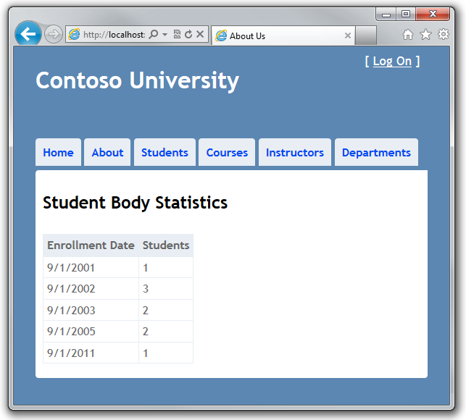

You've now seen how to create a data model and implement basic CRUD, sorting, filtering, paging, and grouping functionality. In the next tutorial you'll begin looking at more advanced topics by expanding the data model.

# 4 Creating a More Complex Data Model for an ASP.NET MVC Application

The Contoso University sample web application demonstrates how to create ASP.NET MVC applications using the Entity Framework. The sample application is a website for a fictional Contoso University. It includes functionality such as student admission, course creation, and instructor assignments.

This tutorial series explains the steps taken to build the Contoso University sample application. You can [download the completed application](http://go.microsoft.com/fwlink/?LinkId=215669) or create it by following the steps in the tutorial. The tutorial shows examples in C#. The downloadable sample contains code in both C# and Visual Basic. If you have questions that are not directly related to the tutorial, you can post them to the [ASP.NET Entity Framework forum](http://forums.asp.net/1227.aspx) or the [Entity Framework and LINQ to Entities forum](http://social.msdn.microsoft.com/forums/en-US/adodotnetentityframework/threads/).

This tutorial series assumes you know how to work with ASP.NET MVC in Visual Studio. If you don’t, a good place to start is a [basic ASP.NET MVC Tutorial](http://www.asp.net/mvc/tutorials/getting-started-with-MVC3-part1-cs). If you prefer to work with the ASP.NET Web Forms model, see the [Getting Started with the Entity Framework](http://www.asp.net/entity-framework/tutorials#Getting Started) and [Continuing with the Entity Framework](http://www.asp.net/entity-framework/tutorials#Continuing) tutorials.

Before you start, make sure you have the following software installed on your computer:

* [Visual Studio 2010 SP1](http://www.microsoft.com/web/gallery/install.aspx?appsxml=&appid=VS2010SP1Pack) or [Visual Web Developer Express 2010 SP1](http://www.microsoft.com/web/gallery/install.aspx?appsxml=&appid=VWD2010SP1Pack) (If you use one of these links, the following items will be installed automatically.)
* [ASP.NET MVC 3 Tools Update](http://www.microsoft.com/web/gallery/install.aspx?appid=MVC3)
* [Microsoft SQL Server Compact 4.0](http://www.microsoft.com/web/gallery/install.aspx?appid=SQLCE)
* [Microsoft Visual Studio 2010 SP1 Tools for SQL Server Compact 4.0](http://www.microsoft.com/web/gallery/install.aspx?appid=SQLCEVSTools)

In the previous tutorials you worked with a simple data model that was composed of three entities. In this tutorial you'll add more entities and relationships and make use of data annotation attributes to control the behavior of your model classes.

When you're finished, the entity classes will make up the completed data model that's shown in the following illustration:

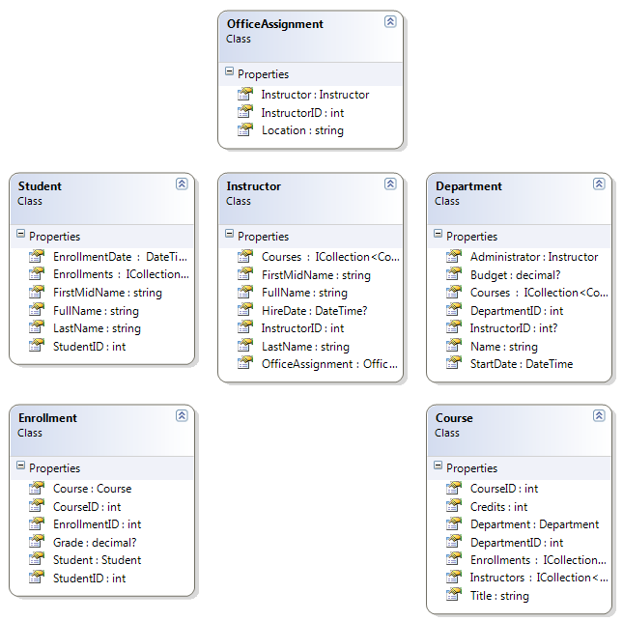

## Using Attributes to Control Formatting, Validation, and Database Mapping

In this section you'll see examples of attributes you can add to model classes to specify formatting, validation, and database mapping. Then in the following sections you'll create the complete School data model by adding attributes to the classes you already created and creating new classes for the remaining entity types in the model.

## The DisplayFormat Attribute

For student enrollment dates, all of the web pages currently display the time along with the date, although all you care about for this field is the date. By using data annotation attributes, you can make one code change that will fix the display format everywhere. To see an example of that, you'll add an attribute to the EnrollmentDate property in the Student class.

In Models\Student.cs, add a using statement for the System.ComponentModel.DataAnnotations namespace and add a DisplayFormat attribute to the EnrollmentDate property, as shown in the following example:

using System;

using System.Collections.Generic;

using System.ComponentModel.DataAnnotations;

namespace ContosoUniversity.Models

{

public class Student

{

public int StudentID { get; set; }

public string LastName { get; set; }

public string FirstMidName { get; set; }

[DisplayFormat(DataFormatString = "{0:d}", ApplyFormatInEditMode = true)]

public DateTime EnrollmentDate { get; set; }

public virtual ICollection<Enrollment> Enrollments { get; set; }

}

}

The format string specifies that only a short date should be displayed for this property. The ApplyFormatInEditMode setting specifies that this formatting should also be applied when the value is displayed in a text box for editing. (You might not want that for some fields — for example, for currency values, you might not want the currency symbol in the text box for editing.)

Run the Student Index page again and notice that times are no longer displayed for the enrollment dates. The same will be true if you run the other Student pages.

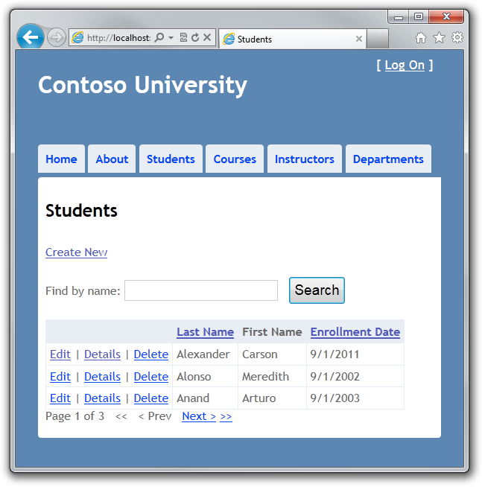

## The MaxLength Attribute

You can also specify data validation rules and messages using attributes. Suppose you want to ensure that users don't enter more than 50 characters for a name. To add this limitation, add Range attributes to the LastName and FirstMidName properties, as shown in the following example:

using System;

using System.Collections.Generic;

using System.ComponentModel.DataAnnotations;

namespace ContosoUniversity.Models

{

public class Student

{

public int StudentID { get; set; }

[MaxLength(50)]

public string LastName { get; set; }

[MaxLength(50, ErrorMessage = "First name cannot be longer than 50 characters.")]

public string FirstMidName { get; set; }

[DisplayFormat(DataFormatString = "{0:d}", ApplyFormatInEditMode = true)]

public DateTime EnrollmentDate { get; set; }

public virtual ICollection<Enrollment> Enrollments { get; set; }

}

}

If a user attempts to enter a last name that's too long, a default error message will be displayed. If a long first name is entered, the custom error message you specified will be displayed.

Run the Create page, enter two names longer than 50 characters, and click **Create** to see the error messages. (You'll have to enter a valid date in order to get past the date validation.)

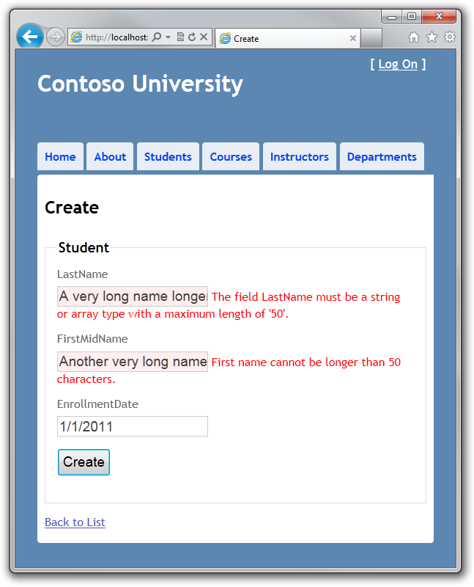

It's a good idea to always specify the maximum length for string properties. If you don't, when Code First creates the database, the corresponding columns will have the maximum length allowed for strings in the database, which would be an inefficient database table structure.

## The Column Attribute

You can also use attributes to control how your classes and properties are mapped to the database. Suppose you had used the name FirstMidName for the first-name field because the field might also contain a middle name. But you want the database column to be named FirstName, because users who will be writing ad-hoc queries against the database are accustomed to that name. To make this mapping, you can use the Column attribute.

The Column attribute specifies that when the database is created, the column of the Student table that maps to the FirstMidName property will be named FirstName. In other words, when your code refers to Student.FirstMidName, the data will come from or be updated in the FirstName column of the Student table. (If you don't specify column names, they are assumed to be the same as property names.)

Add the column name attribute to the FirstMidName property, as shown in the following example:

[Column("FirstName")]

public string FirstMidName { get; set; }

Run the Student Index page again and you see that nothing has changed. (You can't just run the site and view the home page; you have to select the Student Index page because that causes the database to be accessed, which causes the database to be automatically dropped and re-created.) However, if you open the database in **Server Explorer** as you did earlier, you can expand the Student table to see that the column name is FirstName.

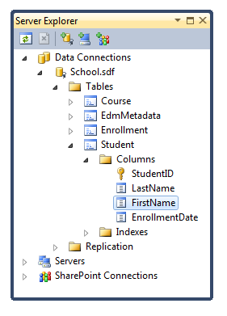

In the **Properties** window, you'll also notice that the name-related fields are defined as 50 characters in length, thanks to the MaxLength attributes you added earlier.

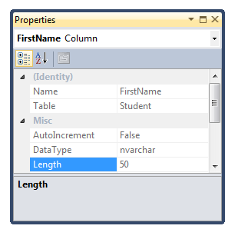

In most cases, you can also make mapping changes using method calls, as you'll see later in this tutorial.

In the following sections you'll make more use of data annotations attributes as you expand the School data model. In each section you'll create a class for an entity or modify a class that you created in the first tutorial.

**Note** If you try to compile before you finish creating all of these entity classes, you might get compiler errors.

## Creating the Instructor Entity

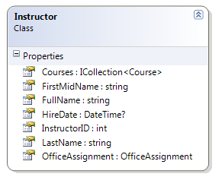

Create Models\Instructor.cs, replacing the existing code with the following code:

using System;

using System.Collections.Generic;

using System.ComponentModel.DataAnnotations;

namespace ContosoUniversity.Models

{

public class Instructor

{

public Int32 InstructorID { get; set; }

[Required(ErrorMessage = "Last name is required.")]

[Display(Name="Last Name")]

[MaxLength(50)]

public string LastName { get; set; }

[Required(ErrorMessage = "First name is required.")]

[Column("FirstName")]

[Display(Name = "First Name")]

[MaxLength(50)]

public string FirstMidName { get; set; }

[DisplayFormat(DataFormatString = "{0:d}", ApplyFormatInEditMode = true)]

[Required(ErrorMessage = "Hire date is required.")]

[Display(Name = "Hire Date")]

public DateTime? HireDate { get; set; }

public string FullName

{

get

{

return LastName + ", " + FirstMidName;

}

}

public virtual ICollection<Course> Courses { get; set; }

public virtual OfficeAssignment OfficeAssignment { get; set; }

}

}

Notice that several properties are the same in the Student and Instructor entities. In the [Implementing Inheritance](http://www.asp.net/entity-framework/tutorials/implementing-inheritance-with-the-entity-framework-in-an-asp-net-mvc-application) tutorial later in this series, you'll refactor using inheritance to eliminate this redundancy.

## The Required and Display Attributes

The attributes on the LastName property specify that it's a required field, that the caption for the text box should be "Last Name" (instead of the property name, which would be "LastName" with no space), and that the value can't be longer than 50 characters.

[Required(ErrorMessage = "Last name is required.")]

[Display(Name="Last Name")]

[MaxLength(50)]

public string LastName { get; set; }

## The FullName Calculated Property

FullName is a calculated property that returns a value that's created by concatenating two other properties. Therefore it has only a get accessor, and no FullName column will be generated in the database.

public string FullName

{

get

{

return LastName + ", " + FirstMidName;

}

}

## The Courses and OfficeAssignment Navigation Properties

The Courses and OfficeAssignment properties are navigation properties. As was explained earlier, they are typically defined as virtual so that they can take advantage of an Entity Framework feature called lazy loading. In addition, if a navigation property can hold multiple entities, its type must be ICollection.

An instructor can teach any number of courses, so Courses is defined as a collection of Course entities. On the other hand, an instructor can only have one office, so OfficeAssignment is defined as a single OfficeAssignment entity (which may be null if no office is assigned).

public virtual ICollection<Course> Courses { get; set; }

public virtual OfficeAssignment OfficeAssignment { get; set; }

## Creating the OfficeAssignment Entity

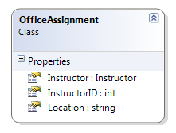

Create Models\OfficeAssignment.cs, replacing the existing code with the following code:

using System;

using System.Collections.Generic;

using System.ComponentModel.DataAnnotations;

namespace ContosoUniversity.Models

{

public class OfficeAssignment

{

[Key]

public int InstructorID { get; set; }

[MaxLength(50)]

[Display(Name = "Office Location")]

public string Location { get; set; }

public virtual Instructor Instructor { get; set; }

}

}

## The Key Attribute

There's a one-to-zero-or-one relationship between the Instructor and the OfficeAssignment entities. An office assignment only exists in relation to the instructor it's assigned to, and therefore its primary key is also its foreign key to the Instructor entity. But the Entity Framework can't automatically recognize InstructorID as the primary key of this entity because its name doesn't follow the ID or classnameID naming convention. Therefore, the Key attribute is used to identify it as the key:

[Key]

public int InstructorID { get; set; }

You can also use the Key attribute if the entity does have its own primary key but you want to name the property something different than classnameID or ID.

## The Instructor Navigation Property

The Instructor entity has a nullable OfficeAssignment navigation property (because an instructor might not have an office assignment), and the OfficeAssignment entity has a non-nullable Instructor navigation property (because an office assignment can't exist without an instructor). When an Instructor entity has a related OfficeAssignment entity, each entity will have a reference to the other one in its navigation property.

## Modifying the Course Entity

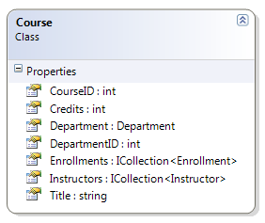

In Models\Course.cs, replace the code you added earlier with the following code:

using System;

using System.Collections.Generic;

using System.ComponentModel.DataAnnotations;

namespace ContosoUniversity.Models

{

public class Course

{

[DatabaseGenerated(DatabaseGeneratedOption.None)]

[Display(Name = "Number")]

public int CourseID { get; set; }

[Required(ErrorMessage = "Title is required.")]

[MaxLength(50)]

public string Title { get; set; }

[Required(ErrorMessage = "Number of credits is required.")]

[Range(0,5,ErrorMessage="Number of credits must be between 0 and 5.")]

public int Credits { get; set; }

[Display(Name = "Department")]

public int DepartmentID { get; set; }

public virtual Department Department { get; set; }

public virtual ICollection<Enrollment> Enrollments { get; set; }

public virtual ICollection<Instructor> Instructors { get; set; }

}

}

## The DatabaseGenerated Attribute

The DatabaseGenerated attribute with the None parameter on the CourseID property specifies that primary key values are provided by the user rather than generated by the database.

[DatabaseGenerated(DatabaseGeneratedOption.None)]

[Display(Name = "Number")]

public int CourseID { get; set; }

By default, the Entity Framework assumes that primary key values are generated by the database. That's what you want in most scenarios. However, for Course entities, you'll use a user-specified course number such as a 1000 series for one department, a 2000 series for another department, and so on.

## Foreign Key and Navigation Properties

The foreign key properties and navigation properties in the Course entity reflect the following relationships:

* A course is assigned to one department, so there's a DepartmentID foreign key and a Department navigation property:
* public int DepartmentID { get; set; }

public virtual Department Department { get; set; }

* A course can have any number of students enrolled in it, so there's an Enrollments navigation property:

public virtual ICollection<Enrollment> Enrollments { get; set; }

* A course may be taught by multiple instructors, so there's an Instructors navigation property:

public virtual ICollection<Instructor> Instructors { get; set; }

## Creating the Department Entity

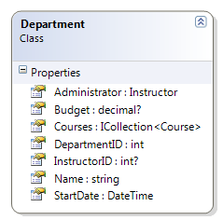

Create Models\Department.cs, replacing the existing code with the following code:

using System;

using System.Collections.Generic;

using System.ComponentModel.DataAnnotations;

namespace ContosoUniversity.Models

{

public class Department

{

public int DepartmentID { get; set; }

[Required(ErrorMessage = "Department name is required.")]

[MaxLength(50)]

public string Name { get; set; }

[DisplayFormat(DataFormatString="{0:c}")]

[Required(ErrorMessage = "Budget is required.")]

[Column(TypeName="money")]

public decimal? Budget { get; set; }

[DisplayFormat(DataFormatString="{0:d}", ApplyFormatInEditMode=true)]

[Required(ErrorMessage = "Start date is required.")]

public DateTime StartDate { get; set; }

[Display(Name="Administrator")]

public int? InstructorID { get; set; }

public virtual Instructor Administrator { get; set; }

public virtual ICollection<Course> Courses { get; set; }

}

}

## The Column Attribute

Earlier you used the Column attribute to change column name mapping. In the code for the Department entity, the Column attribute is being used to change SQL data type mapping so that the column will be defined using the SQL Server money type in the database:

[Column(TypeName="money")]

public decimal? Budget { get; set; }

This is normally not required, because the Entity Framework chooses the appropriate SQL Server data type based on the CLR type that you define for the property. The CLR decimal type would normally map to a SQL Server decimal type. But in this case you know that the column will be holding currency amounts, and the money data type is more appropriate for that.

## Foreign Key and Navigation Properties

The foreign key and navigation properties reflect the following relationships:

* A department may or may not have an administrator, and an administrator is always an instructor. Therefore the InstructorID property is included as the foreign key to the Instructor entity, and a question mark is added after the int type designation to mark the property as nullable. The navigation property is named Administrator but holds an Instructor entity:
* public int? InstructorID { get; set; }

public virtual Instructor Administrator { get; set; }

* A department may have many courses, so there's a Courses navigation property:

public virtual ICollection<Course> Courses { get; set; }

**Note** By convention, the Entity Framework enables cascade delete for non-nullable foreign keys and for many-to-many relationships. This can result in circular cascade delete rules, which will cause an exception when your initializer code runs. For example, if you didn't define the Department.InstructorID property as nullable, you'd get the following exception message when the initializer runs: "The referential relationship will result in a cyclical reference that's not allowed."

## Modifying the Student Entity

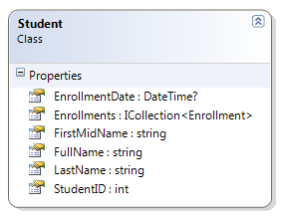

In Models\Student.cs, replace the code you added earlier with the following code:

using System;

using System.Collections.Generic;

using System.ComponentModel.DataAnnotations;

namespace ContosoUniversity.Models

{

public class Student

{

public int StudentID { get; set; }

[Required(ErrorMessage = "Last name is required.")]

[Display(Name="Last Name")]

[MaxLength(50)]

public string LastName { get; set; }

[Required(ErrorMessage = "First name is required.")]

[Column("FirstName")]

[Display(Name = "First Name")]

[MaxLength(50)]

public string FirstMidName { get; set; }

[Required(ErrorMessage = "Enrollment date is required.")]

[DisplayFormat(DataFormatString = "{0:d}", ApplyFormatInEditMode = true)]

[Display(Name = "Enrollment Date")]

public DateTime? EnrollmentDate { get; set; }

public string FullName

{

get

{

return LastName + ", " + FirstMidName;

}

}

public virtual ICollection<Enrollment> Enrollments { get; set; }

}

}

This code just adds attributes that you've now already seen in the other classes.

## Modifying the Enrollment Entity

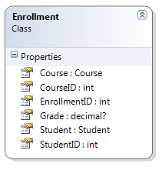

In Models\Enrollment.cs, replace the code you added earlier with the following code:

using System;

using System.Collections.Generic;

using System.ComponentModel.DataAnnotations;

namespace ContosoUniversity.Models

{

public class Enrollment

{

public int EnrollmentID { get; set; }

public int CourseID { get; set; }

public int StudentID { get; set; }

[DisplayFormat(DataFormatString="{0:#.#}",ApplyFormatInEditMode=true,NullDisplayText="No grade")]

public decimal? Grade { get; set; }

public virtual Course Course { get; set; }

public virtual Student Student { get; set; }

}

}

## Foreign Key and Navigation Properties

The foreign key properties and navigation properties reflect the following relationships:

* An enrollment record is for a single course, so there's a CourseID foreign key property and a Course navigation property:
* public int CourseID { get; set; }

public virtual Course Course { get; set; }

* An enrollment record is for a single student, so there's a StudentID foreign key property and a Student navigation property:
* public int StudentID { get; set; }

public virtual Student Student { get; set; }

## Many-to-Many Relationships

There's a many-to-many relationship between the Student and Course entities, and the Enrollment entity corresponds to a many-to-many join table with payload in the database. This means that the Enrollment table contains additional data besides foreign keys for the joined tables (in this case, a primary key and a Grade property).

The following illustration shows what these relationships look like in an entity diagram. (This diagram was generated using the Entity Framework designer; creating the diagram isn't part of the tutorial, it's just being used here as an illustration.)

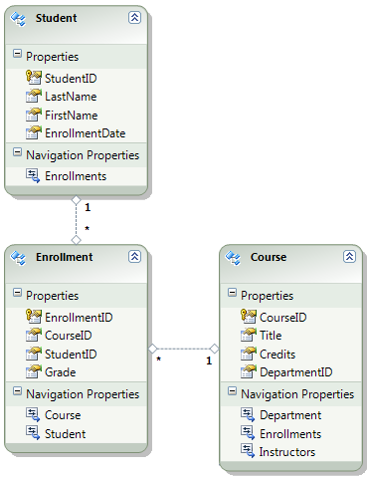

Each relationship line has a 1 at one end and an asterisk (*) at the other, indicating a one-to-many relationship.

If the Enrollment table didn't include grade information, it would only need to contain the two foreign keys CourseID and StudentID. In that case, it would correspond to a many-to-many join table without payload (or a pure join table) in the database, and you wouldn't have to create a model class for it at all. The Instructor and Course entities have that kind of many-to-many relationship, and as you can see, there is no entity class between them:

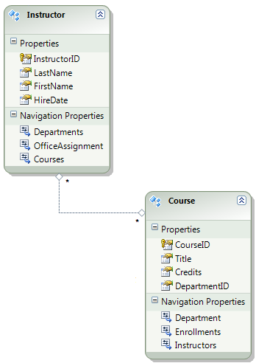

A join table is required in the database, however, as shown in the following database diagram:

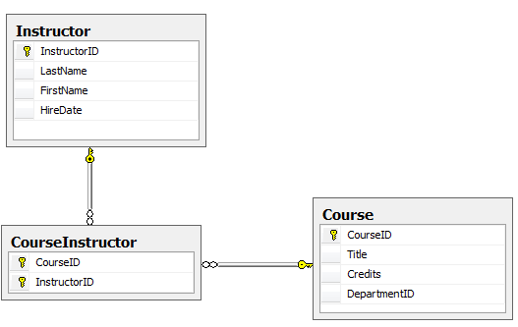

The Entity Framework automatically creates the CourseInstructor table, and you read and update it indirectly by reading and updating the Instructor.Courses and Course.Instructors navigation properties.

## The DisplayFormat Attribute

The DisplayFormat attribute on the Grade property specifies how the data will be formatted:

[DisplayFormat(DataFormatString="{0:#.#}",ApplyFormatInEditMode=true,NullDisplayText="No grade")]

public decimal? Grade { get; set; }

* The grade displays as two digits separated by a period — for example, "3.5" or "4.0".
* The grade is also displayed this way in edit mode (in a text box).
* If there's no grade (the question mark after decimal indicates that the property is nullable), the text "No grade" is displayed.

## Entity Diagram Showing Relationships

The following illustration shows the diagram that the Entity Framework Database First designer creates for the School model.

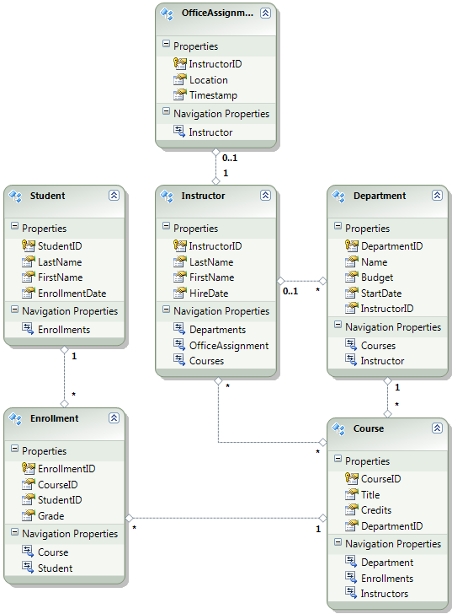

Besides the many-to-many relationship lines (* to *) and the one-to-many relationship lines (1 to *), you can see here the one-to-zero-or-one relationship line (1 to 0..1) between the Instructor and OfficeAssignment entities and the zero-or-one-to-many relationship line (0..1 to *) between the Instructor and Department entities.

## Customizing the Database Context

Next you'll add the new entities to the SchoolContext class and customize some of the mapping using fluent API calls. (The API is "fluent" because it's often used by stringing a series of method calls together into a single statement.) In some cases you need to use methods rather than attributes because there's no attribute for a particular function. In other cases you can choose to use a method when both methods and attributes are available. (Some people prefer not to use attributes.)

Replace the code in DAL\SchoolContext.cs with the following code:

using System;

using System.Collections.Generic;

using System.Data.Entity;

using ContosoUniversity.Models;

using System.Data.Entity.ModelConfiguration.Conventions;

namespace ContosoUniversity.Models

{

public class SchoolContext : DbContext

{

public DbSet<Course> Courses { get; set; }

public DbSet<Department> Departments { get; set; }

public DbSet<Enrollment> Enrollments { get; set; }

public DbSet<Instructor> Instructors { get; set; }

public DbSet<Student> Students { get; set; }

public DbSet<OfficeAssignment> OfficeAssignments { get; set; }

protected override void OnModelCreating(DbModelBuilder modelBuilder)

{

modelBuilder.Conventions.Remove<PluralizingTableNameConvention>();

modelBuilder.Entity<Instructor>()

.HasOptional(p => p.OfficeAssignment).WithRequired(p => p.Instructor);

modelBuilder.Entity<Course>()

.HasMany(c => c.Instructors).WithMany(i => i.Courses)

.Map(t => t.MapLeftKey("CourseID")

.MapRightKey("InstructorID")

.ToTable("CourseInstructor"));

modelBuilder.Entity<Department>()

.HasOptional(x => x.Administrator);

}

}

}

The new statements in the OnModelCreating method specify the following relationships:

* A one-to-zero-or-one relationship between the Instructor and OfficeAssignment entities:
* modelBuilder.Entity<Instructor>()

.HasOptional(p => p.OfficeAssignment).WithRequired(p => p.Instructor);

* A many-to-many relationship between the Instructor and Course entities. The code specifies the table and column names for the join table. Code First can configure the many-to-many relationship for you without this code, but if you don't call it, you will get default names such as InstructorInstructorID for the InstructorID column.
* modelBuilder.Entity<Course>()
* .HasMany(c => c.Instructors).WithMany(i => i.Courses)
* .Map(t => t.MapLeftKey("CourseID")
* .MapRightKey("InstructorID")

.ToTable("CourseInstructor"));

* A zero-or-one-to-many relationship between the Instructor and Department tables. In other words, a department may or may not have an instructor assigned to it as administrator; the assigned administrator is represented by the Department.Administrator navigation property:
* modelBuilder.Entity<Department>()

.HasOptional(x => x.Administrator);

For more details about what these "fluent API" statements are doing behind the scenes, see the [Fluent API](http://blogs.msdn.com/b/aspnetue/archive/2011/05/04/entity-framework-code-first-tutorial-supplement-what-is-going-on-in-a-fluent-api-call.aspx) blog post on the ASP.NET User Education Team's blog.

## Initializing the Database with Test Data

Earlier you created DAL\SchoolInitializer.cs to initialize your database with test data. Now replace the code in that file with the following code in order to provide test data for the new entities you've created.

using System;

using System.Collections.Generic;

using System.Linq;

using System.Web;

using System.Data.Entity;

using ContosoUniversity.Models;

namespace ContosoUniversity.DAL

{

public class SchoolInitializer : DropCreateDatabaseIfModelChanges<SchoolContext>

{

protected override void Seed(SchoolContext context)

{

var students = new List<Student>

{

new Student { FirstMidName = "Carson", LastName = "Alexander", EnrollmentDate = DateTime.Parse("2005-09-01") },

new Student { FirstMidName = "Meredith", LastName = "Alonso", EnrollmentDate = DateTime.Parse("2002-09-01") },

new Student { FirstMidName = "Arturo", LastName = "Anand", EnrollmentDate = DateTime.Parse("2003-09-01") },

new Student { FirstMidName = "Gytis", LastName = "Barzdukas", EnrollmentDate = DateTime.Parse("2002-09-01") },

new Student { FirstMidName = "Yan", LastName = "Li", EnrollmentDate = DateTime.Parse("2002-09-01") },

new Student { FirstMidName = "Peggy", LastName = "Justice", EnrollmentDate = DateTime.Parse("2001-09-01") },

new Student { FirstMidName = "Laura", LastName = "Norman", EnrollmentDate = DateTime.Parse("2003-09-01") },

new Student { FirstMidName = "Nino", LastName = "Olivetto", EnrollmentDate = DateTime.Parse("2005-09-01") }

};

students.ForEach(s => context.Students.Add(s));

context.SaveChanges();

var instructors = new List<Instructor>

{

new Instructor { FirstMidName = "Kim", LastName = "Abercrombie", HireDate = DateTime.Parse("1995-03-11") },

new Instructor { FirstMidName = "Fadi", LastName = "Fakhouri", HireDate = DateTime.Parse("2002-07-06") },

new Instructor { FirstMidName = "Roger", LastName = "Harui", HireDate = DateTime.Parse("1998-07-01") },

new Instructor { FirstMidName = "Candace", LastName = "Kapoor", HireDate = DateTime.Parse("2001-01-15") },

new Instructor { FirstMidName = "Roger", LastName = "Zheng", HireDate = DateTime.Parse("2004-02-12") }

};

instructors.ForEach(s => context.Instructors.Add(s));

context.SaveChanges();

var departments = new List<Department>

{

new Department { Name = "English", Budget = 350000, StartDate = DateTime.Parse("2007-09-01"), InstructorID = 1 },

new Department { Name = "Mathematics", Budget = 100000, StartDate = DateTime.Parse("2007-09-01"), InstructorID = 2 },

new Department { Name = "Engineering", Budget = 350000, StartDate = DateTime.Parse("2007-09-01"), InstructorID = 3 },

new Department { Name = "Economics", Budget = 100000, StartDate = DateTime.Parse("2007-09-01"), InstructorID = 4 }

};

departments.ForEach(s => context.Departments.Add(s));

context.SaveChanges();

var courses = new List<Course>

{

new Course { CourseID = 1050, Title = "Chemistry", Credits = 3, DepartmentID = 3, Instructors = new List<Instructor>() },

new Course { CourseID = 4022, Title = "Microeconomics", Credits = 3, DepartmentID = 4, Instructors = new List<Instructor>() },

new Course { CourseID = 4041, Title = "Macroeconomics", Credits = 3, DepartmentID = 4, Instructors = new List<Instructor>() },

new Course { CourseID = 1045, Title = "Calculus", Credits = 4, DepartmentID = 2, Instructors = new List<Instructor>() },

new Course { CourseID = 3141, Title = "Trigonometry", Credits = 4, DepartmentID = 2, Instructors = new List<Instructor>() },

new Course { CourseID = 2021, Title = "Composition", Credits = 3, DepartmentID = 1, Instructors = new List<Instructor>() },

new Course { CourseID = 2042, Title = "Literature", Credits = 4, DepartmentID = 1, Instructors = new List<Instructor>() }

};

courses.ForEach(s => context.Courses.Add(s));

context.SaveChanges();

courses[0].Instructors.Add(instructors[0]);

courses[0].Instructors.Add(instructors[1]);

courses[1].Instructors.Add(instructors[2]);

courses[2].Instructors.Add(instructors[2]);

courses[3].Instructors.Add(instructors[3]);

courses[4].Instructors.Add(instructors[3]);

courses[5].Instructors.Add(instructors[3]);

courses[6].Instructors.Add(instructors[3]);

context.SaveChanges();

var enrollments = new List<Enrollment>

{

new Enrollment { StudentID = 1, CourseID = 1050, Grade = 1 },

new Enrollment { StudentID = 1, CourseID = 4022, Grade = 3 },

new Enrollment { StudentID = 1, CourseID = 4041, Grade = 1 },

new Enrollment { StudentID = 2, CourseID = 1045, Grade = 2 },

new Enrollment { StudentID = 2, CourseID = 3141, Grade = 4 },

new Enrollment { StudentID = 2, CourseID = 2021, Grade = 4 },

new Enrollment { StudentID = 3, CourseID = 1050 },

new Enrollment { StudentID = 4, CourseID = 1050, },

new Enrollment { StudentID = 4, CourseID = 4022, Grade = 4 },

new Enrollment { StudentID = 5, CourseID = 4041, Grade = 3 },

new Enrollment { StudentID = 6, CourseID = 1045 },

new Enrollment { StudentID = 7, CourseID = 3141, Grade = 2 },

};

enrollments.ForEach(s => context.Enrollments.Add(s));

context.SaveChanges();

var officeAssignments = new List<OfficeAssignment>

{

new OfficeAssignment { InstructorID = 1, Location = "Smith 17" },

new OfficeAssignment { InstructorID = 2, Location = "Gowan 27" },

new OfficeAssignment { InstructorID = 3, Location = "Thompson 304" },

};

officeAssignments.ForEach(s => context.OfficeAssignments.Add(s));

context.SaveChanges();

}

}

}

As you saw in the first tutorial, most of this code simply creates new entity objects and loads sample data into properties as required for testing. However, notice how the Course entity, which has a many-to-many relationship with the Instructor entity, is handled:

var courses = new List

{

new Course { CourseID = 1050, Title = "Chemistry", Credits = 3, DepartmentID = 3, Instructors = new List() },

...

};

courses.ForEach(s => context.Courses.Add(s));

context.SaveChanges();

courses[0].Instructors.Add(instructors[0]);

...

context.SaveChanges();

When you create a Course object, you initialize the Instructors navigation property as an empty collection using the code Instructors = new List(). This makes it possible to add Instructor entities that are related to this Course by using the Instructors.Add method. If you didn't create an empty list, you wouldn't be able to add these relationships, because the Instructors property would be null and wouldn't have an Add method.

**Note** Remember that when you deploy an application to a production web server, you must remove any code you've added to seed the database.

## Dropping and Re-Creating the Database

Now run the site and select the Student Index page.



The page looks the same as it did before, but behind the scenes the database has been re-created.

If you don't see the Student Index page and instead you get an error that indicates that the School.sdf file is in use (see the following illustration), you need to reopen **Server Explorer** and close the connection to the database. Then try displaying the Student Index page again.

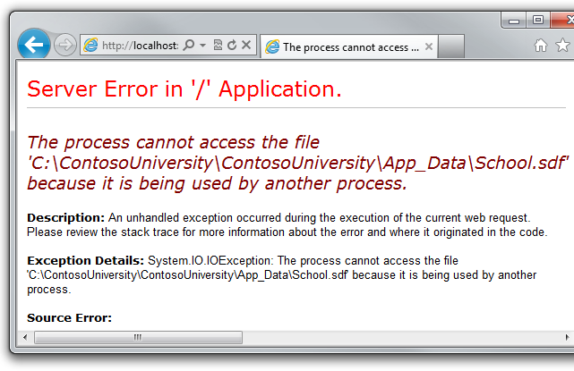

After viewing the Student Index page, open the database in **Server Explorer** as you did earlier, and expand the **Tables** node to see that all of the tables have been created.

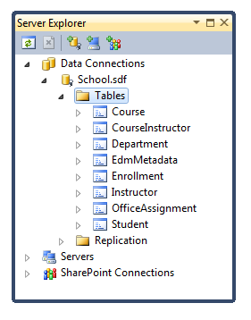

Besides EdmMetadata, you see one table you didn't create a model class for: CourseInstructor. As explained earlier, this is a join table for the many-to-many relationship between the Instructor and Course entities.

Right-click the CourseInstructor table and select **Show Table Data** to verify that it has data in it as a result of the Instructor entities you added to the Course.Instructors navigation property.

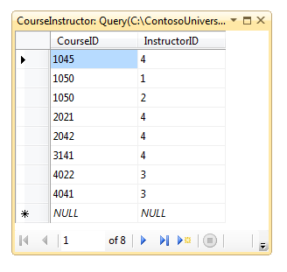

You now have a more complex data model and corresponding database. In the following tutorial you'll learn more about different ways to access related data.

# 5 Reading Related Data with the Entity Framework in an ASP.NET MVC Application

The Contoso University sample web application demonstrates how to create ASP.NET MVC applications using the Entity Framework. The sample application is a website for a fictional Contoso University. It includes functionality such as student admission, course creation, and instructor assignments.

This tutorial series explains the steps taken to build the Contoso University sample application. You can [download the completed application](http://go.microsoft.com/fwlink/?LinkId=215669) or create it by following the steps in the tutorial. The tutorial shows examples in C#. The downloadable sample contains code in both C# and Visual Basic. If you have questions that are not directly related to the tutorial, you can post them to the [ASP.NET Entity Framework forum](http://forums.asp.net/1227.aspx) or the [Entity Framework and LINQ to Entities forum](http://social.msdn.microsoft.com/forums/en-US/adodotnetentityframework/threads/).

This tutorial series assumes you know how to work with ASP.NET MVC in Visual Studio. If you don’t, a good place to start is a [basic ASP.NET MVC Tutorial](http://www.asp.net/mvc/tutorials/getting-started-with-MVC3-part1-cs). If you prefer to work with the ASP.NET Web Forms model, see the [Getting Started with the Entity Framework](http://www.asp.net/entity-framework/tutorials#Getting Started) and [Continuing with the Entity Framework](http://www.asp.net/entity-framework/tutorials#Continuing) tutorials.

Before you start, make sure you have the following software installed on your computer:

* [Visual Studio 2010 SP1](http://www.microsoft.com/web/gallery/install.aspx?appsxml=&appid=VS2010SP1Pack) or [Visual Web Developer Express 2010 SP1](http://www.microsoft.com/web/gallery/install.aspx?appsxml=&appid=VWD2010SP1Pack) (If you use one of these links, the following items will be installed automatically.)
* [ASP.NET MVC 3 Tools Update](http://www.microsoft.com/web/gallery/install.aspx?appid=MVC3)
* [Microsoft SQL Server Compact 4.0](http://www.microsoft.com/web/gallery/install.aspx?appid=SQLCE)
* [Microsoft Visual Studio 2010 SP1 Tools for SQL Server Compact 4.0](http://www.microsoft.com/web/gallery/install.aspx?appid=SQLCEVSTools)

In the previous tutorial you completed the School data model. In this tutorial you'll read and display related data — that is, data that the Entity Framework loads into navigation properties.

The following illustrations show the pages that you'll work with.

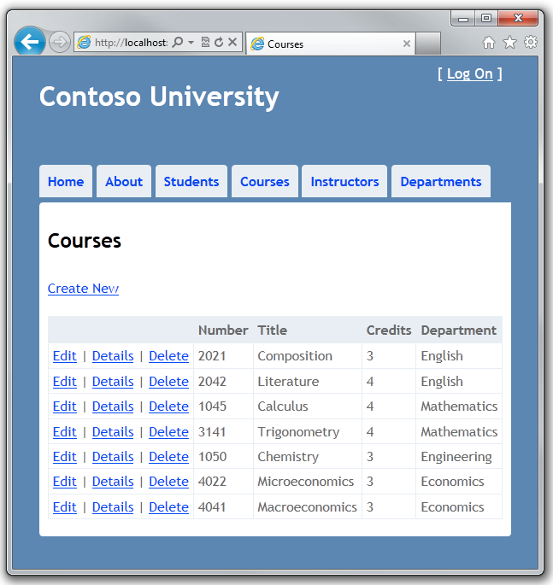

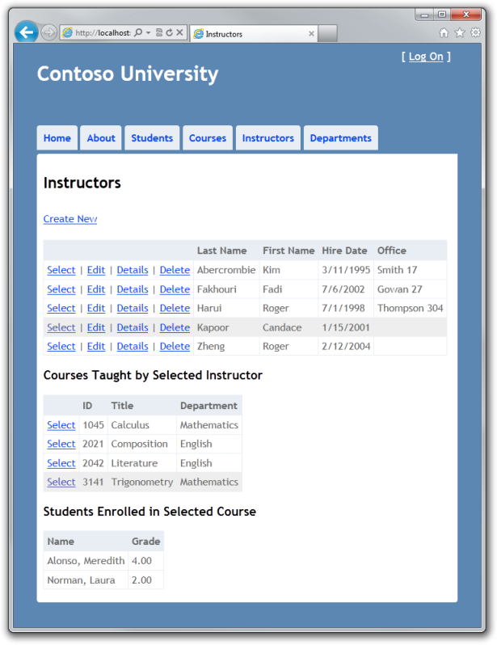

## Lazy, Eager, and Explicit Loading of Related Data

There are several ways that the Entity Framework can load related data into the navigation properties of an entity:

* Lazy loading. When the entity is first read, related data isn't retrieved. However, the first time you attempt to access a navigation property, the data required for that navigation property is automatically retrieved. This results in multiple queries sent to the database — one for the entity itself and one each time that related data for the entity must be retrieved.

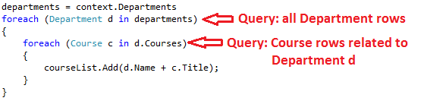

* Eager loading. When the entity is read, related data is retrieved along with it. This typically results in a single join query that retrieves all of the data that's needed. You specify eager loading by using the Include method.

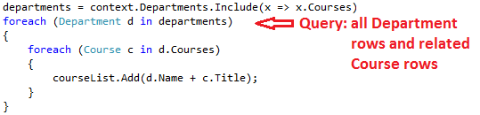

* Explicit loading. This is similar to lazy loading, except that you explicitly retrieve the related data in code; it doesn't happen automatically when you access a navigation property. You load related data manually by getting the object state manager entry for an entity and calling the Collection.Load method for collections or the Reference.Load method for properties that hold a single entity. (In the following example, if you wanted to load the Administrator navigation property, you'd replace Collection(x => x.Courses) with Reference(x => x.Administrator).)

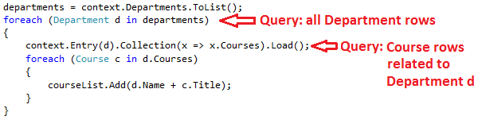

Because they don't immediately retrieve the property values, lazy loading and explicit loading are also both known as deferred loading.

In general, if you know you need related data for every entity retrieved, eager loading offers the best performance, because a single query sent to the database is typically more efficient than separate queries for each entity retrieved. For example, in the above examples, suppose that each department has ten related courses. The eager loading example would result in just a single (join) query. The lazy loading and explicit loading examples would both result in eleven queries.

On the other hand, if you need to access an entity's navigation properties only infrequently or only for a small portion of a set of entities you're processing, lazy loading may be more efficient, because eager loading would retrieve more data than you need. Typically you'd use explicit loading only when you've turned lazy loading off. One scenario when you might turn lazy loading off is during serialization, when you know you don't need all navigation properties loaded. If lazy loading were on, all navigation properties would all be loaded automatically, because serialization accesses all properties.

The database context class performs lazy loading by default. There are two ways to turn off lazy loading:

* For specific navigation properties, omit the virtual keyword when you declare the property.
* For all navigation properties, set LazyLoadingEnabled to false.

Lazy loading can mask code that causes performance problems. For example, code that doesn't specify eager or explicit loading but processes a high volume of entities and uses several navigation properties in each iteration might be very inefficient (because of many round trips to the database), but it would work without errors if it relies on lazy loading. Temporarily disabling lazy loading is one way to discover where the code is relying on lazy loading, because without it the navigation properties will be null and the code will fail.

## Creating a Courses Index Page That Displays Department Name

The Course entity includes a navigation property that contains the Department entity of the department that the course is assigned to. To display the name of the assigned department in a list of courses, you need to get the Name property from the Department entity that is in the Course.Department navigation property.

Create a controller for the Course entity type, using the same options that you did earlier for the Student controller, as shown in the following illustration:

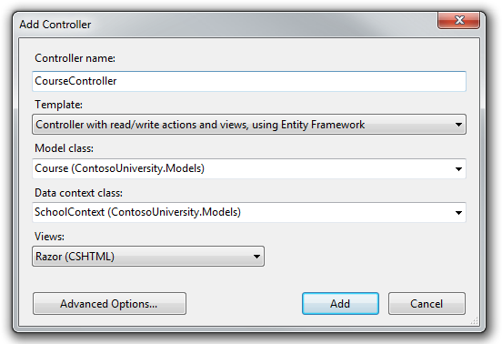

Open Controllers\CourseController.cs and look at the Index method:

public ViewResult Index()

{

var courses = db.Courses.Include(c => c.Department);

return View(courses.ToList());

}

The automatic scaffolding has specified eager loading for the Department navigation property by using the Include method.

Open Views\Course\Index.cshtml and replace the existing code with the following code:

@model IEnumerable<ContosoUniversity.Models.Course>

@{

ViewBag.Title = "Courses";

}

<h2>Courses</h2>

<p>

@Html.ActionLink("Create New", "Create")

</p>

<table>

<tr>

<th></th>

<th>Number</th>

<th>Title</th>

<th>Credits</th>

<th>Department</th>

</tr>

@foreach (var item in Model) {

<tr>

<td>

@Html.ActionLink("Edit", "Edit", new { id=item.CourseID }) |

@Html.ActionLink("Details", "Details", new { id=item.CourseID }) |

@Html.ActionLink("Delete", "Delete", new { id=item.CourseID })

</td>

<td>

@Html.DisplayFor(modelItem => item.CourseID)

</td>

<td>

@Html.DisplayFor(modelItem => item.Title)

</td>

<td>

@Html.DisplayFor(modelItem => item.Credits)

</td>

<td>

@Html.DisplayFor(modelItem => item.Department.Name)

</td>

</tr>

}

</table>

You've made the following changes to the scaffolded code:

* Changed the heading from **Index** to **Courses**.
* Moved the row links to the left.
* Added a column under the heading **Number** that shows the CourseID property value. (Primary keys aren't scaffolded because normally they are meaningless. However, in this case the primary key is meaningful and you want to show it.)
* Changed the last column heading from **DepartmentID** (the name of the foreign key to the Department entity) to **Department**.

Notice that for the last column, the scaffolded code displays the Name property of the Department entity that's loaded into the Department navigation property:

<td>

@Html.DisplayFor(modelItem => item.Department.Name)

</td>

Run the page (select the **Courses** tab on the Contoso University home page) to see the list with department names.



## Creating an Instructors Index Page That Shows Courses and Enrollments

In this section you'll create a controller and view for the Instructor entity in order to display the Instructors Index page:



This page reads and displays related data in the following ways:

* The list of instructors displays related data from the OfficeAssignment entity. The Instructor and OfficeAssignment entities are in a one-to-zero-or-one relationship. You'll use eager loading for the OfficeAssignment entities. As explained earlier, eager loading is typically more efficient when you need the related data for all retrieved rows of the primary table. In this case, you want to display office assignments for all displayed instructors.
* When the user selects an instructor, related Course entities are displayed. The Instructor and Course entities are in a many-to-many relationship. You will use eager loading for the Course entities and their related Department entities. In this case, lazy loading might be more efficient because you need courses only for the selected instructor. However, this example shows how to use eager loading for navigation properties within entities that are themselves in navigation properties.
* When the user selects a course, related data from the Enrollments entity set is displayed. The Course and Enrollment entities are in a one-to-many relationship. You'll add explicit loading for Enrollment entities and their related Student entities. (Explicit loading isn't necessary because lazy loading is enabled, but this shows how to do explicit loading.)

## Creating a View Model for the Instructor Index View

The Instructor Index page shows three different tables. Therefore, you'll create a view model that includes three properties, each holding the data for one of the tables.

In the ViewModels folder, create InstructorIndexData.cs and replace the existing code with the following code:

using System;

using System.Collections.Generic;

using ContosoUniversity.Models;

namespace ContosoUniversity.ViewModels

{

public class InstructorIndexData

{

public IEnumerable<Instructor> Instructors { get; set; }

public IEnumerable<Course> Courses { get; set; }

public IEnumerable<Enrollment> Enrollments { get; set; }

}

}

## Adding a Style for Selected Rows

To mark selected rows you need a different background color. To provide a style for this UI, add the following code to the section marked MISC in Content\Site.css, as shown in the following example:

/* MISC

----------------------------------------------------------*/

.selectedrow

{

background-color: #EEEEEE;

}

## Creating the Instructor Controller and Views

Create a controller for the Instructor entity type, using the same options that you did earlier for the Student controller, as shown in the following illustration:

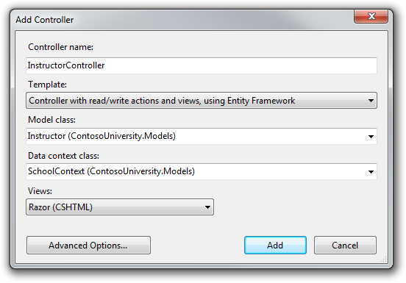

Open Controllers\InstructorController.cs and add a using statement for the ViewModels namespace:

using ContosoUniversity.ViewModels;

The scaffolded code in the Index method specifies eager loading only for the OfficeAssignment navigation property:

public ViewResult Index()

{

var instructors = db.Instructors.Include(i => i.OfficeAssignment);

return View(instructors.ToList());

}

Replace the Index method with the following code to load additional related data and put it in the view model:

public ActionResult Index(Int32? id, Int32? courseID)

{

var viewModel = new InstructorIndexData();

viewModel.Instructors = db.Instructors

.Include(i => i.OfficeAssignment)

.Include(i => i.Courses.Select(c => c.Department))

.OrderBy(i => i.LastName);

if (id != null)

{

ViewBag.InstructorID = id.Value;

viewModel.Courses = viewModel.Instructors.Where(i => i.InstructorID == id.Value).Single().Courses;

}

if (courseID != null)

{

ViewBag.CourseID = courseID.Value;

viewModel.Enrollments = viewModel.Courses.Where(x => x.CourseID == courseID).Single().Enrollments;

}

return View(viewModel);

}

The method accepts optional query string parameters that provide the ID values of the selected instructor and selected course, and passes all of the required data to the view. The query string parameters are provided by the **Select** hyperlinks on the page.

The code begins by creating an instance of the view model and putting in it the list of instructors:

var viewModel = new InstructorIndexData();

viewModel.Instructors = db.Instructors

.Include(i => i.OfficeAssignment);

.Include(i => i.Courses.Select(c => c.Department))

.OrderBy(i => i.LastName);

This statement specifies eager loading for the Instructor.OfficeAssignment and the Instructor.Courses navigation property. For the related Course entities, eager loading is specified for the Course.Department navigation property by using the Select method within the Include method. The results are sorted by last name.

If an instructor was selected, the selected instructor is retrieved from the list of instructors in the view model. The view model's Courses property is then loaded with the Course entities from that instructor's Courses navigation property.

if (id != null)

{

ViewBag.InstructorID = id.Value;

viewModel.Courses = viewModel.Instructors.Where(i => i.InstructorID == id.Value).Single().Courses;

}

The Where method returns a collection, but in this case the criteria passed to that method result in only a single Instructor entity being returned. The Single method converts the collection into a single Instructor entity, which gives you access to that entity's Courses property.

You use the Single method on a collection when you know the collection will have only one item. The Single method throws an exception if the collection passed to it is empty or if there's more than one item. An alternative is SingleOrDefault, which returns null if the collection is empty. However, in this case that would still result in an exception (from trying to find a Courses property on a null reference), and the exception message would less clearly indicate the cause of the problem. When you call the Single method, you can also pass in the Where condition instead of calling the Where method separately:

.Single(i => i.InstructorID == id.Value)

Instead of:

.Where(I => i.InstructorID == id.Value).Single()

Next, if a course was selected, the selected course is retrieved from the list of courses in the view model. Then the view model's Enrollments property is loaded with the Enrollment entities from that course's Enrollments navigation property.

if (courseID != null)

{

ViewBag.CourseID = courseID.Value;

viewModel.Enrollments = viewModel.Courses.Where(x => x.CourseID == courseID).Single().Enrollments;

}

Finally, the view model is returned to the view:

return View(viewModel);

## Modifying the Instructor Index View

In Views\Instructor\Index.cshtml, replace the existing code with the following code:

@model ContosoUniversity.ViewModels.InstructorIndexData

@{

ViewBag.Title = "Instructors";

}

<h2>Instructors</h2>

<p>

@Html.ActionLink("Create New", "Create")

</p>

<table>

<tr>

<th></th>

<th>Last Name</th>

<th>First Name</th>

<th>Hire Date</th>

<th>Office</th>

</tr>

@foreach (var item in Model.Instructors)

{

string selectedRow = "";

if (item.InstructorID == ViewBag.InstructorID)

{

selectedRow = "selectedrow";

}

<tr class="@selectedRow" valign="top">

<td>

@Html.ActionLink("Select", "Index", new { id = item.InstructorID }) |

@Html.ActionLink("Edit", "Edit", new { id = item.InstructorID }) |

@Html.ActionLink("Details", "Details", new { id = item.InstructorID }) |

@Html.ActionLink("Delete", "Delete", new { id = item.InstructorID })

</td>

<td>

@item.LastName

</td>

<td>

@item.FirstMidName

</td>

<td>

@String.Format("{0:d}", item.HireDate)

</td>

<td>

@if (item.OfficeAssignment != null)

{

@item.OfficeAssignment.Location

}

</td>

</tr>

}

</table>

You've made the following changes to the existing code:

* Changed the page title from **Index** to **Instructors**.
* Moved the row link columns to the left.
* Removed the **FullName** column.
* Added an **Office** column that displays item.OfficeAssignment.Location only if item.OfficeAssignment is not null. (Because this is a one-to-zero-or-one relationship, there might not be a related OfficeAssignment entity.)
* <td>
* @if (item.OfficeAssignment != null)
* {
* @item.OfficeAssignment.Location
* }

</td>

* Added code that will dynamically add class="selectedrow" to the tr element of the selected instructor. This sets a background color for the selected row using the CSS class that you created earlier. (The valign attribute will be useful in the following tutorial when you add a multirow column to the table.)
* string selectedRow = "";
* if (item.InstructorID == ViewBag.InstructorID)
* {
* selectedRow = "selectedrow";
* }

<tr class="@selectedRow" valign="top">

* Added a new ActionLink labeled **Select** immediately before the other links in each row, which causes the selected instructor ID to be sent to the Index method.

Run the page to see the list of instructors. The page displays the Location property of related OfficeAssignment entities and an empty table cell when there's no related OfficeAssignment entity.

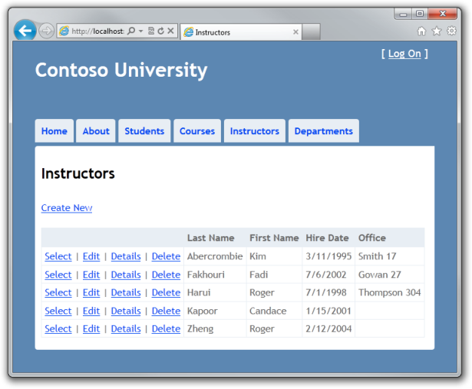

While you still have Views\Instructor\Index.cshtml open, after the table element, add the following code. This displays a list of courses related to an instructor when an instructor is selected.

@if (Model.Courses != null)

{

<h3>Courses Taught by Selected Instructor</h3>

<table>

<tr>

<th></th>

<th>ID</th>

<th>Title</th>

<th>Department</th>

</tr>

@foreach (var item in Model.Courses)

{

string selectedRow = "";

if (item.CourseID == ViewBag.CourseID)

{

selectedRow = "selectedrow";

}

<tr class="@selectedRow">

<td>

@Html.ActionLink("Select", "Index", new { courseID = item.CourseID })

</td>

<td>

@item.CourseID

</td>

<td>

@item.Title

</td>

<td>

@item.Department.Name

</td>

</tr>

}

</table>

}

This code reads the Courses property of the view model to display a list of courses. It also provides a Select hyperlink that sends the ID of the selected course to the Index action method.

Run the page and select an instructor. Now you see a grid that displays courses assigned to the selected instructor, and for each course you see the name of the assigned department.

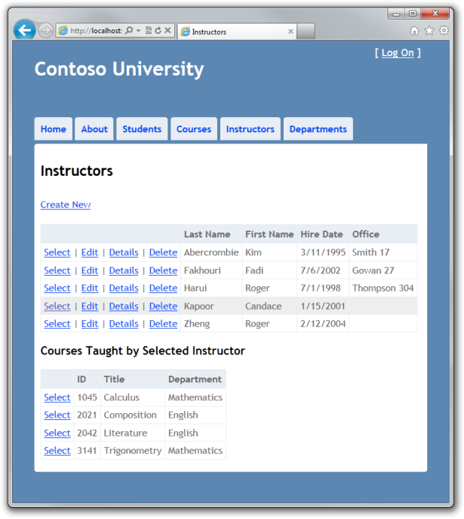

**Note** If the selected row isn't highlighted, click the **Refresh** button on your browser (or press F5) ; this is sometimes required in order to reload the .css file. If that doesn't work, you might have to do a hard refresh (hold down the CTRL key while clicking the **Refresh** button, or press CTRL-F5).

After the code block you just added, add the following code. This displays a list of the students who are enrolled in a course when that course is selected.

@if (Model.Enrollments != null)

{

<h3>

Students Enrolled in Selected Course</h3>

<table>

<tr>

<th>Name</th>

<th>Grade</th>

</tr>

@foreach (var item in Model.Enrollments)

{

<tr>

<td>

@item.Student.FullName

</td>

<td>

@Html.DisplayFor(modelItem => item.Grade)

</td>

</tr>

}

</table>

}

This code reads the Enrollments property of the view model in order to display a list of students enrolled in the course. The DisplayFor helper is used so that null grades will display as "No grade", as specified in the DisplayFormat data annotation attribute for that field.

Run the page and select an instructor. Then select a course to see the list of enrolled students and their grades.



## Adding Explicit Loading

Open InstructorController.cs and look at how the Index method gets the list of enrollments for a selected course:

if (courseID != null)

{

ViewBag.CourseID = courseID.Value;

viewModel.Enrollments = viewModel.Courses.Where(x => x.CourseID == courseID).Single().Enrollments;

}

When you retrieved the list of instructors, you specified eager loading for the Courses navigation property and for the Department property of each course. Then you put the Courses collection in the view model, and now you're accessing the Enrollments navigation property from one entity in that collection. Because you didn't specify eager loading for the Course.Enrollments navigation property, the data from that property is appearing in the page as a result of lazy loading.

If you disabled lazy loading without changing the code in any other way, the Enrollments property would be null regardless of how many enrollments the course actually had. In that case, to load the Enrollments property, you'd have to specify either eager loading or explicit loading. You've already seen how to do eager loading. In order to see an example of explicit loading, replace the Index method with the following code, which explicitly loads the Enrollments property:

public ActionResult Index(Int32? id, Int32? courseID)

{

var viewModel = new InstructorIndexData();

viewModel.Instructors = db.Instructors

.Include(i => i.OfficeAssignment)

.Include(i => i.Courses.Select(c => c.Department))

.OrderBy(i => i.LastName);

if (id != null)

{

ViewBag.InstructorID = id.Value;

viewModel.Courses = viewModel.Instructors.Where(i => i.InstructorID == id.Value).Single().Courses;

}

if (courseID != null)

{

ViewBag.CourseID = courseID.Value;

var selectedCourse = viewModel.Courses.Where(x => x.CourseID == courseID).Single();

db.Entry(selectedCourse).Collection(x => x.Enrollments).Load();

foreach (Enrollment enrollment in selectedCourse.Enrollments)

{

db.Entry(enrollment).Reference(x => x.Student).Load();

}

viewModel.Enrollments = selectedCourse.Enrollments;

}

return View(viewModel);

}

After getting the selected Course entity, the new code explicitly loads that course's Enrollments navigation property:

db.Entry(selectedCourse).Collection(x => x.Enrollments).Load();

Then it explicitly loads each Enrollment entity's related Student entity:

db.Entry(enrollment).Reference(x => x.Student).Load();

Notice that you use the Collection method to load a collection property, but for a property that holds just one entity, you use the Reference method. You can run the Instructor Index page now and you'll see no difference in what's displayed on the page, although you've changed how the data is retrieved.

You've now used all three ways (lazy, eager, and explicit) to load related data into navigation properties. In the next tutorial you'll learn how to update related data.

# 6 Updating Related Data with the Entity Framework in an ASP.NET MVC Application

The Contoso University sample web application demonstrates how to create ASP.NET MVC applications using the Entity Framework. The sample application is a website for a fictional Contoso University. It includes functionality such as student admission, course creation, and instructor assignments.

This tutorial series explains the steps taken to build the Contoso University sample application. You can [download the completed application](http://go.microsoft.com/fwlink/?LinkId=215669) or create it by following the steps in the tutorial. The tutorial shows examples in C#. The downloadable sample contains code in both C# and Visual Basic. If you have questions that are not directly related to the tutorial, you can post them to the [ASP.NET Entity Framework forum](http://forums.asp.net/1227.aspx) or the [Entity Framework and LINQ to Entities forum](http://social.msdn.microsoft.com/forums/en-US/adodotnetentityframework/threads/).

This tutorial series assumes you know how to work with ASP.NET MVC in Visual Studio. If you don’t, a good place to start is a [basic ASP.NET MVC Tutorial](http://www.asp.net/mvc/tutorials/getting-started-with-MVC3-part1-cs). If you prefer to work with the ASP.NET Web Forms model, see the [Getting Started with the Entity Framework](http://www.asp.net/entity-framework/tutorials#Getting Started) and [Continuing with the Entity Framework](http://www.asp.net/entity-framework/tutorials#Continuing) tutorials.

Before you start, make sure you have the following software installed on your computer:

* [Visual Studio 2010 SP1](http://www.microsoft.com/web/gallery/install.aspx?appsxml=&appid=VS2010SP1Pack) or [Visual Web Developer Express 2010 SP1](http://www.microsoft.com/web/gallery/install.aspx?appsxml=&appid=VWD2010SP1Pack) (If you use one of these links, the following items will be installed automatically.)
* [ASP.NET MVC 3 Tools Update](http://www.microsoft.com/web/gallery/install.aspx?appid=MVC3)
* [Microsoft SQL Server Compact 4.0](http://www.microsoft.com/web/gallery/install.aspx?appid=SQLCE)
* [Microsoft Visual Studio 2010 SP1 Tools for SQL Server Compact 4.0](http://www.microsoft.com/web/gallery/install.aspx?appid=SQLCEVSTools)

In the previous tutorial you displayed related data; in this tutorial you'll update related data. For most relationships, this can be done by updating the appropriate foreign key fields. For many-to-many relationships, the Entity Framework doesn't expose the join table directly, so you must explicitly add and remove entities to and from the appropriate navigation properties.

The following illustrations show the pages that you'll work with.

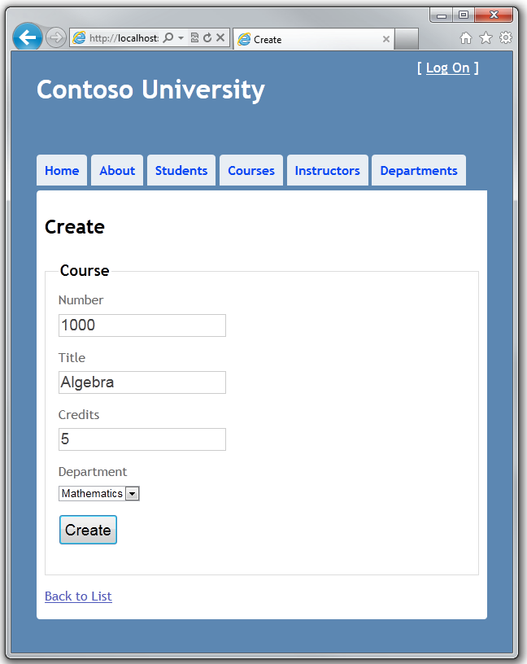

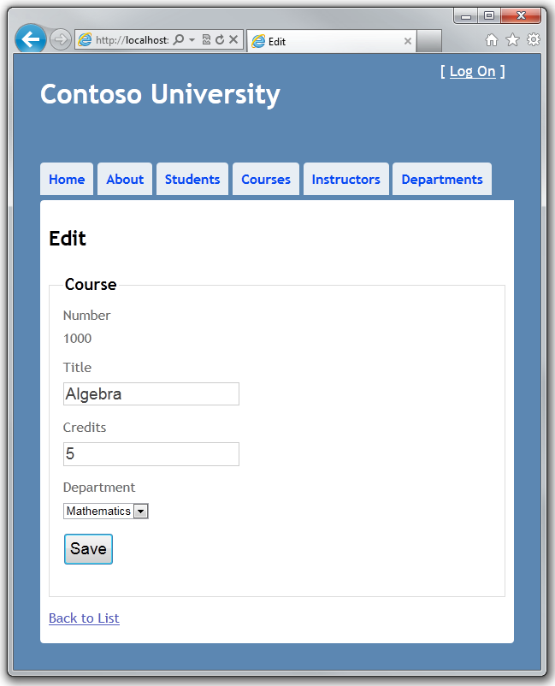

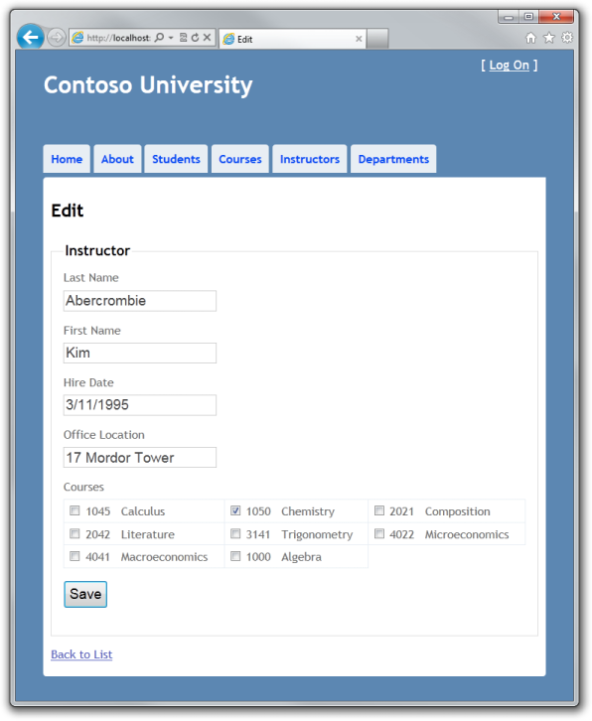

## Customizing the Create and Edit Pages for Courses

When a new course entity is created, it must have a relationship to an existing department. To facilitate this, the scaffolded code includes controller methods and Create and Edit views that include a drop-down list for selecting the department. The drop-down list sets the Course.DepartmentID foreign key property, and that is all the Entity Framework needs in order to load the Department navigation property with the appropriate Department entity. You'll use the scaffolded code, but change it slightly to add error handling and sort the drop-down list.

In CourseController.cs, delete the four Edit and Create methods and replace them with the following code:

public ActionResult Create()

{

PopulateDepartmentsDropDownList();

return View();

}

[HttpPost]

public ActionResult Create(Course course)

{

try

{

if (ModelState.IsValid)

{

db.Courses.Add(course);

db.SaveChanges();

return RedirectToAction("Index");

}

}

catch (DataException)

{

//Log the error (add a variable name after DataException)

ModelState.AddModelError("", "Unable to save changes. Try again, and if the problem persists, see your system administrator.");

}

PopulateDepartmentsDropDownList(course.DepartmentID);

return View(course);

}

public ActionResult Edit(int id)

{

Course course = db.Courses.Find(id);

PopulateDepartmentsDropDownList(course.DepartmentID);

return View(course);

}

[HttpPost]

public ActionResult Edit(Course course)

{

try

{

if (ModelState.IsValid)

{

db.Entry(course).State = EntityState.Modified;

db.SaveChanges();

return RedirectToAction("Index");

}

}

catch (DataException)

{

//Log the error (add a variable name after DataException)

ModelState.AddModelError("", "Unable to save changes. Try again, and if the problem persists, see your system administrator.");

}

PopulateDepartmentsDropDownList(course.DepartmentID);

return View(course);

}

private void PopulateDepartmentsDropDownList(object selectedDepartment = null)

{

var departmentsQuery = from d in db.Departments

orderby d.Name

select d;

ViewBag.DepartmentID = new SelectList(departmentsQuery, "DepartmentID", "Name", selectedDepartment);

}

The PopulateDepartmentsDropDownList method gets a list of all departments sorted by name, creates a SelectList collection for a drop-down list, and passes the collection to the view in a ViewBag property. The method accepts a parameter that allows the caller to optionally specify the item that will be selected initially when the drop-down list is rendered.

The HttpGet Create method calls the PopulateDepartmentsDropDownList method without setting the selected item, because for a new course the department is not established yet:

public ActionResult Create()

{

PopulateDepartmentsDropDownList();

return View();

}

The HttpGet Edit method sets the selected item, based on the ID of the department that is already assigned to the course being edited:

public ActionResult Edit(int id)

{

Course course = db.Courses.Find(id);

PopulateDepartmentsDropDownList(course.DepartmentID);

return View(course);

}

The HttpPost methods for both Create and Edit also include code that sets the selected item when they redisplay the page after an error:

catch (DataException)

{

//Log the error (add a variable name after DataException)

ModelState.AddModelError("", "Unable to save changes. Try again, and if the problem persists, see your system administrator.");

}

PopulateDepartmentsDropDownList(course.DepartmentID);

return View(course);

This code ensures that when the page is redisplayed to show the error message, whatever department was selected stays selected.

In Views\Course\Create.cshtml, add a new field before the **Title** field to allow the user to enter the course number. As explained in an earlier tutorial, primary key fields aren't scaffolded, but this primary key is meaningful, so you want the user to be able to enter the key value.

<div class="editor-label">

@Html.LabelFor(model => model.CourseID)

</div>

<div class="editor-field">

@Html.EditorFor(model => model.CourseID)

@Html.ValidationMessageFor(model => model.CourseID)

</div>

In Views\Course\Edit.cshtml, Views\Course\Delete.cshtml, and Views\Course\Details.cshtml, add a new field before the **Title** field to display the course number. Because it's the primary key, it's displayed, but it can't be changed.

<div class="editor-label">

@Html.LabelFor(model => model.CourseID)

</div>

<div class="editor-field">

@Html.DisplayFor(model => model.CourseID)

</div>

Run the **Create** page (display the Course Index page and click **Create New**) and enter data for a new course:



Click **Create**. The Course Index page is displayed with the new course added to the list. The department name in the Index page list comes from the navigation property, showing that the relationship was established correctly.

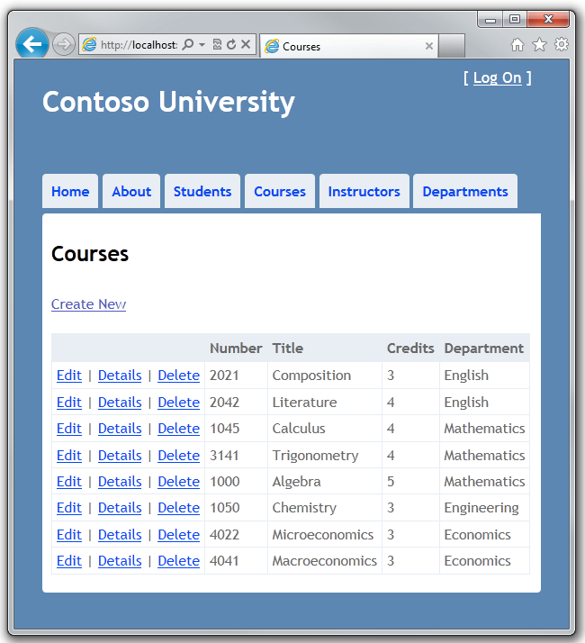

Run the **Edit** page (display the Course Index page and click **Edit** on a course).



Change data on the page and click **Save**. The Course Index page is displayed with the updated course data.

## Adding an Edit Page for Instructors

When you edit an instructor record, you want to be able to update the instructor's office assignment. The Instructor entity has a one-to-zero-or-one relationship with the OfficeAssignment entity, which means you must handle the following situations:

* If the user clears the office assignment and it originally had a value, you must remove and delete the OfficeAssignment entity.
* If the user enters an office assignment value and it originally was empty, you must create a new OfficeAssignment entity.
* If the user changes the value of an office assignment, you must change the value in an existing OfficeAssignment entity.

Open InstructorController.cs and look at the HttpGet Edit method:

public ActionResult Edit(int id)

{

Instructor instructor = db.Instructors.Find(id);

ViewBag.InstructorID = new SelectList(db.OfficeAssignments, "InstructorID", "Location", instructor.InstructorID);

return View(instructor);

}

The scaffolded code here isn't what you want. It's setting up data for a drop-down list, but you what you need is a text box. Replace this method with the following code:

public ActionResult Edit(int id)

{

Instructor instructor = db.Instructors

.Include(i => i.OfficeAssignment)

.Include(i => i.Courses)

.Where(i => i.InstructorID == id)

.Single();

return View(instructor);

}

This code drops the ViewBag statement and adds eager loading for associated OfficeAssignment and Course entities. (You don't need Courses now, but you'll need it later.) You can't perform eager loading with the Find method, so the Where and Single methods are used instead to select the instructor.

Replace the HttpPost Edit method with the following code. which handles office assignment updates:

[HttpPost]

public ActionResult Edit(int id, FormCollection formCollection)

{

var instructorToUpdate = db.Instructors

.Include(i => i.OfficeAssignment)

.Include(i => i.Courses)

.Where(i => i.InstructorID == id)

.Single();

if (TryUpdateModel(instructorToUpdate, "", null, new string[] { "Courses" }))

{

try

{

if (String.IsNullOrWhiteSpace(instructorToUpdate.OfficeAssignment.Location))

{

instructorToUpdate.OfficeAssignment = null;

}

db.Entry(instructorToUpdate).State = EntityState.Modified;

db.SaveChanges();

return RedirectToAction("Index");

}

catch (DataException)

{

//Log the error (add a variable name after DataException)

ModelState.AddModelError("", "Unable to save changes. Try again, and if the problem persists, see your system administrator.");

return View();

}

}

return View(instructorToUpdate);

}

The code does the following:

* Gets the current Instructor entity from the database using eager loading for the OfficeAssignment and Courses navigation properties. This is the same as what you did in the HttpGet Edit method.
* Updates the retrieved Instructor entity with values from the model binder, excluding the Courses navigation property:

If (TryUpdateModel(instructorToUpdate, "", null, new string[] { "Courses" }))

(The second and third parameters specify no prefix on the property names and no list of properties to include.) If validation fails, TryUpdateModel returns false, and the code falls through to the return View statement at the end of the method.

* If the office location is blank, sets the Instructor.OfficeAssignment property to null so that the related row in the OfficeAssignment table will be deleted.
* if (String.IsNullOrWhiteSpace(instructorToUpdate.OfficeAssignment.Location))
* {
* instructorToUpdate.OfficeAssignment = null;

}

* Saves the changes to the database.

In Views\Instructor\Edit.cshtml, after the div elements for the **Hire Date** field, add a new field for editing the office location:

<div class="editor-label">

@Html.LabelFor(model => model.OfficeAssignment.Location)

</div>

<div class="editor-field">

@Html.EditorFor(model => model.OfficeAssignment.Location)

@Html.ValidationMessageFor(model => model.OfficeAssignment.Location)

</div>

Run the page (select the **Instructors** tab and then click **Edit** on an instructor).

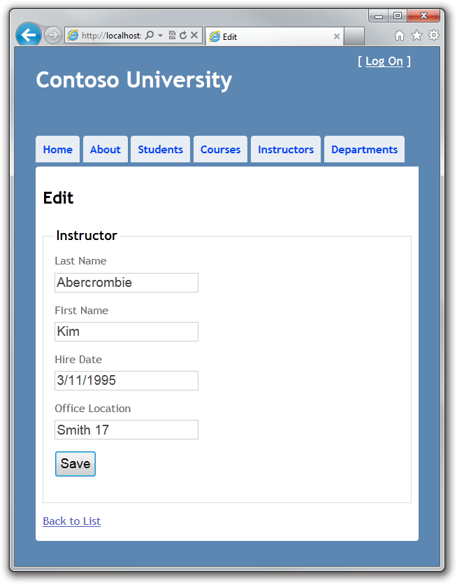

Change the **Office Location** and click **Save**.

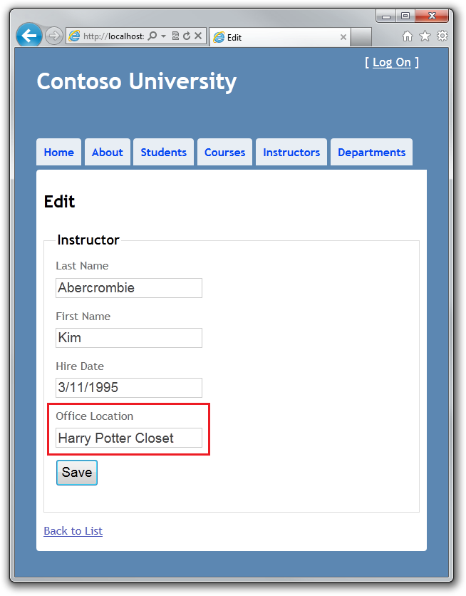

The new location appears on the Index page, and you can see the table row when you open the OfficeAssignment table in **Server Explorer**.

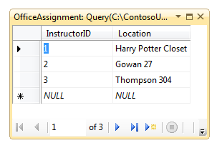

Return to the Edit page, clear the **Office Location** and click **Save**. The Index page shows a blank office location and **Server Explorer** shows that the row has been deleted.

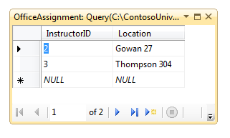

Return to the **Edit** page, enter a new value in the **Office Location** and click **Save**. The **Index** page shows the new location, and **Server Explorer** shows that a row has been created.

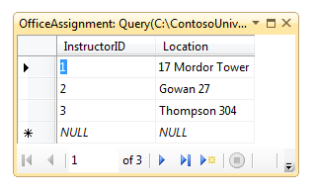

## Adding Course Assignments to the Instructor Edit Page

Instructors may teach any number of courses. You'll now enhance the Instructor Edit page by adding the ability to change course assignments using a group of check boxes, as shown in the following screen shot:



The relationship between the Course and Instructor entities is many-to-many, which means you do not have direct access to the join table or foreign key fields. Instead, you will add and remove entities to and from the Instructor.Courses navigation property.

The UI that enables you to change which courses an instructor is assigned to is a group of check boxes. A check box for every course in the database is displayed, and the ones that the instructor is currently assigned to are selected. The user can select or clear check boxes to change course assignments. If the number of courses were much greater, you probably would want to use a different method of presenting the data in the view, but you'd use the same method of manipulating navigation properties in order to create or delete relationships.

To provide data to the view for the list of check boxes, you'll use a view model class. Create AssignedCourseData.cs in the ViewModels folder and replace the existing code with the following code:

using System;

using System.Collections.Generic;

using System.ComponentModel.DataAnnotations;

namespace ContosoUniversity.ViewModels

{

public class AssignedCourseData

{

public int CourseID { get; set; }

public string Title { get; set; }

public bool Assigned { get; set; }

}

}

In InstructorController.cs, in the HttpGet Edit method, call a new method that provides information for the check box array using the new view model class, as shown in the following example:

public ActionResult Edit(int id)

{

Instructor instructor = db.Instructors

.Include(i => i.OfficeAssignment)

.Include(i => i.Courses)

.Where(i => i.InstructorID == id)

.Single();

PopulateAssignedCourseData(instructor);

return View(instructor);

}

private void PopulateAssignedCourseData(Instructor instructor)

{

var allCourses = db.Courses;

var instructorCourses = new HashSet<int>(instructor.Courses.Select(c => c.CourseID));

var viewModel = new List<AssignedCourseData>();

foreach (var course in allCourses)

{

viewModel.Add(new AssignedCourseData

{

CourseID = course.CourseID,

Title = course.Title,

Assigned = instructorCourses.Contains(course.CourseID)

});

}

ViewBag.Courses = viewModel;

}

The code in the new method reads through all Course entities in order to load a list of courses using the view model class. For each course, the code checks whether the course exists in the instructor's Courses navigation property. To create efficient lookup when checking whether a course is assigned to the instructor, the courses assigned to the instructor are put into a [HashSet](http://msdn.microsoft.com/en-us/library/bb359438.aspx) collection. The Assigned property of courses that are assigned to the instructor is set to true. The view will use this property to determine which check boxes must be displayed as selected. Finally, the list is passed to the view in a ViewBag property.

Next, add the code that's executed when the user clicks **Save**. Replace the HttpPost Edit method with the following code, which calls a new method that updates the Courses navigation property of the Instructor entity.

[HttpPost]

public ActionResult Edit(int id, FormCollection formCollection, string[] selectedCourses)

{

var instructorToUpdate = db.Instructors

.Include(i => i.OfficeAssignment)

.Include(i => i.Courses)

.Where(i => i.InstructorID == id)

.Single();

if (TryUpdateModel(instructorToUpdate, "", null, new string[] { "Courses" }))

{

try

{

if (String.IsNullOrWhiteSpace(instructorToUpdate.OfficeAssignment.Location))

{

instructorToUpdate.OfficeAssignment = null;

}

UpdateInstructorCourses(selectedCourses, instructorToUpdate);

db.Entry(instructorToUpdate).State = EntityState.Modified;

db.SaveChanges();

return RedirectToAction("Index");

}

catch (DataException)

{

//Log the error (add a variable name after DataException)

ModelState.AddModelError("", "Unable to save changes. Try again, and if the problem persists, see your system administrator.");

}

}

PopulateAssignedCourseData(instructorToUpdate);

return View(instructorToUpdate);

}

private void UpdateInstructorCourses(string[] selectedCourses, Instructor instructorToUpdate)

{

if (selectedCourses == null)

{

instructorToUpdate.Courses = new List<Course>();

return;

}

var selectedCoursesHS = new HashSet<string>(selectedCourses);

var instructorCourses = new HashSet<int>

(instructorToUpdate.Courses.Select(c => c.CourseID));

foreach (var course in db.Courses)

{

if (selectedCoursesHS.Contains(course.CourseID.ToString()))

{

if (!instructorCourses.Contains(course.CourseID))

{

instructorToUpdate.Courses.Add(course);

}

}

else

{

if (instructorCourses.Contains(course.CourseID))

{

instructorToUpdate.Courses.Remove(course);

}

}

}

}

If no check boxes were selected, the code in UpdateInstructorCourses initializes the Courses navigation property with an empty collection:

if (selectedCourses == null)

{

instructorToUpdate.Courses = new List();

return;

}

The code then loops through all courses in the database. If the check box for a course was selected but the course isn't in the Instructor.Courses navigation property, the course is added to the collection in the navigation property.

if (selectedCoursesHS.Contains(course.CourseID.ToString()))

{

if (!instructorCourses.Contains(course.CourseID))

{

instructorToUpdate.Courses.Add(course);

}

}

If a course wasn't selected, but the course is in the Instructor.Courses navigation property, the course is removed from the navigation property.

else

{

if (instructorCourses.Contains(course.CourseID))

{

instructorToUpdate.Courses.Remove(course);

}

}

In Views\Instructor\Edit.cshtml, add a **Courses** field with an array of check boxes by adding the following code immediately after the div elements for the OfficeAssignment field:

<div class="editor-field">

<table>

<tr>

@{

int cnt = 0;

List<ContosoUniversity.ViewModels.AssignedCourseData> courses = ViewBag.Courses;

foreach (var course in courses) {

if (cnt++ % 3 == 0) {

@: </tr> <tr>

}

@: <td>

<input type="checkbox"

name="selectedCourses"

value="@course.CourseID"

@(Html.Raw(course.Assigned ? "checked=\"checked\"" : "")) />

@course.CourseID @: @course.Title

@:</td>

}

@: </tr>

}

</table>

</div>

This code creates an HTML table that has three columns. In each column is a check box followed by a caption that consists of the course number and title. The check boxes all have the same name ("selectedCourses"), which informs the model binder that they are to be treated as a group. The value attribute of each check box is set to the value of CourseID. When the page is posted, the model binder passes an array to the controller that consists of the CourseID values for only the check boxes which are selected.

When the check boxes are initially rendered, those that are for courses already assigned to the instructor have checked attributes, which selects them.

After changing course assignments, you'll want to be able to verify the changes when the site returns to the Index page. Therefore, you need to add a column to the table in that page. In this case you don't need to use the ViewBag object, because the information you want to display is already in the Courses navigation property of the Instructor entity that you're passing to the page as the model.

In Views\Instructor\Index.cshtml, add a <th>Courses</th> heading cell immediately following the <th>Office</th> heading, as shown in the following example:

<tr>

<th></th>

<th>Last Name</th>

<th>First Name</th>

<th>Hire Date</th>

<th>Office</th>

<th>Courses</th>

</tr>

Then add a new detail cell immediately following the office location detail cell:

<td>

@{

foreach (var course in item.Courses)

{

@course.CourseID @: @course.Title <br />

}

}

</td>

Run the **Instructor Index** page to see the courses assigned to each instructor:

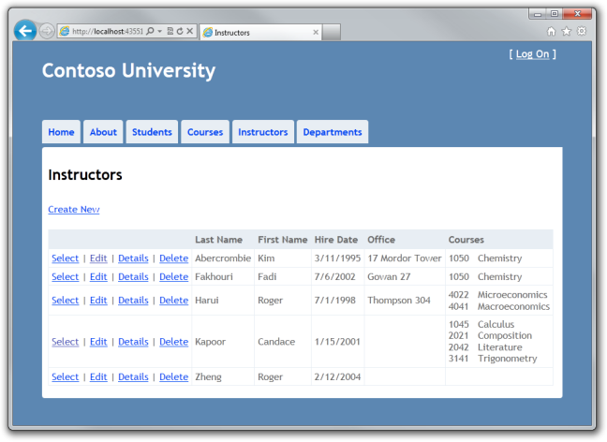

Click **Edit** on an instructor to see the Edit page.



Change some course assignments and click **Save**. The changes you make are reflected on the Index page.

You have now completed this introduction to working with related data. So far in these tutorials you've done a full range of CRUD operations, but you haven't dealt with concurrency issues. The next tutorial will introduce the topic of concurrency, explain options for handling it, and add concurrency handling to the CRUD code you've already written for one entity type.

# 7 Handling Concurrency with the Entity Framework in an ASP.NET MVC Application

The Contoso University sample web application demonstrates how to create ASP.NET MVC applications using the Entity Framework. The sample application is a website for a fictional Contoso University. It includes functionality such as student admission, course creation, and instructor assignments.

This tutorial series explains the steps taken to build the Contoso University sample application. You can [download the completed application](http://go.microsoft.com/fwlink/?LinkId=215669) or create it by following the steps in the tutorial. The tutorial shows examples in C#. The downloadable sample contains code in both C# and Visual Basic. If you have questions that are not directly related to the tutorial, you can post them to the [ASP.NET Entity Framework forum](http://forums.asp.net/1227.aspx) or the [Entity Framework and LINQ to Entities forum](http://social.msdn.microsoft.com/forums/en-US/adodotnetentityframework/threads/).

This tutorial series assumes you know how to work with ASP.NET MVC in Visual Studio. If you don’t, a good place to start is a [basic ASP.NET MVC Tutorial](http://www.asp.net/mvc/tutorials/getting-started-with-MVC3-part1-cs). If you prefer to work with the ASP.NET Web Forms model, see the [Getting Started with the Entity Framework](http://www.asp.net/entity-framework/tutorials#Getting Started) and [Continuing with the Entity Framework](http://www.asp.net/entity-framework/tutorials#Continuing) tutorials.

Before you start, make sure you have the following software installed on your computer:

* [Visual Studio 2010 SP1](http://www.microsoft.com/web/gallery/install.aspx?appsxml=&appid=VS2010SP1Pack) or [Visual Web Developer Express 2010 SP1](http://www.microsoft.com/web/gallery/install.aspx?appsxml=&appid=VWD2010SP1Pack) (If you use one of these links, the following items will be installed automatically.)
* [ASP.NET MVC 3 Tools Update](http://www.microsoft.com/web/gallery/install.aspx?appid=MVC3)
* [Microsoft SQL Server Compact 4.0](http://www.microsoft.com/web/gallery/install.aspx?appid=SQLCE)
* [Microsoft Visual Studio 2010 SP1 Tools for SQL Server Compact 4.0](http://www.microsoft.com/web/gallery/install.aspx?appid=SQLCEVSTools)

In the previous two tutorials you worked with related data. This tutorial shows how to handle concurrency. You'll create web pages that work with the Department entity, and the pages that edit and delete Department entities will handle concurrency errors. The following illustrations show the Index and Delete pages, including some messages that are displayed if a concurrency conflict occurs.

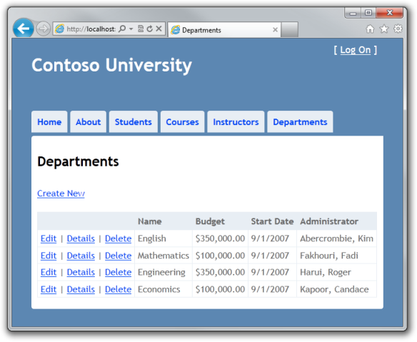

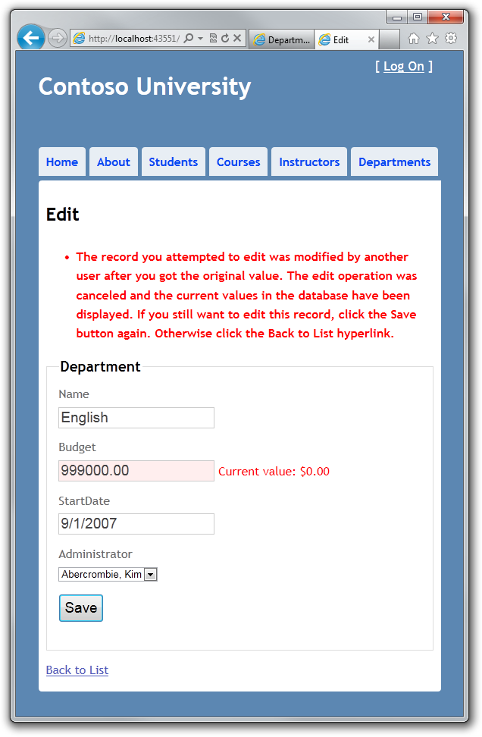

## Concurrency Conflicts

A concurrency conflict occurs when one user displays an entity's data in order to edit it, and then another user updates the same entity's data before the first user's change is written to the database. If you don't set up the Entity Framework to detect such conflicts, whoever updates the database last overwrites the other user's changes. In many applications, this risk is acceptable: if there are few users, or few updates, or if isn't really critical if some changes are overwritten, the cost of programming for concurrency might outweigh the benefit. In that case, you don't have to configure the application to handle concurrency conflicts.

## Pessimistic Concurrency (Locking)

If your application does need to prevent accidental data loss in concurrency scenarios, one way to do that is to use database locks. This is called pessimistic concurrency. For example, before you read a row from a database, you request a lock for read-only or for update access. If you lock a row for update access, no other users are allowed to lock the row either for read-only or update access, because they would get a copy of data that's in the process of being changed. If you lock a row for read-only access, others can also lock it for read-only access but not for update.

Managing locks has some disadvantages. It can be complex to program. It requires significant database management resources, and it can cause performance problems as the number of users of an application increases (that is, it doesn't scale well). For these reasons, not all database management systems support pessimistic concurrency. The Entity Framework provides no built-in support for it, and this tutorial doesn't show you how to implement it.

## Optimistic Concurrency

The alternative to pessimistic concurrency is optimistic concurrency. Optimistic concurrency means allowing concurrency conflicts to happen, and then reacting appropriately if they do. For example, John runs the Departments Edit page, changes the **Budget** amount for the English department from $350,000.00 to $100,000.00. (John administers a competing department and wants to free up money for his own department.)

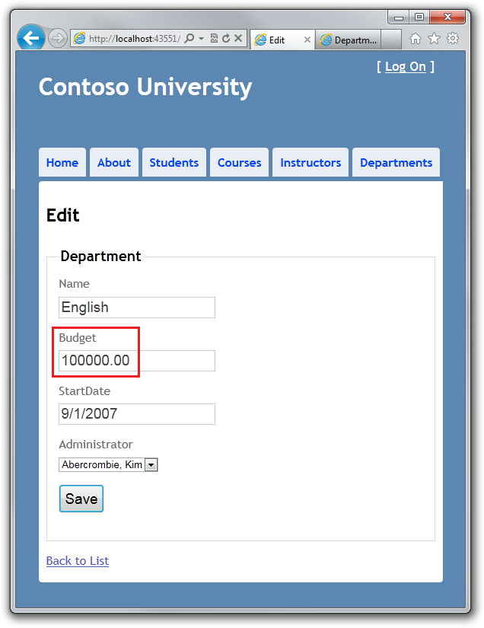

Before John clicks **Save**, Jane runs the same page and changes the **Start Date** field from 9/1/2007 to 1/1/1999. (Jane administers the History department and wants to give it more seniority.)

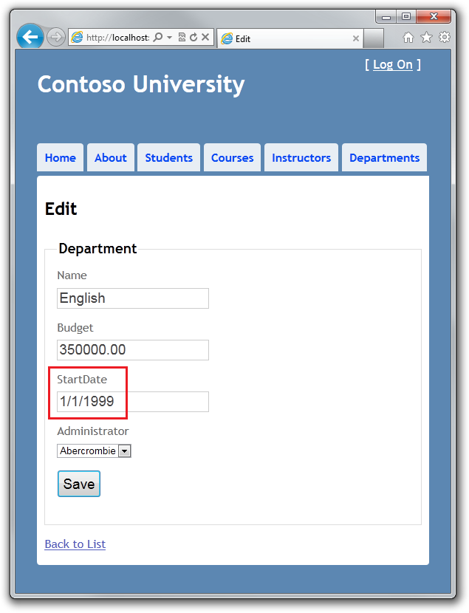

John clicks **Save** first and sees his change when the browser returns to the Index page, then Jane clicks **Save**. What happens next is determined by how you handle concurrency conflicts. Some of the options include the following:

* You can keep track of which property a user has modified and update only the corresponding columns in the database. In the example scenario, no data would be lost, because different properties were updated by the two users. The next time someone browses the English department, they'll see both John's and Jane's changes — a start date of 1/1/999 and a budget of $100,000.00.

This method of updating can reduce the number of conflicts that could result in data loss, but it can't avoid data loss if competing changes are made to the same property of an entity. Whether the Entity Framework works this way depends on how you implement your update code. It's often not practical in a web application, because it can require that you maintain large amounts of state in order to keep track of all original values as well as new values. Maintaining large amounts of state can affect application performance because it either requires server resources or must be included in the web page itself (for example, in hidden fields).

* You can let Jane's change overwrite John's change. The next time someone browses the English department, they'll see 1/1/1999 and the restored $350,000.00 value. This is called a Client Wins or Last in Wins scenario. (The client's values take precedence over what's in the data store.) As noted in the introduction to this section, if you don't do any coding for concurrency handling, this will happen automatically.
* You can prevent Jane's change from being updated in the database. Typically, you would display an error message, show her the current state of the data, and allow her to reapply her changes if she still wants to make them. This is called a Store Wins scenario. (The data-store values take precedence over the values submitted by the client.) You'll implement the Store Wins scenario in this tutorial. This method ensures that no changes are overwritten without a user being alerted to what's happening.

## Detecting Concurrency Conflicts

You can resolve conflicts by handling OptimisticConcurrencyException exceptions that the Entity Framework throws. In order to know when to throw these exceptions, the Entity Framework must be able to detect conflicts. Therefore, you must configure the database and the data model appropriately. Some options for enabling conflict detection include the following:

* In the database table, include a tracking column that can be used to determine when a row has been changed. You can then configure the Entity Framework to include that column in the Where clause of SQL Update or Delete commands.

The data type of the tracking column is typically timestamp, but it doesn't actually contain a date or time value. Instead, the value is a sequential number that's incremented each time the row is updated. (Therefore the same type can be called rowversion in recent versions of SQL Server.) In an Update or Delete command, the Where clause includes the original value of the tracking column. If the row being updated has been changed by another user, the value in that column is different than the original value, so the Update or Delete statement can't find the row to update because of the Where clause. When the Entity Framework finds that no rows have been updated by the Update or Delete command (that is, when the number of affected rows is zero), it interprets that as a concurrency conflict.

* Configure the Entity Framework to include the original values of every column in the table in the Where clause of Update and Delete commands.

As in the first option, if anything in the row has changed since the row was first read, the Where clause won't return a row to update, which the Entity Framework interprets as a concurrency conflict. This method is as effective as using a tracking column. However, for database tables that have many columns, this approach can result in very large Where clauses, and can require that you maintain large amounts of state. As noted earlier, maintaining large amounts of state can affect application performance because it either requires server resources or must be included in the web page itself. Therefore this approach generally not recommended, and it isn't the method used in this tutorial.

In the remainder of this tutorial you'll add a tracking property to the Department entity, create a controller and views, and test to verify that everything works correctly.

**Note** If you were implementing concurrency without a tracking column, you would have to mark all non-primary-key properties in the entity for concurrency tracking by adding the ConcurrencyCheck attribute to them. That change would enable the Entity Framework to include all columns in the SQL WHERE clause of UPDATE statements.

## Adding a Tracking Property to the Department Entity

In Models\Department.cs, add a tracking property:

[Timestamp]

public Byte[] Timestamp { get; set; }

The Timestamp attribute specifies that this column will be included in the Where clause of Update and Delete commands sent to the database.

## Creating a Department Controller

Create a Department controller and views the same way you did the other controllers, using the following settings:

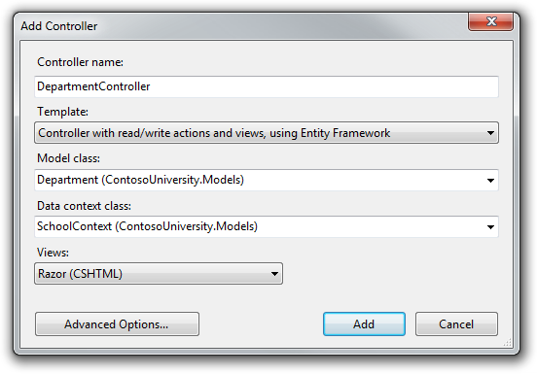

In Controllers\DepartmentController.cs, add a using statement:

using System.Data.Entity.Infrastructure;

Change "LastName" to "FullName" everywhere in this file (four occurrences) so that the department administrator drop-down lists will contain the full name of the instructor rather than just the last name.

Replace the existing code for the HttpPost Edit method with the following code:

[HttpPost]

public ActionResult Edit(Department department)

{

try

{

if (ModelState.IsValid)

{

db.Entry(department).State = EntityState.Modified;

db.SaveChanges();

return RedirectToAction("Index");

}

}

catch (DbUpdateConcurrencyException ex)

{

var entry = ex.Entries.Single();

var databaseValues = (Department)entry.GetDatabaseValues().ToObject();

var clientValues = (Department)entry.Entity;

if (databaseValues.Name != clientValues.Name)

ModelState.AddModelError("Name", "Current value: "

+ databaseValues.Name);

if (databaseValues.Budget != clientValues.Budget)

ModelState.AddModelError("Budget", "Current value: "

+ String.Format("{0:c}", databaseValues.Budget));

if (databaseValues.StartDate != clientValues.StartDate)

ModelState.AddModelError("StartDate", "Current value: "

+ String.Format("{0:d}", databaseValues.StartDate));

if (databaseValues.InstructorID != clientValues.InstructorID)

ModelState.AddModelError("InstructorID", "Current value: "

+ db.Instructors.Find(databaseValues.InstructorID).FullName);

ModelState.AddModelError(string.Empty, "The record you attempted to edit "

+ "was modified by another user after you got the original value. The "

+ "edit operation was canceled and the current values in the database "

+ "have been displayed. If you still want to edit this record, click "

+ "the Save button again. Otherwise click the Back to List hyperlink.");

department.Timestamp = databaseValues.Timestamp;

}

catch (DataException)

{

//Log the error (add a variable name after Exception)

ModelState.AddModelError(string.Empty, "Unable to save changes. Try again, and if the problem persists contact your system administrator.");

}

ViewBag.InstructorID = new SelectList(db.Instructors, "InstructorID", "FullName", department.InstructorID);

return View(department);

}

The view will store the original timestamp value in a hidden field. When the model binder creates the department instance, that object will have the original Timestamp property value and the new values for the other properties, as entered by the user on the Edit page. Then when the Entity Framework creates a SQL UPDATE command, that command will include a WHERE clause that looks for a row that has the original Timestamp value.

If zero rows are affected by the UPDATE command, the Entity Framework throws a DbUpdateConcurrencyException exception, and the code in the catch block gets the affected Department entity from the exception object. This entity has both the values read from the database and the new values entered by the user:

var entry = ex.Entries.Single();

var databaseValues = (Department)entry.GetDatabaseValues().ToObject();

var clientValues = (Department)entry.Entity;

Next, the code adds a custom error message for each column that has database values different from what the user entered on the Edit page:

if (databaseValues.Name != currentValues.Name)

ModelState.AddModelError("Name", "Current value: " + databaseValues.Name);

// ...

A longer error message explains what happened and what to do about it:

ModelState.AddModelError(string.Empty, "The record you attempted to edit "

+ "was modified by another user after you got the original value. The"

+ "edit operation was canceled and the current values in the database "

+ "have been displayed. If you still want to edit this record, click "

+ "the Save button again. Otherwise click the Back to List hyperlink.");

Finally, the code sets the Timestamp value of the Department object to the new value retrieved from the database. This new Timestamp value will be stored in the hidden field when the Edit page is redisplayed, and the next time the user clicks **Save**, only concurrency errors that happen since the redisplay of the Edit page will be caught.

In Views\Department\Edit.cshtml, add a hidden field to save the Timestamp property value, immediately following the hidden field for the DepartmentID property:

@Html.HiddenFor(model => model.Timestamp)

In Views\Department\Index.cshtml, replace the existing code with the following code to move row links to the left and change the page title and column headings to display FullName instead of LastName in the **Administrator** column:

@model IEnumerable<ContosoUniversity.Models.Department>

@{

ViewBag.Title = "Departments";

}

<h2>Departments</h2>

<p>

@Html.ActionLink("Create New", "Create")

</p>

<table>

<tr>

<th></th>

<th>Name</th>

<th>Budget</th>

<th>Start Date</th>

<th>Administrator</th>

</tr>

@foreach (var item in Model) {

<tr>

<td>

@Html.ActionLink("Edit", "Edit", new { id=item.DepartmentID }) |

@Html.ActionLink("Details", "Details", new { id=item.DepartmentID }) |

@Html.ActionLink("Delete", "Delete", new { id=item.DepartmentID })

</td>

<td>

@Html.DisplayFor(modelItem => item.Name)

</td>

<td>

@Html.DisplayFor(modelItem => item.Budget)

</td>

<td>

@Html.DisplayFor(modelItem => item.StartDate)

</td>

<td>

@Html.DisplayFor(modelItem => item.Administrator.FullName)

</td>

</tr>

}

</table>

## Testing Optimistic Concurrency Handling

Run the site and click **Departments**:



Click an **Edit** hyperlink and then open a new browser window and go to the same URL in that window. The windows display the same information.

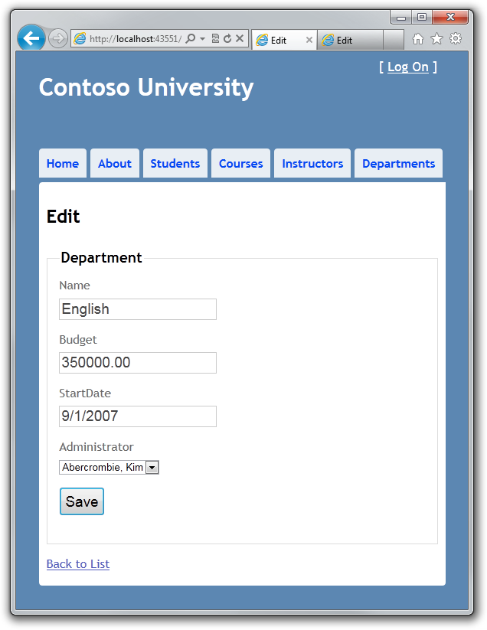

Change a field in the first browser window and click **Save**.

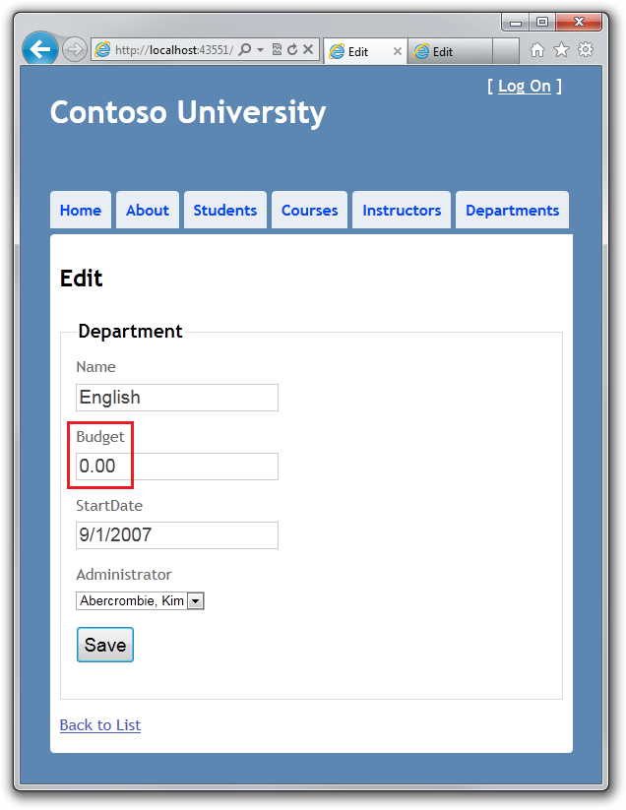

The browser shows the Index page with the changed value.

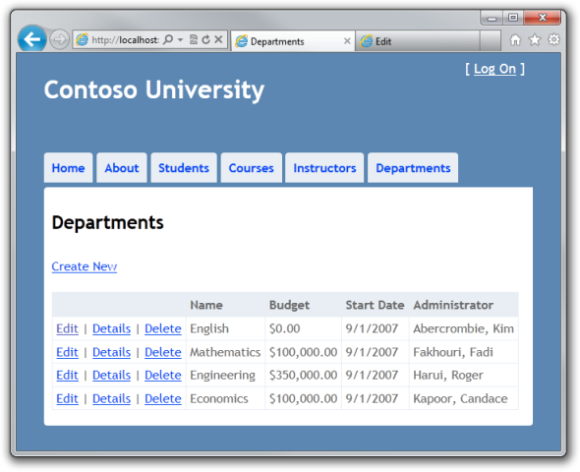

Change the same field to a different value in the second browser window.

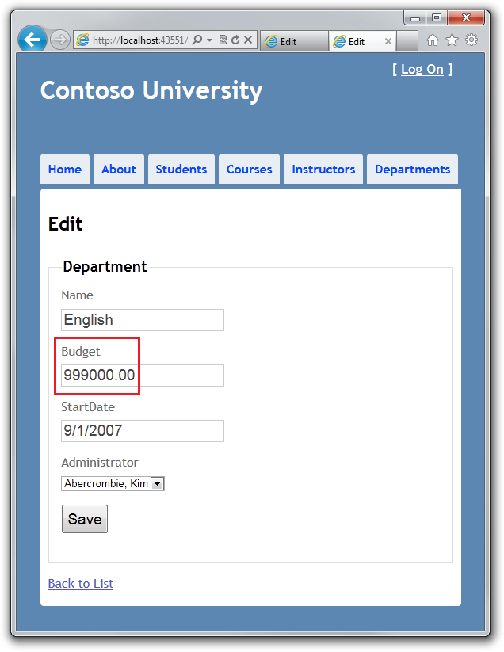

Click **Save** in the second browser window. You see an error message:



Click **Save** again. The value you entered in the second browser is saved in the database and you see that value when the Index page appears.

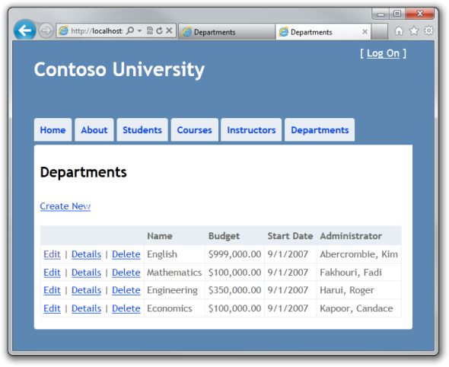

## Adding a Delete Page

For the Delete page, the Entity Framework detects concurrency conflicts in a similar manner. When the HttpGet Delete method displays the confirmation view, the view includes the original Timestamp value in a hidden field. That value is then available to the HttpPost Delete method that's called when the user confirms the deletion. When the Entity Framework creates the SQL DELETE command, it includes a WHERE clause with the original Timestamp value. If the command results in zero rows affected (meaning the row was changed after the Delete confirmation page was displayed), a concurrency exception is thrown, and the HttpGet Delete method is called with an error flag set to true in order to redisplay the confirmation page with an error message.

In DepartmentController.cs, replace the HttpGet Delete method with the following code:

public ActionResult Delete(int id, bool? concurrencyError)

{

if (concurrencyError.GetValueOrDefault())

{

ViewBag.ConcurrencyErrorMessage = "The record you attempted to delete "

+ "was modified by another user after you got the original values. "

+ "The delete operation was canceled and the current values in the "

+ "database have been displayed. If you still want to delete this "

+ "record, click the Delete button again. Otherwise "

+ "click the Back to List hyperlink.";

}

Department department = db.Departments.Find(id);

return View(department);

}

The method accepts an optional parameter that indicates whether the page is being redisplayed after a concurrency error. If this flag is true, error message text is sent to the view using a ViewBag property.

Replace the code in the HttpPost Delete method (named DeleteConfirmed) with the following code:

[HttpPost, ActionName("Delete")]

public ActionResult DeleteConfirmed(Department department)

{

try

{

db.Entry(department).State = EntityState.Deleted;

db.SaveChanges();

return RedirectToAction("Index");

}

catch (DbUpdateConcurrencyException)

{

return RedirectToAction("Delete",

new System.Web.Routing.RouteValueDictionary { { "concurrencyError", true } });

}

catch (DataException)

{

//Log the error (add a variable name after Exception)

ModelState.AddModelError(string.Empty, "Unable to save changes. Try again, and if the problem persists contact your system administrator.");

return View(department);

}

}

In the scaffolded code that you just replaced, this method accepted only a record ID:

public ActionResult DeleteConfirmed(int id)

You've changed this parameter to a Department entity instance created by the model binder. This gives you access to the Timestamp property value in addition to the record key.

public ActionResult DeleteConfirmed(Department department)

If a concurrency error is caught, the code redisplays the Delete confirmation page and provides a flag that indicates it should display a concurrency error message.

In Views\Department\Delete.cshtml, replace the scaffolded code with the following code to make some formatting changes and add an error message field:

@model ContosoUniversity.Models.Department

@{

ViewBag.Title = "Delete";

}

<h2>Delete</h2>

<p class="error">@ViewBag.ConcurrencyErrorMessage</p>

<h3>Are you sure you want to delete this?</h3>

<fieldset>

<legend>Department</legend>

<div class="display-label">

@Html.LabelFor(model => model.Name)

</div>

<div class="display-field">

@Html.DisplayFor(model => model.Name)

</div>

<div class="display-label">

@Html.LabelFor(model => model.Budget)

</div>

<div class="display-field">

@Html.DisplayFor(model => model.Budget)

</div>

<div class="display-label">

@Html.LabelFor(model => model.StartDate)

</div>

<div class="display-field">

@Html.DisplayFor(model => model.StartDate)

</div>

<div class="display-label">

@Html.LabelFor(model => model.InstructorID)

</div>

<div class="display-field">

@Html.DisplayFor(model => model.Administrator.FullName)

</div>

</fieldset>

@using (Html.BeginForm()) {

@Html.HiddenFor(model => model.DepartmentID)

@Html.HiddenFor(model => model.Timestamp)

<p>

<input type="submit" value="Delete" /> |

@Html.ActionLink("Back to List", "Index")

</p>

}

This code adds an error message between the h2 and h3 headings:

<p class="error">@ViewBag.ConcurrencyErrorMessage</p>

It replaces LastName with FullName in the Administrator field:

<div class="display-label">

@Html.LabelFor(model => model.InstructorID)

</div>

<div class="display-field">

@Html.DisplayFor(model => model.Administrator.FullName)

</div>

Finally, it adds hidden fields for the DepartmentID and Timestamp properties after the Html.BeginForm statement:

@Html.HiddenFor(model => model.DepartmentID)

@Html.HiddenFor(model => model.Timestamp)

Run the Departments Index page and open a second browser window with the same URL.

In the first window, click **Edit** on a department and change one of the values, but don't click **Save** yet:



In the second window, select **Delete** on the same department. The Delete confirmation page appears.

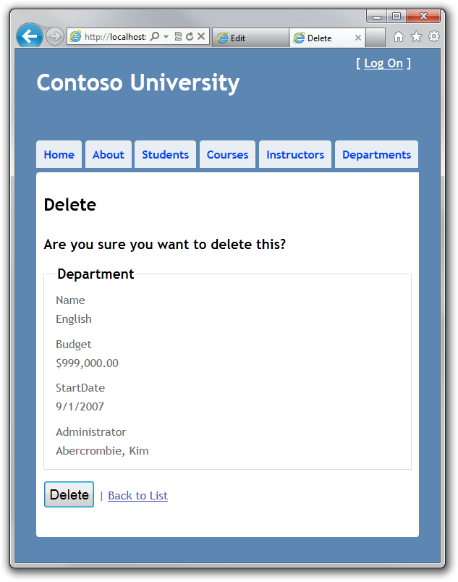

Click **Save** in the first browser window. The Index page confirms the change.

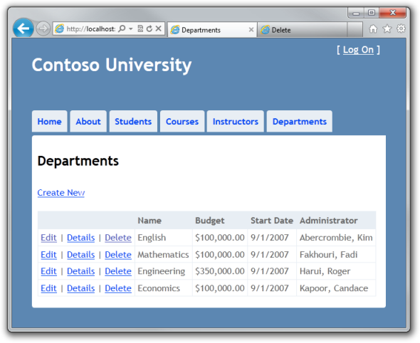

Now click **Delete** in the second browser. You see the concurrency error message, and the Department values are refreshed with what's currently in the database.

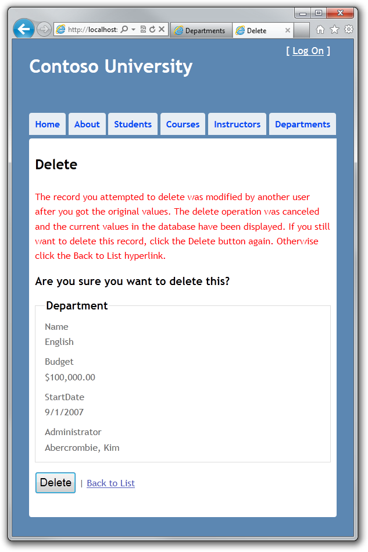

If you click **Delete** again, you're redirected to the Index page, which shows that the department has been deleted.

This completes the introduction to handling concurrency conflicts. For information about other ways to handle various concurrency scenarios, see [Optimistic Concurrency Patterns](http://blogs.msdn.com/b/adonet/archive/2011/02/03/using-dbcontext-in-ef-feature-ctp5-part-9-optimistic-concurrency-patterns.aspx) and [Working with Property Values](http://blogs.msdn.com/b/adonet/archive/2011/01/30/using-dbcontext-in-ef-feature-ctp5-part-5-working-with-property-values.aspx) on the Entity Framework team blog. The next tutorial shows how to implement table-per-hierarchy inheritance for the Instructor and Student entities.

# 8 Implementing Inheritance with the Entity Framework in an ASP.NET MVC Application

The Contoso University sample web application demonstrates how to create ASP.NET MVC applications using the Entity Framework. The sample application is a website for a fictional Contoso University. It includes functionality such as student admission, course creation, and instructor assignments.

This tutorial series explains the steps taken to build the Contoso University sample application. You can [download the completed application](http://go.microsoft.com/fwlink/?LinkId=215669) or create it by following the steps in the tutorial. The tutorial shows examples in C#. The downloadable sample contains code in both C# and Visual Basic. If you have questions that are not directly related to the tutorial, you can post them to the [ASP.NET Entity Framework forum](http://forums.asp.net/1227.aspx) or the [Entity Framework and LINQ to Entities forum](http://social.msdn.microsoft.com/forums/en-US/adodotnetentityframework/threads/).

This tutorial series assumes you know how to work with ASP.NET MVC in Visual Studio. If you don’t, a good place to start is a [basic ASP.NET MVC Tutorial](http://www.asp.net/mvc/tutorials/getting-started-with-MVC3-part1-cs). If you prefer to work with the ASP.NET Web Forms model, see the [Getting Started with the Entity Framework](http://www.asp.net/entity-framework/tutorials#Getting Started) and [Continuing with the Entity Framework](http://www.asp.net/entity-framework/tutorials#Continuing) tutorials.

Before you start, make sure you have the following software installed on your computer:

* [Visual Studio 2010 SP1](http://www.microsoft.com/web/gallery/install.aspx?appsxml=&appid=VS2010SP1Pack) or [Visual Web Developer Express 2010 SP1](http://www.microsoft.com/web/gallery/install.aspx?appsxml=&appid=VWD2010SP1Pack) (If you use one of these links, the following items will be installed automatically.)
* [ASP.NET MVC 3 Tools Update](http://www.microsoft.com/web/gallery/install.aspx?appid=MVC3)
* [Microsoft SQL Server Compact 4.0](http://www.microsoft.com/web/gallery/install.aspx?appid=SQLCE)
* [Microsoft Visual Studio 2010 SP1 Tools for SQL Server Compact 4.0](http://www.microsoft.com/web/gallery/install.aspx?appid=SQLCEVSTools)

In the previous tutorial you handled concurrency exceptions. This tutorial will show you how to implement inheritance in the data model.

In object-oriented programming, you can use inheritance to eliminate redundant code. In this tutorial, you'll change the Instructor and Student classes so that they derive from a Person base class which contains properties such as LastName that are common to both instructors and students. You won't add or change any web pages, but you'll change some of the code and those changes will be automatically reflected in the database.

## Table-per-Hierarchy versus Table-per-Type Inheritance

In object-oriented programming, you can use inheritance to make it easier to work with related classes. For example, the Instructor and Student classes in the School data model share several properties, which results in redundant code:

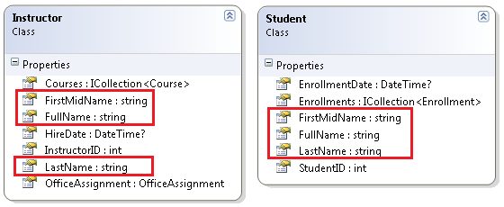

Suppose you want to eliminate the redundant code for the properties that are shared by the Instructor and Student entities. You could create a Person base class which contains only those shared properties, then make the Instructor and Student entities inherit from that base class, as shown in the following illustration:

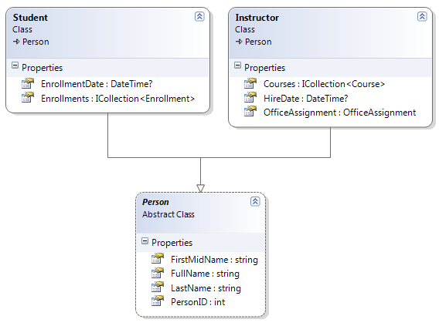

There are several ways this inheritance structure could be represented in the database. You could have a Person table that includes information about both students and instructors in a single table. Some of the columns could apply only to instructors (HireDate), some only to students (EnrollmentDate), some to both (LastName, FirstName). Typically you'd have a discriminator column to indicate which type each row represents. (In this case , the discriminator column might have "Instructor" for instructors and "Student" for students.)

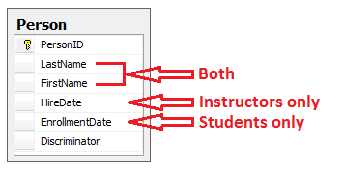

This pattern of generating an entity inheritance structure from a single database table is called table-per-hierarchy (TPH) inheritance.

An alternative is to make the database look more like the inheritance structure. For example, you could have only the name fields in the Person table and have separate Instructor and Student tables with the date fields.

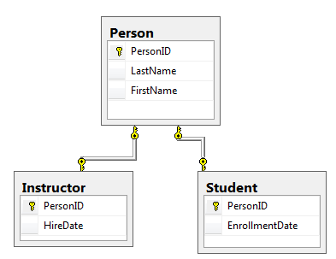

This pattern of making a database table for each entity class is called table per type (TPT) inheritance.

TPH inheritance patterns generally deliver better performance in the Entity Framework than TPT inheritance patterns, because TPT patterns can result in complex join queries. This tutorial demonstrates how to implement TPH inheritance. You'll do that by performing the following steps:

* Create a Person class and change the Instructor and Student classes to derive from Person.
* Add model-to-database mapping code to the database context class.
* Change InstructorID and StudentID references throughout the project to PersonID.

## Creating the Person Class

In the Models folder, create Person.cs and replace the existing code with the following code:

using System;

using System.Collections.Generic;

using System.ComponentModel.DataAnnotations;

namespace ContosoUniversity.Models

{

public abstract class Person

{

[Key]

public int PersonID { get; set; }

[Required(ErrorMessage = "Last name is required.")]

[Display(Name="Last Name")]

[MaxLength(50)]

public string LastName { get; set; }

[Required(ErrorMessage = "First name is required.")]

[Column("FirstName")]

[Display(Name = "First Name")]

[MaxLength(50)]

public string FirstMidName { get; set; }

public string FullName

{

get

{

return LastName + ", " + FirstMidName;

}

}

}

}

In Instructor.cs, derive the Instructor class from the Person class and remove the key and name fields. The code will look like the following example:

using System;

using System.Collections.Generic;

using System.ComponentModel.DataAnnotations;

namespace ContosoUniversity.Models

{

public class Instructor : Person

{

[DisplayFormat(DataFormatString = "{0:d}", ApplyFormatInEditMode = true)]

[Required(ErrorMessage = "Hire date is required.")]

[Display(Name = "Hire Date")]

public DateTime? HireDate { get; set; }

public virtual ICollection<Course> Courses { get; set; }

public virtual OfficeAssignment OfficeAssignment { get; set; }

}

}

Make similar changes to Student.cs. The Student class will look like the following example:

using System;

using System.Collections.Generic;

using System.ComponentModel.DataAnnotations;

namespace ContosoUniversity.Models

{

public class Student : Person

{

[Required(ErrorMessage = "Enrollment date is required.")]

[DisplayFormat(DataFormatString = "{0:d}", ApplyFormatInEditMode = true)]

[Display(Name = "Enrollment Date")]

public DateTime? EnrollmentDate { get; set; }

public virtual ICollection<Enrollment> Enrollments { get; set; }

}

}

## Adding the Person Entity Type to the Model

In SchoolContext.cs, add a DbSet property for the Person entity type:

public DbSet<Person> People { get; set; }

This is all that the Entity Framework needs in order to configure table-per-hierarchy inheritance. As you'll see, when the database is re-created, it will have a Person table in place of the Student and Instructor tables.

## Changing InstructorID and StudentID to PersonID

In SchoolContext.cs, in the Instructor-Course mapping statement, change MapRightKey("InstructorID") to MapRightKey("PersonID"):

modelBuilder.Entity<Course>()

.HasMany(c => c.Instructors).WithMany(i => i.Courses)

.Map(t => t.MapLeftKey("CourseID")

.MapRightKey("PersonID")

.ToTable("CourseInstructor"));

This change isn't required; it just changes the name of the InstructorID column in the many-to-many join table. If you left the name as InstructorID, the application would still work correctly.

Next, perform a global change (all files in the project) to change InstructorID to PersonID and StudentID to PersonID. Make sure that this change is case-sensitive. (Note that this demonstrates a disadvantage of the classnameID pattern for naming primary keys. If you had named primary keys ID without prefixing the class name, no renaming would be necessary now.)

## Adjusting Primary Key Values in the Initializer

In SchoolInitializer.cs, the code currently assumes that primary key values for Student and Instructor entities are numbered separately. This is still correct for Student entities (they'll still be 1 through 8), but Instructor entities will now be 9 through 13 instead of 1 through 5, because the block of code that adds instructors comes after the one that adds students in the initializer class. Replace the code that seeds the Department and OfficeAssignment entity sets with the following code that uses the new ID values for instructors:

var departments = new List<Department>

{

new Department { Name = "English", Budget = 350000, StartDate = DateTime.Parse("2007-09-01"), PersonID = 9 },

new Department { Name = "Mathematics", Budget = 100000, StartDate = DateTime.Parse("2007-09-01"), PersonID = 10 },

new Department { Name = "Engineering", Budget = 350000, StartDate = DateTime.Parse("2007-09-01"), PersonID = 11 },

new Department { Name = "Economics", Budget = 100000, StartDate = DateTime.Parse("2007-09-01"), PersonID = 12 }

};

var officeAssignments = new List<OfficeAssignment>

{

new OfficeAssignment { PersonID = 9, Location = "Smith 17" },

new OfficeAssignment { PersonID = 10, Location = "Gowan 27" },

new OfficeAssignment { PersonID = 11, Location = "Thompson 304" },

};

## Changing OfficeAssignment to Lazy Loading

The current version of the Entity Framework doesn't support eager loading for one-to-zero-or-one relationships when the navigation property is on the derived class of a TPH inheritance structure. This is the case with the OfficeAssignment property on the Instructor entity. To work around this, you'll remove the code you added earlier to perform eager loading on this property.

In InstructorController.cs, delete the three occurrences of the following line of code:

.Include(i => i.OfficeAssignment)

## Testing

Run the site and try various pages. Everything works the same as it did before.

In **Solution Explorer**, double-click School.sdf to open the database in **Server Explorer**. Expand **School.sdf** and then **Tables**, and you see that the **Student** and **Instructor** tables have been replaced by a **Person** table. Expand the **Person** table and you see that it has all of the columns that used to be in the **Student** and **Instructor** tables, plus the discriminator column.

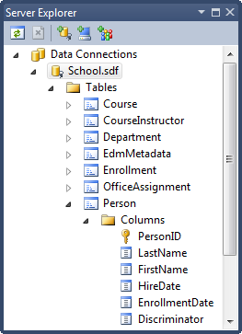

The following diagram illustrates the structure of the new School database:

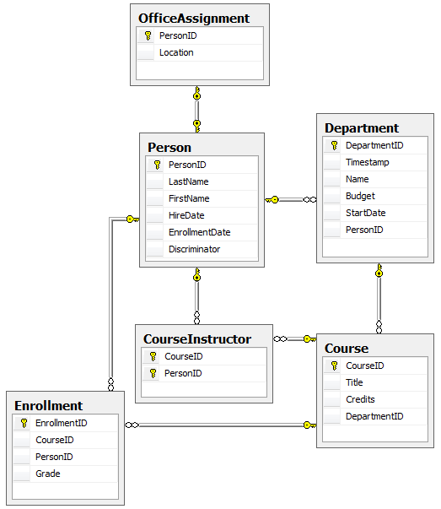

Table-per-hierarchy inheritance has now been implemented for the Person, Student, and Instructor classes. For more information about this and other inheritance structures, see [Inheritance Mapping Strategies](http://weblogs.asp.net/manavi/archive/2010/12/24/inheritance-mapping-strategies-with-entity-framework-code-first-ctp5-part-1-table-per-hierarchy-tph.aspx) on Morteza Manavi's blog. In the next tutorial you'll see some ways to implement the repository and unit of work patterns

# 9 Implementing the Repository and Unit of Work Patterns in an ASP.NET MVC Application

The Contoso University sample web application demonstrates how to create ASP.NET MVC applications using the Entity Framework. The sample application is a website for a fictional Contoso University. It includes functionality such as student admission, course creation, and instructor assignments.

This tutorial series explains the steps taken to build the Contoso University sample application. You can [download the completed application](http://go.microsoft.com/fwlink/?LinkId=215669) or create it by following the steps in the tutorial. The tutorial shows examples in C#. The downloadable sample contains code in both C# and Visual Basic. If you have questions that are not directly related to the tutorial, you can post them to the [ASP.NET Entity Framework forum](http://forums.asp.net/1227.aspx) or the [Entity Framework and LINQ to Entities forum](http://social.msdn.microsoft.com/forums/en-US/adodotnetentityframework/threads/).

This tutorial series assumes you know how to work with ASP.NET MVC in Visual Studio. If you don’t, a good place to start is a [basic ASP.NET MVC Tutorial](http://www.asp.net/mvc/tutorials/getting-started-with-MVC3-part1-cs). If you prefer to work with the ASP.NET Web Forms model, see the [Getting Started with the Entity Framework](http://www.asp.net/entity-framework/tutorials#Getting Started) and [Continuing with the Entity Framework](http://www.asp.net/entity-framework/tutorials#Continuing) tutorials.

Before you start, make sure you have the following software installed on your computer:

* [Visual Studio 2010 SP1](http://www.microsoft.com/web/gallery/install.aspx?appsxml=&appid=VS2010SP1Pack) or [Visual Web Developer Express 2010 SP1](http://www.microsoft.com/web/gallery/install.aspx?appsxml=&appid=VWD2010SP1Pack) (If you use one of these links, the following items will be installed automatically.)
* [ASP.NET MVC 3 Tools Update](http://www.microsoft.com/web/gallery/install.aspx?appid=MVC3)
* [Microsoft SQL Server Compact 4.0](http://www.microsoft.com/web/gallery/install.aspx?appid=SQLCE)
* [Microsoft Visual Studio 2010 SP1 Tools for SQL Server Compact 4.0](http://www.microsoft.com/web/gallery/install.aspx?appid=SQLCEVSTools)

In the previous tutorial you used inheritance to reduce redundant code in the Student and Instructor entity classes. In this tutorial you'll see some ways to use the repository and unit of work patterns for CRUD operations. As in the previous tutorial, in this one you'll change the way your code works with pages you already created rather than creating new pages.

## The Repository and Unit of Work Patterns

The repository and unit of work patterns are intended to create an abstraction layer between the data access layer and the business logic layer of an application. Implementing these patterns can help insulate your application from changes in the data store and can facilitate automated unit testing or test-driven development (TDD).

In this tutorial you'll implement a repository class for each entity type. For the Student entity type you'll create a repository interface and a repository class. When you instantiate the repository in your controller, you'll use the interface so that the controller will accept a reference to any object that implements the repository interface. When the controller runs under a web server, it receives a repository that works with the Entity Framework. When the controller runs under a unit test class, it receives a repository that works with data stored in a way that you can easily manipulate for testing, such as an in-memory collection.

Later in the tutorial you'll use multiple repositories and a unit of work class for the Course and Department entity types in the Course controller. The unit of work class coordinates the work of multiple repositories by creating a single database context class shared by all of them. If you wanted to be able to perform automated unit testing, you'd create and use interfaces for these classes in the same way you did for the Student repository. However, to keep the tutorial simple, you'll create and use these classes without interfaces.

The following illustration shows one way to conceptualize the relationships between the controller and context classes compared to not using the repository or unit of work pattern at all.

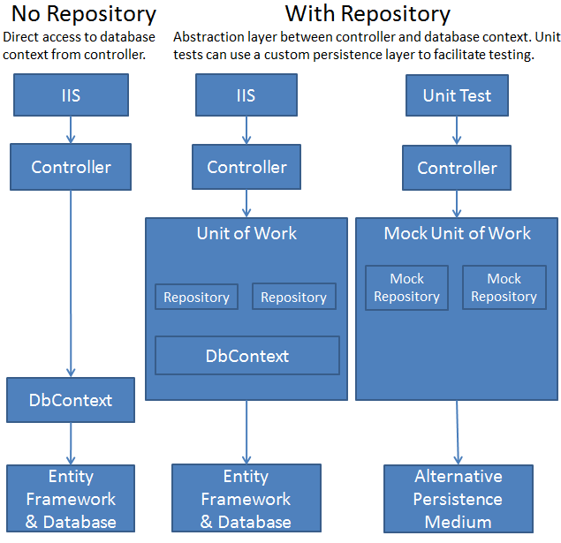

You won't create unit tests in this tutorial series. For an introduction to TDD with an MVC application that uses the repository pattern, see [Walkthrough: Using TDD with ASP.NET MVC](http://msdn.microsoft.com/en-us/library/ff847525.aspx) on the MSDN Library web site. For more information about the repository pattern, see [Using Repository and Unit of Work patterns with Entity Framework 4.0](http://blogs.msdn.com/b/adonet/archive/2009/06/16/using-repository-and-unit-of-work-patterns-with-entity-framework-4-0.aspx) on the Entity Framework team blog and the [Agile Entity Framework 4 Repository](http://thedatafarm.com/blog/data-access/agile-entity-framework-4-repository-part-1-model-and-poco-classes/) series of posts on Julie Lerman's blog.

**Note** There are many ways to implement the repository and unit of work patterns. You can use repository classes with or without a unit of work class. You can implement a single repository for all entity types, or one for each type. If you implement one for each type, you can use separate classes, a generic base class and derived classes, or an abstract base class and derived classes. You can include business logic in your repository or restrict it to data access logic. You can also build an abstraction layer into your database context class by using IDbSet interfaces there instead of DbSet types for your entity sets. The approach to implementing an abstraction layer shown in this tutorial is one option for you to consider, not a recommendation for all scenarios and environments.

## Creating the Student Repository Class

In the DAL folder, create a class file named IStudentRepository.cs and replace the existing code with the following code:

using System;

using System.Collections.Generic;

using System.Linq;

using System.Web;

using ContosoUniversity.Models;

namespace ContosoUniversity.DAL

{

public interface IStudentRepository : IDisposable

{

IEnumerable<Student> GetStudents();

Student GetStudentByID(int studentId);

void InsertStudent(Student student);

void DeleteStudent(int studentID);

void UpdateStudent(Student student);

void Save();

}

}

This code declares a typical set of CRUD methods, including two read methods — one that returns all Student entities, and one that finds a single Student entity by ID.

In the DAL folder, create a class file named StudentRepository.cs file. Replace the existing code with the following code, which implements the IStudentRepository interface:

using System;

using System.Collections.Generic;

using System.Linq;

using System.Data;

using ContosoUniversity.Models;

namespace ContosoUniversity.DAL

{

public class StudentRepository : IStudentRepository, IDisposable

{

private SchoolContext context;

public StudentRepository(SchoolContext context)

{

this.context = context;

}

public IEnumerable<Student> GetStudents()

{

return context.Students.ToList();

}

public Student GetStudentByID(int id)

{

return context.Students.Find(id);

}

public void InsertStudent(Student student)

{

context.Students.Add(student);

}

public void DeleteStudent(int studentID)

{

Student student = context.Students.Find(studentID);

context.Students.Remove(student);

}

public void UpdateStudent(Student student)

{

context.Entry(student).State = EntityState.Modified;

}

public void Save()

{

context.SaveChanges();

}

private bool disposed = false;

protected virtual void Dispose(bool disposing)

{

if (!this.disposed)

{

if (disposing)

{

context.Dispose();

}

}

this.disposed = true;

}

public void Dispose()

{

Dispose(true);

GC.SuppressFinalize(this);

}

}

}

The database context is defined in a class variable, and the constructor expects the calling object to pass in an instance of the context:

private SchoolContext context;

public StudentRepository(SchoolContext context)

{

this.context = context;

}

You could instantiate a new context in the repository, but then if you used multiple repositories in one controller, each would end up with a separate context. Later you'll use multiple repositories in the Course controller, and you'll see how a unit of work class can ensure that all repositories use the same context.

The repository implements IDisposable and disposes the database context as you saw earlier in the controller, and its CRUD methods make calls to the database context in the same way that you saw earlier.

## Changing the Student Controller to Use the Repository

In StudentController.cs, replace the code currently in the class with the following code:

using System;

using System.Collections.Generic;

using System.Data;

using System.Data.Entity;

using System.Linq;

using System.Web;

using System.Web.Mvc;

using ContosoUniversity.Models;

using ContosoUniversity.DAL;

using PagedList;

namespace ContosoUniversity.Controllers

{

public class StudentController : Controller

{

private IStudentRepository studentRepository;

public StudentController()

{

this.studentRepository = new StudentRepository(new SchoolContext());

}

public StudentController(IStudentRepository studentRepository)

{

this.studentRepository = studentRepository;

}

//

// GET: /Student/

public ViewResult Index(string sortOrder, string currentFilter, string searchString, int? page)

{

ViewBag.CurrentSort = sortOrder;

ViewBag.NameSortParm = String.IsNullOrEmpty(sortOrder) ? "Name desc" : "";

ViewBag.DateSortParm = sortOrder == "Date" ? "Date desc" : "Date";

if (Request.HttpMethod == "GET")

{

searchString = currentFilter;

}

else

{

page = 1;

}

ViewBag.CurrentFilter = searchString;

var students = from s in studentRepository.GetStudents()

select s;

if (!String.IsNullOrEmpty(searchString))

{

students = students.Where(s => s.LastName.ToUpper().Contains(searchString.ToUpper())

|| s.FirstMidName.ToUpper().Contains(searchString.ToUpper()));

}

switch (sortOrder)

{

case "Name desc":

students = students.OrderByDescending(s => s.LastName);

break;

case "Date":

students = students.OrderBy(s => s.EnrollmentDate);

break;

case "Date desc":

students = students.OrderByDescending(s => s.EnrollmentDate);

break;

default:

students = students.OrderBy(s => s.LastName);

break;

}

int pageSize = 3;

int pageNumber = (page ?? 1);

return View(students.ToPagedList(pageNumber, pageSize));

}

//

// GET: /Student/Details/5

public ViewResult Details(int id)

{

Student student = studentRepository.GetStudentByID(id);

return View(student);

}

//

// GET: /Student/Create

public ActionResult Create()

{

return View();

}

//

// POST: /Student/Create

[HttpPost]

public ActionResult Create(Student student)

{

try

{

if (ModelState.IsValid)

{

studentRepository.InsertStudent(student);

studentRepository.Save();

return RedirectToAction("Index");

}

}

catch (DataException)

{

//Log the error (add a variable name after DataException)

ModelState.AddModelError("", "Unable to save changes. Try again, and if the problem persists see your system administrator.");

}

return View(student);

}

//

// GET: /Student/Edit/5

public ActionResult Edit(int id)

{

Student student = studentRepository.GetStudentByID(id);

return View(student);

}

//

// POST: /Student/Edit/5

[HttpPost]

public ActionResult Edit(Student student)

{

try

{

if (ModelState.IsValid)

{

studentRepository.UpdateStudent(student);

studentRepository.Save();

return RedirectToAction("Index");

}

}

catch (DataException)

{

//Log the error (add a variable name after DataException)

ModelState.AddModelError("", "Unable to save changes. Try again, and if the problem persists see your system administrator.");

}

return View(student);

}

//

// GET: /Student/Delete/5

public ActionResult Delete(int id, bool? saveChangesError)

{

if (saveChangesError.GetValueOrDefault())

{

ViewBag.ErrorMessage = "Unable to save changes. Try again, and if the problem persists see your system administrator.";

}

Student student = studentRepository.GetStudentByID(id);

return View(student);

}

//

// POST: /Student/Delete/5

[HttpPost, ActionName("Delete")]

public ActionResult DeleteConfirmed(int id)

{

try

{

Student student = studentRepository.GetStudentByID(id);

studentRepository.DeleteStudent(id);

studentRepository.Save();

}

catch (DataException)

{

//Log the error (add a variable name after DataException)

return RedirectToAction("Delete",

new System.Web.Routing.RouteValueDictionary {

{ "id", id },

{ "saveChangesError", true } });

}

return RedirectToAction("Index");

}

protected override void Dispose(bool disposing)

{

studentRepository.Dispose();

base.Dispose(disposing);

}

}

}

The controller now declares a class variable for an object that implements the IStudentRepository interface instead of the context class:

private IStudentRepository studentRepository;

The default constructor creates a new context instance, and an optional constructor allows the caller to pass in a context instance.

public StudentController()

{

this.studentRepository = new StudentRepository(new SchoolContext());

}

public StudentController(IStudentRepository studentRepository)

{

this.studentRepository = studentRepository;

}

(If you were using dependency injection, or DI, you wouldn't need the default constructor because the DI software would ensure that the correct repository object would always be provided.)

In the CRUD methods, the repository is now called instead of the context:

var students = from s in studentRepository.GetStudents()

select s;

Student student = studentRepository.GetStudentByID(id);

studentRepository.InsertStudent(student);

studentRepository.Save();

studentRepository.UpdateStudent(student);

studentRepository.Save();

studentRepository.DeleteStudent(id);

studentRepository.Save();

And the Dispose method now disposes the repository instead of the context:

studentRepository.Dispose();

Run the site and click the **Students** tab.

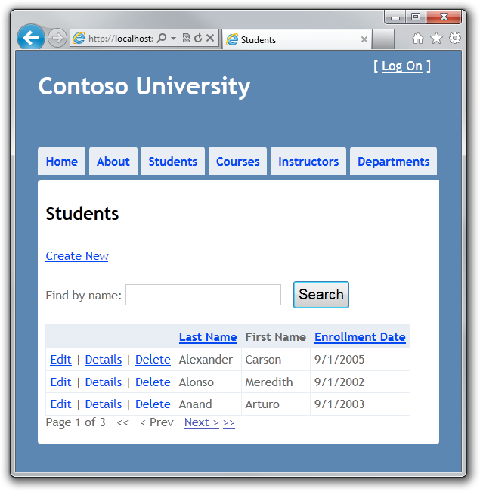

The page looks and works the same as it did before you changed the code to use the repository, and the other Student pages also work the same. However, there's an important difference in the way the Index method of the controller does filtering and ordering. The original version of this method contained the following code:

var students = from s in context.Students

select s;

if (!String.IsNullOrEmpty(searchString))

{

students = students.Where(s => s.LastName.ToUpper().Contains(searchString.ToUpper())

|| s.FirstMidName.ToUpper().Contains(searchString.ToUpper()));

}

In the original version of the code, students is typed as an IQueryable object. The query isn't sent to the database until it's converted into a collection using a method such as ToList, which means that this Where method becomes a WHERE clause in the SQL query and is processed by the database. That in turn means that only the selected entities are returned by the database. However, as a result of changing context.Students to studentRepository.GetStudents(), the students variable after this statement is an IEnumerable collection that includes all students in the database. The end result of applying the Where method is the same, but now the work is done in memory on the web server and not by the database. For large volumes of data, this is likely to be inefficient. The following section shows how to implement repository methods that enable you to specify that this work should be done by the database.

You've now created an abstraction layer between the controller and the Entity Framework database context. If you were going to perform automated unit testing with this application, you could create an alternative repository class in a unit test project that implements IStudentRepository. Instead of calling the context to read and write data, this mock repository class could manipulate in-memory collections in order to test controller functions.

## Implementing a Generic Repository and a Unit of Work Class

Creating a repository class for each entity type could result in a lot of redundant code, and it could result in partial updates. For example, suppose you have to update two different entity types as part of the same transaction. If each uses a separate database context instance, one might succeed and the other might fail. One way to minimize redundant code is to use a generic repository, and one way to ensure that all repositories use the same database context (and thus coordinate all updates) is to use a unit of work class.

In this section of the tutorial, you'll create a GenericRepository class and a UnitOfWork class, and use them in the Course controller to access both the Department and the Course entity sets. As explained earlier, to keep this part of the tutorial simple, you aren't creating interfaces for these classes. But if you were going to use them to facilitate TDD, you'd typically implement them with interfaces the same way you did the Student repository.

## Creating a Generic Repository

In the DAL folder, create GenericRepository.cs and replace the existing code with the following code:

using System;

using System.Collections.Generic;

using System.Linq;

using System.Data;

using System.Data.Entity;

using ContosoUniversity.Models;

using System.Linq.Expressions;

namespace ContosoUniversity.DAL

{

public class GenericRepository<TEntity> where TEntity : class

{

internal SchoolContext context;

internal DbSet<TEntity> dbSet;

public GenericRepository(SchoolContext context)

{

this.context = context;

this.dbSet = context.Set<TEntity>();

}

public virtual IEnumerable<TEntity> Get(

Expression<Func<TEntity, bool>> filter = null,

Func<IQueryable<TEntity>, IOrderedQueryable<TEntity>> orderBy = null,

string includeProperties = "")

{

IQueryable<TEntity> query = dbSet;

if (filter != null)

{

query = query.Where(filter);

}

foreach (var includeProperty in includeProperties.Split

(new char[] { ',' }, StringSplitOptions.RemoveEmptyEntries))

{

query = query.Include(includeProperty);

}

if (orderBy != null)

{

return orderBy(query).ToList();

}

else

{

return query.ToList();

}

}

public virtual TEntity GetByID(object id)

{

return dbSet.Find(id);

}

public virtual void Insert(TEntity entity)

{

dbSet.Add(entity);

}

public virtual void Delete(object id)

{

TEntity entityToDelete = dbSet.Find(id);

Delete(entityToDelete);

}

public virtual void Delete(TEntity entityToDelete)

{

if (context.Entry(entityToDelete).State == EntityState.Detached)

{

dbSet.Attach(entityToDelete);

}

dbSet.Remove(entityToDelete);

}

public virtual void Update(TEntity entityToUpdate)

{

dbSet.Attach(entityToUpdate);

context.Entry(entityToUpdate).State = EntityState.Modified;

}

}

}

Class variables are declared for the database context and for the entity set that the repository is instantiated for:

internal SchoolContext context;

internal DbSet dbSet;

The constructor accepts a database context instance and initializes the entity set variable:

public GenericRepository(SchoolContext context)

{

this.context = context;

this.dbSet = context.Set();

}

The Get method uses lambda expressions to allow the calling code to specify a filter condition and a column to order the results by, and a string parameter lets the caller provide a comma-delimited list of navigation properties for eager loading:

public virtual IEnumerable<TEntity> Get(

Expression<Func<TEntity, bool>> filter = null,

Func<IQueryable<TEntity>, IOrderedQueryable<TEntity>> orderBy = null,

string includeProperties = "")

The code Expression<Func<TEntity, bool>> filter means the caller will provide a lambda expression based on the TEntity type, and this expression will return a Boolean value. For example, if the repository is instantiated for the Student entity type, the code in the calling method might specify student => student.LastName == "Smith" for the filter parameter.

The code Func<IQueryable<TEntity>, IOrderedQueryable<TEntity>> orderBy also means the caller will provide a lambda expression. But in this case, the input to the expression is an IQueryable object for the TEntity type. The expression will return an ordered version of that IQueryable object. For example, if the repository is instantiated for the Student entity type, the code in the calling method might specify q => q.OrderBy(s => s.LastName) for the orderBy parameter.

The code in the Get method creates an IQueryable object and then applies the filter expression if there is one:

IQueryable<TEntity> query = dbSet;

if (filter != null)

{

query = query.Where(filter);

}

Next it applies the eager-loading expressions after parsing the comma-delimited list:

foreach (var includeProperty in includeProperties.Split

(new char[] { ',' }, StringSplitOptions.RemoveEmptyEntries))

{

query = query.Include(includeProperty);

}

Finally, it applies the orderBy expression if there is one and returns the results; otherwise it returns the results from the unordered query:

if (orderBy != null)

{

return orderBy(query).ToList();

}

else

{

return query.ToList();

}

When you call the Get method, you could do filtering and sorting on the IEnumerable collection returned by the method instead of providing parameters for these functions. But the sorting and filtering work would then be done in memory on the web server. By using these parameters, you ensure that the work is done by the database rather than the web server. An alternative is to create derived classes for specific entity types and add specialized Get methods, such as GetStudentsInNameOrder or GetStudentsByName. However, in a complex application, this can result in a large number of such derived classes and specialized methods, which could be more work to maintain.

The code in the GetByID, Insert, and Update methods is similar to what you saw in the non-generic repository. (You aren't providing an eager loading parameter in the GetByID signature, because you can't do eager loading with the Find method.)

Two overloads are provided for the Delete method:

public virtual void Delete(object id)

{

TEntity entityToDelete = dbSet.Find(id);

dbSet.Remove(entityToDelete);

}

public virtual void Delete(TEntity entityToDelete)

{

if (context.Entry(entityToDelete).State == EntityState.Detached)

{

dbSet.Attach(entityToDelete);

}

dbSet.Remove(entityToDelete);

}

One of these lets you pass in just the ID of the entity to be deleted, and one takes an entity instance. As you saw in the [Handling Concurrency](http://www.asp.net/entity-framework/tutorials/handling-concurrency-with-the-entity-framework-in-an-asp-net-mvc-application) tutorial, for concurrency handling you need a Delete method that takes an entity instance that includes the original value of a tracking property.

This generic repository will handle typical CRUD requirements. When a particular entity type has special requirements, such as more complex filtering or ordering, you can create a derived class that has additional methods for that type.

## Creating the Unit of Work Class

The unit of work class serves one purpose: to make sure that when you use multiple repositories, they share a single database context. That way, when a unit of work is complete you can call the SaveChanges method on that instance of the context and be assured that all related changes will be coordinated. All that the class needs is a Save method and a property for each repository. Each repository property returns a repository instance that has been instantiated using the same database context instance as the other repository instances.

In the DAL folder, create a class file named UnitOfWork.cs and replace the existing code with the following code:

using System;

using ContosoUniversity.Models;

namespace ContosoUniversity.DAL

{

public class UnitOfWork : IDisposable

{

private SchoolContext context = new SchoolContext();

private GenericRepository<Department> departmentRepository;

private GenericRepository<Course> courseRepository;

public GenericRepository<Department> DepartmentRepository

{

get

{

if (this.departmentRepository == null)

{

this.departmentRepository = new GenericRepository<Department>(context);

}

return departmentRepository;

}

}

public GenericRepository<Course> CourseRepository

{

get

{

if (this.courseRepository == null)

{

this.courseRepository = new GenericRepository<Course>(context);

}

return courseRepository;

}

}

public void Save()

{

context.SaveChanges();

}

private bool disposed = false;

protected virtual void Dispose(bool disposing)

{

if (!this.disposed)

{

if (disposing)

{

context.Dispose();

}

}

this.disposed = true;

}

public void Dispose()

{

Dispose(true);

GC.SuppressFinalize(this);

}

}

}

The code creates class variables for the database context and each repository. For the context variable, a new context is instantiated:

private SchoolContext context = new SchoolContext();

private GenericRepository<Department> departmentRepository;

private GenericRepository<Course> courseRepository;

Each repository property checks whether the repository already exists. If not, it instantiates the repository, passing in the context instance. As a result, all repositories share the same context instance.

public GenericRepository<Department> DepartmentRepository

{

get

{

if (this.departmentRepository == null)

{

this.departmentRepository = new GenericRepository<Department>(context);

}

return departmentRepository;

}

}

The Save method calls SaveChanges on the database context.

Like any class that instantiates a database context in a class variable, the UnitOfWork class implements IDisposable and disposes the context.

## Changing the Course Controller to use the UnitOfWork Class and Repositories

Replace the code you currently have in CourseController.cs with the following code:

using System;

using System.Collections.Generic;

using System.Data;

using System.Data.Entity;

using System.Linq;

using System.Web;

using System.Web.Mvc;

using ContosoUniversity.Models;

using ContosoUniversity.DAL;

namespace ContosoUniversity.Controllers

{

public class CourseController : Controller

{

private UnitOfWork unitOfWork = new UnitOfWork();

//

// GET: /Course/

public ViewResult Index()

{

var courses = unitOfWork.CourseRepository.Get(includeProperties: "Department");

return View(courses.ToList());

}

//

// GET: /Course/Details/5

public ViewResult Details(int id)

{

Course course = unitOfWork.CourseRepository.GetByID(id);

return View(course);

}

//

// GET: /Course/Create

public ActionResult Create()

{

PopulateDepartmentsDropDownList();

return View();

}

[HttpPost]

public ActionResult Create(Course course)

{

try

{

if (ModelState.IsValid)

{

unitOfWork.CourseRepository.Insert(course);

unitOfWork.Save();

return RedirectToAction("Index");

}

}

catch (DataException)

{

//Log the error (add a variable name after DataException)

ModelState.AddModelError("", "Unable to save changes. Try again, and if the problem persists, see your system administrator.");

}

PopulateDepartmentsDropDownList(course.DepartmentID);

return View(course);

}

public ActionResult Edit(int id)

{

Course course = unitOfWork.CourseRepository.GetByID(id);

PopulateDepartmentsDropDownList(course.DepartmentID);

return View(course);

}

[HttpPost]

public ActionResult Edit(Course course)

{

try

{

if (ModelState.IsValid)

{

unitOfWork.CourseRepository.Update(course);

unitOfWork.Save();

return RedirectToAction("Index");

}

}

catch (DataException)

{

//Log the error (add a variable name after DataException)

ModelState.AddModelError("", "Unable to save changes. Try again, and if the problem persists, see your system administrator.");

}

PopulateDepartmentsDropDownList(course.DepartmentID);

return View(course);

}

private void PopulateDepartmentsDropDownList(object selectedDepartment = null)

{

var departmentsQuery = unitOfWork.DepartmentRepository.Get(

orderBy: q => q.OrderBy(d => d.Name));

ViewBag.DepartmentID = new SelectList(departmentsQuery, "DepartmentID", "Name", selectedDepartment);

}

//

// GET: /Course/Delete/5

public ActionResult Delete(int id)

{

Course course = unitOfWork.CourseRepository.GetByID(id);

return View(course);

}

//

// POST: /Course/Delete/5

[HttpPost, ActionName("Delete")]

public ActionResult DeleteConfirmed(int id)

{

Course course = unitOfWork.CourseRepository.GetByID(id);

unitOfWork.CourseRepository.Delete(id);

unitOfWork.Save();

return RedirectToAction("Index");

}

protected override void Dispose(bool disposing)

{

unitOfWork.Dispose();

base.Dispose(disposing);

}

}

}

This code adds a class variable for the UnitOfWork class. (If you were using interfaces here, you wouldn't initialize the variable here; instead, you'd implement a pattern of two constructors just as you did for the Student repository.)

private UnitOfWork unitOfWork = new UnitOfWork();

In the rest of the class, all references to the database context are replaced by references to the appropriate repository, using UnitOfWork properties to access the repository. The Dispose method disposes the UnitOfWork instance.

var courses = unitOfWork.CourseRepository.Get(includeProperties: "Department");

// ...

Course course = unitOfWork.CourseRepository.GetByID(id);

// ...

unitOfWork.CourseRepository.Insert(course);

unitOfWork.Save();

// ...

Course course = unitOfWork.CourseRepository.GetByID(id);

// ...

unitOfWork.CourseRepository.Update(course);

unitOfWork.Save();

// ...

var departmentsQuery = unitOfWork.DepartmentRepository.Get(

orderBy: q => q.OrderBy(d => d.Name));

// ...

Course course = unitOfWork.CourseRepository.GetByID(id);

// ...

unitOfWork.CourseRepository.Delete(id);

unitOfWork.Save();

// ...

unitOfWork.Dispose();

Run the site and click the **Courses** tab.

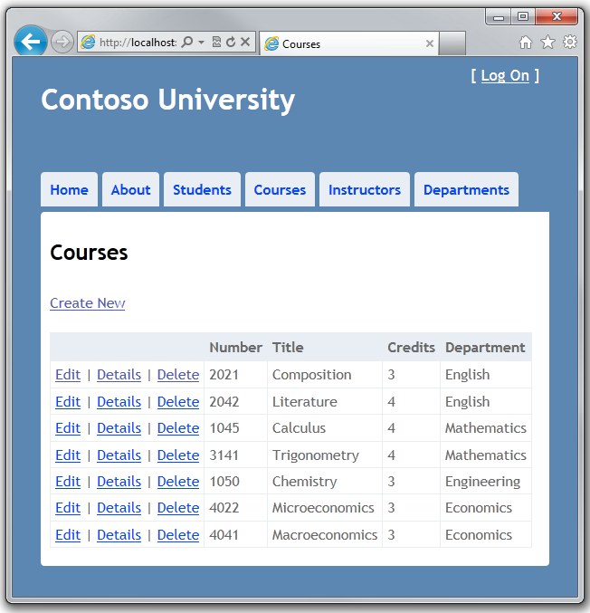

The page looks and works the same as it did before your changes, and the other Course pages also work the same.

You have now implemented both the repository and unit of work patterns. You have used lambda expressions as method parameters in the generic repository. For more information about how to use these expressions with an IQueryable object, see [IQueryable(T) Interface (System.Linq)](http://msdn.microsoft.com/en-us/library/bb351562.aspx) in the MSDN Library. In the next tutorial you'll learn how to handle some advanced scenarios.

# 10 Advanced Entity Framework Scenarios for an MVC Web Application

The Contoso University sample web application demonstrates how to create ASP.NET MVC applications using the Entity Framework. The sample application is a website for a fictional Contoso University. It includes functionality such as student admission, course creation, and instructor assignments.

This tutorial series explains the steps taken to build the Contoso University sample application. You can [download the completed application](http://go.microsoft.com/fwlink/?LinkId=215669) or create it by following the steps in the tutorial. The tutorial shows examples in C#. The downloadable sample contains code in both C# and Visual Basic. If you have questions that are not directly related to the tutorial, you can post them to the [ASP.NET Entity Framework forum](http://forums.asp.net/1227.aspx) or the [Entity Framework and LINQ to Entities forum](http://social.msdn.microsoft.com/forums/en-US/adodotnetentityframework/threads/).

This tutorial series assumes you know how to work with ASP.NET MVC in Visual Studio. If you don’t, a good place to start is a [basic ASP.NET MVC Tutorial](http://www.asp.net/mvc/tutorials/getting-started-with-MVC3-part1-cs). If you prefer to work with the ASP.NET Web Forms model, see the [Getting Started with the Entity Framework](http://www.asp.net/entity-framework/tutorials#Getting Started) and [Continuing with the Entity Framework](http://www.asp.net/entity-framework/tutorials#Continuing) tutorials.

Before you start, make sure you have the following software installed on your computer:

* [Visual Studio 2010 SP1](http://www.microsoft.com/web/gallery/install.aspx?appsxml=&appid=VS2010SP1Pack) or [Visual Web Developer Express 2010 SP1](http://www.microsoft.com/web/gallery/install.aspx?appsxml=&appid=VWD2010SP1Pack) (If you use one of these links, the following items will be installed automatically.)
* [ASP.NET MVC 3 Tools Update](http://www.microsoft.com/web/gallery/install.aspx?appid=MVC3)
* [Microsoft SQL Server Compact 4.0](http://www.microsoft.com/web/gallery/install.aspx?appid=SQLCE)
* [Microsoft Visual Studio 2010 SP1 Tools for SQL Server Compact 4.0](http://www.microsoft.com/web/gallery/install.aspx?appid=SQLCEVSTools)

In the previous tutorial you implemented the repository and unit of work patterns. This tutorial covers the following topics:

* Performing raw SQL queries.
* Performing no-tracking queries.
* Examining queries sent to the database.
* Working with proxy classes.
* Disabling automatic detection of changes.
* Disabling validation when saving changes.

For most of these you will work with pages that you already created. To use raw SQL to do bulk updates you'll create a new page that updates the number of credits of all courses in the database:

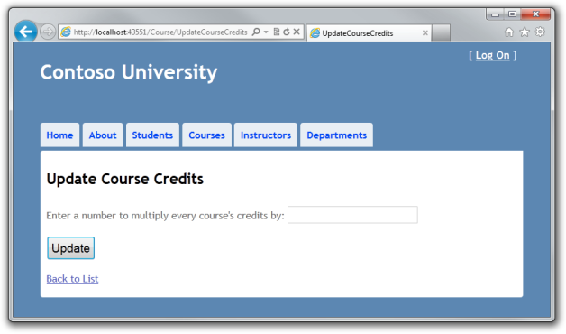

And to use a no-tracking query you'll add new validation logic to the Department Edit page:

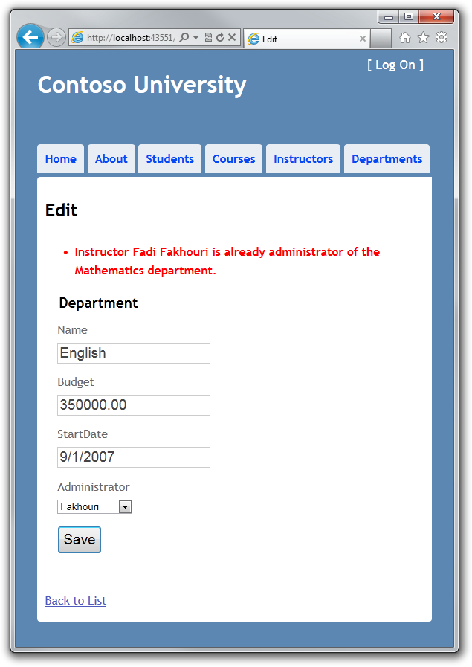

## Performing Raw SQL Queries

The Entity Framework Code First API includes methods that enable you to pass SQL commands directly to the database. You have the following options:

* Use the DbSet.SqlQuery method for queries that return entity types. The returned objects must be of the type expected by the DbSet object, and they are automatically tracked by the database context unless you turn tracking off. (See the following section about the AsNoTracking method.)
* Use the DbDatabase.SqlQuery method for queries that return types that aren't entities. The returned data isn't tracked by the database context, even if you use this method to retrieve entity types.
* Use the DbDatabase.SqlCommand for non-query commands.

One of the advantages of using the Entity Framework is that it avoids tying your code too closely to a particular method of storing data. It does this by generating SQL queries and commands for you, which also frees you from having to write them yourself. But there are exceptional scenarios when you need to run specific SQL queries that you have manually created, and these methods make it possible for you to handle such exceptions.

As is always true when you execute SQL commands in a web application, you must take precautions to protect your site against SQL injection attacks. One way to do that is to use parameterized queries to make sure that strings submitted by a web page can't be interpreted as SQL commands. In this tutorial you'll use parameterized queries when integrating user input into a query.

## Calling a Query that Returns Entities

Suppose you want the GenericRepository class to provide additional filtering and sorting flexibility without requiring that you create a derived class with additional methods. One way to achieve that would be to add a method that accepts a SQL query. You could then specify any kind of filtering or sorting you want in the controller, such as a Where clause that depends on a joins or subquery. In this section you'll see how to implement such a method.

Create the GetWithRawSql method by adding the following code to GenericRepository.cs:

public virtual IEnumerable<TEntity> GetWithRawSql(string query, params object[] parameters)

{

return dbSet.SqlQuery(query, parameters).ToList();

}

In CourseController.cs, call the new method from the Details method, as shown in the following example:

public ActionResult Details(int id)

{

var query = "SELECT * FROM Course WHERE CourseID = @p0";

return View(unitOfWork.CourseRepository.GetWithRawSql(query, id).Single());

}

In this case you could have used the GetByID method, but you're using the GetWithRawSql method to verify that the GetWithRawSQL method works.

Run the Details page to verify that the select query works (select the **Course** tab and then **Details** for one course).

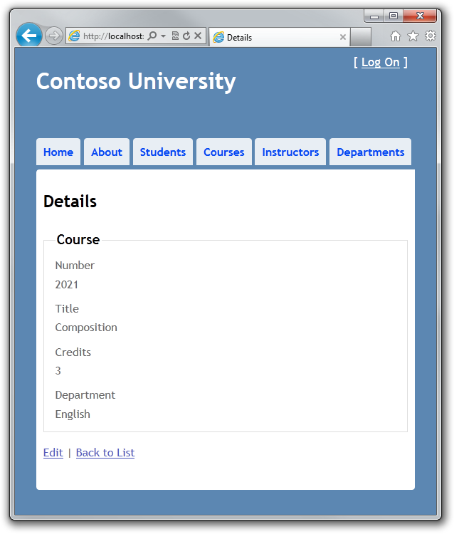

## Calling a Query that Returns Other Types of Objects

Earlier you created a student statistics grid for the About page that showed the number of students for each enrollment date. The code that does this in HomeController.cs uses LINQ:

var data = from student in db.Students

group student by student.EnrollmentDate into dateGroup

select new EnrollmentDateGroup()

{

EnrollmentDate = dateGroup.Key,

StudentCount = dateGroup.Count()

};

Suppose you want to write the code that retrieves this data directly in SQL rather than using LINQ. To do that you need to run a query that returns something other than entity objects, which means you need to use the Database.SqlQuery method.

In HomeController.cs, replace the LINQ statement in the About method with the following code:

var query = "SELECT EnrollmentDate, COUNT(*) AS StudentCount "

+ "FROM Person "

+ "WHERE EnrollmentDate IS NOT NULL "

+ "GROUP BY EnrollmentDate";

var data = db.Database.SqlQuery<EnrollmentDateGroup>(query);

Run the About page. It displays the same data it did before.



## Calling an Update Query

Suppose Contoso University administrators want to be able to perform bulk changes in the database, such as changing the number of credits for every course. If the university has a large number of courses, it would be inefficient to retrieve them all as entities and change them individually. In this section you'll implement a web page that allows the user to specify a factor by which to change the number of credits for all courses, and you'll make the change by executing a SQL UPDATE statement. The web page will look like the following illustration:



In the previous tutorial you used the generic repository to read and update Course entities in the Course controller. For this bulk update operation, you need to create a new repository method that isn't in the generic repository. To do that, you'll create a dedicated CourseRepository class that derives from the GenericRepository class.

In the DAL folder, create CourseRepository.cs and replace the existing code with the following code:

using System;

using ContosoUniversity.Models;

namespace ContosoUniversity.DAL

{

public class CourseRepository : GenericRepository<Course>

{

public CourseRepository(SchoolContext context)

: base(context)

{

}

public int UpdateCourseCredits(int multiplier)

{

return context.Database.ExecuteSqlCommand("UPDATE Course SET Credits = Credits * {0}", multiplier);

}

}

}

In UnitOfWork.cs, change the Course repository type from GenericRepository<Course> to CourseRepository:

private CourseRepository courseRepository;

public CourseRepository CourseRepository

{

get

{

if (this.courseRepository == null)

{

this.courseRepository = new CourseRepository(context);

}

return courseRepository;

}

}

In CourseContoller.cs, add an UpdateCourseCredits method:

public ActionResult UpdateCourseCredits(int? multiplier)

{

if (multiplier != null)

{

ViewBag.RowsAffected = unitOfWork.CourseRepository.UpdateCourseCredits(multiplier.Value);

}

return View();

}

This method will be used for both HttpGet and HttpPost. When the HttpGet UpdateCourseCredits method runs, the multiplier variable will be null and the view will display an empty text box and a submit button, as shown in the preceding illustration.

When the **Update** button is clicked and the HttpPost method runs, multiplier will have the value entered in the text box. The code then calls the repository UpdateCourseCredits method, which returns the number of affected rows, and that value is stored in the ViewBag object. When the view receives the number of affected rows in the ViewBag object, it displays that number instead of the text box and submit button, as shown in the following illustration:

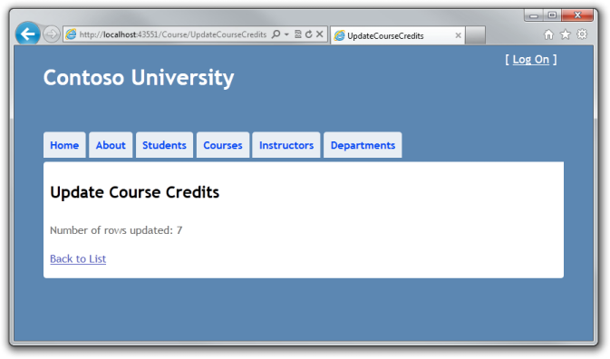

Create a view in the Views\Course folder for the Update Course Credits page:

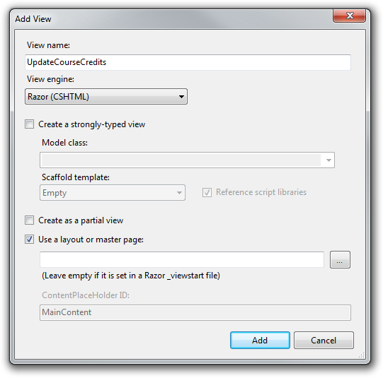

In Views\Course\UpdateCourseCredits.cshtml, replace the existing code with the following code:

@model ContosoUniversity.Models.Course

@{

ViewBag.Title = "UpdateCourseCredits";

}

<h2>Update Course Credits</h2>

@if (ViewBag.RowsAffected == null)

{

using (Html.BeginForm())

{

<p>

Enter a number to multiply every course's credits by: @Html.TextBox("multiplier")

</p>

<p>

<input type="submit" value="Update" />

</p>

}

}

@if (ViewBag.RowsAffected != null)

{

<p>

Number of rows updated: @ViewBag.RowsAffected

</p>

}

<div>

@Html.ActionLink("Back to List", "Index")

</div>

Run the page by selecting the **Courses** tab, then adding "/UpdateCourseCredits" to the end of the URL in the browser's address bar (for example: http://localhost:50205/Course/UpdateCourseCredits). Enter a number in the text box:

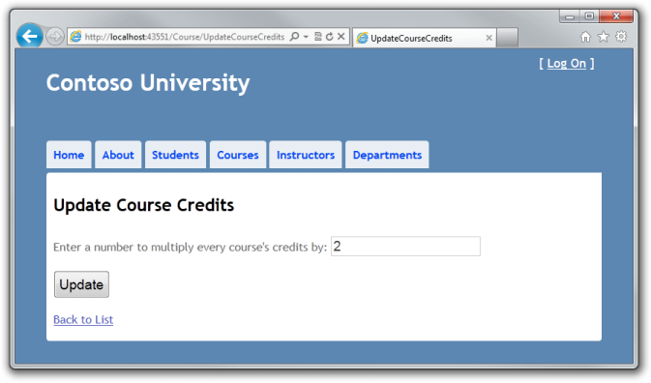

Click **Update**. You see the number of rows affected:



Click **Back to List** to see the list of courses with the revised number of credits.

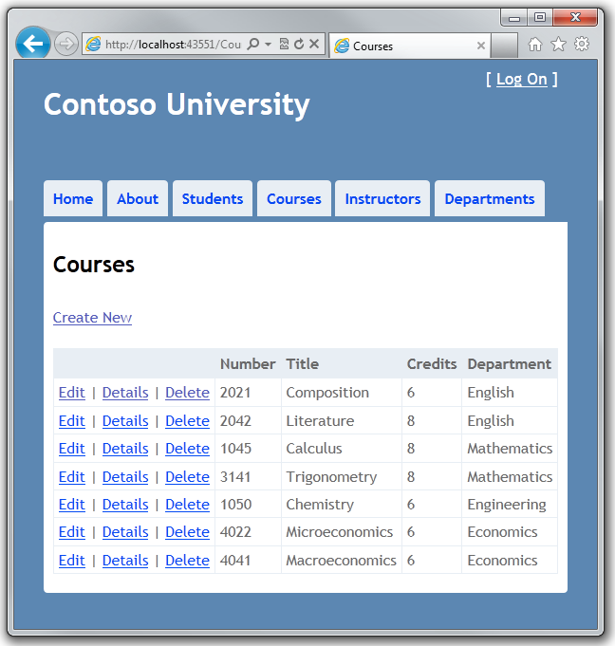

For more information about raw SQL queries, see [Raw SQL Queries](http://blogs.msdn.com/b/adonet/archive/2011/02/04/using-dbcontext-in-ef-feature-ctp5-part-10-raw-sql-queries.aspx) on the Entity Framework team blog.

## No-Tracking Queries

When a database context retrieves database rows and creates entity objects that represent them, by default it keeps track of whether the entities in memory are in sync with what's in the database. The data in memory acts as a cache and is used when you update an entity. This caching is often unnecessary in a web application because context instances are typically short-lived (a new one is created and disposed for each request) and the context that reads an entity is typically disposed before that entity is used again.

You can specify whether the context tracks entity objects for a query by using the AsNoTracking method. Typical scenarios in which you might want to do that include the following:

* The query retrieves such a large volume of data that turning off tracking might noticeably enhance performance.
* You want to attach an entity in order to update it, but you earlier retrieved the same entity for a different purpose. Because the entity is already being tracked by the database context, you can't attach the entity that you want to change. One way to prevent this from happening is to use the AsNoTracking option with the earlier query.

In this section you'll implement business logic that illustrates the second of these scenarios. Specifically, you'll enforce a business rule that says that an instructor can't be the administrator of more than one department.

In DepartmentController.cs, add a new method that you can call from the Edit and Create methods to make sure that no two departments have the same administrator:

private void ValidateOneAdministratorAssignmentPerInstructor(Department department)

{

if (department.PersonID != null)

{

var duplicateDepartment = db.Departments

.Include("Administrator")

.Where(d => d.PersonID == department.PersonID)

.FirstOrDefault();

if (duplicateDepartment != null && duplicateDepartment.DepartmentID != department.DepartmentID)

{

var errorMessage = String.Format(

"Instructor {0} {1} is already administrator of the {2} department.",

duplicateDepartment.Administrator.FirstMidName,

duplicateDepartment.Administrator.LastName,

duplicateDepartment.Name);

ModelState.AddModelError(string.Empty, errorMessage);

}

}

}

Add code in the try block of the HttpPost Edit method to call this new method if there are no validation errors. The try block now looks like the following example:

if (ModelState.IsValid)

{

ValidateOneAdministratorAssignmentPerInstructor(department);

}

if (ModelState.IsValid)

{

db.Entry(department).State = EntityState.Modified;

db.SaveChanges();

return RedirectToAction("Index");

}

Run the Department Edit page and try to change a department's administrator to an instructor who is already the administrator of a different department. You get the expected error message:



Now run the Department Edit page again and this time change the **Budget** amount. When you click **Save**, you see an error page:

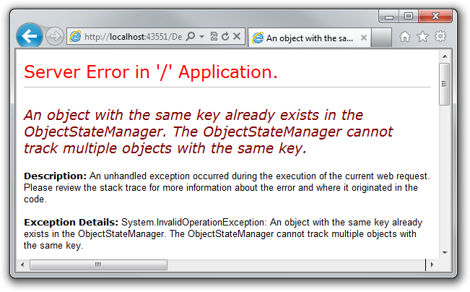

The exception error message is "An object with the same key already exists in the ObjectStateManager. The ObjectStateManager cannot track multiple objects with the same key." This happened because of the following sequence of events:

* The Edit method calls the ValidateOneAdministratorAssignmentPerInstructor method, which retrieves all departments that have Kim Abercrombie as their administrator. That causes the English department to be read. Because that's the department being edited, no error is reported. As a result of this read operation, however, the English department entity that was read from the database is now being tracked by the database context.
* The Edit method tries to set the Modified flag on the English department entity created by the MVC model binder, but that fails because the context is already tracking an entity for the English department.

One solution to this problem is to keep the context from tracking in-memory department entities retrieved by the validation query. There's no disadvantage to doing this, because you won't be updating this entity or reading it again in a way that would benefit from it being cached in memory.

In DepartmentController.cs, in the ValidateOneAdministratorAssignmentPerInstructor method, specify no tracking, as shown in the following example:

var duplicateDepartment = db.Departments

.Include("Administrator")

.Where(d => d.PersonID == department.PersonID)

.AsNoTracking()

.FirstOrDefault();

Repeat your attempt to edit the **Budget** amount of a department. This time the operation is successful, and the site returns as expected to the Departments Index page, showing the revised budget value.

## Examining Queries Sent to the Database

Sometimes it's helpful to be able to see the actual SQL queries that are sent to the database. To do this, you can examine a query variable in the debugger or call the query's ToString method. To try this out, you'll look at a simple query and then look at what happens to it as you add options such eager loading, filtering, and sorting.

In Controllers/CourseController, replace the Index method with the following code:

public ViewResult Index()

{

var courses = unitOfWork.CourseRepository.Get();

return View(courses.ToList());

}

Now set a breakpoint in GenericRepository.cs on the return query.ToList(); and the return orderBy(query).ToList(); statements of the Get method. Run the project in debug mode and select the Course Index page. When the code reaches the breakpoint, examine the query variable. You see the query that's sent to SQL Server Compact. It's a simple Select statement:

{SELECT

[Extent1].[CourseID] AS [CourseID],

[Extent1].[Title] AS [Title],

[Extent1].[Credits] AS [Credits],

[Extent1].[DepartmentID] AS [DepartmentID]

FROM [Course] AS [Extent1]}

Queries can be too long to display in the debugging windows in Visual Studio. To see the entire query, you can copy the variable value and paste it into a text editor:

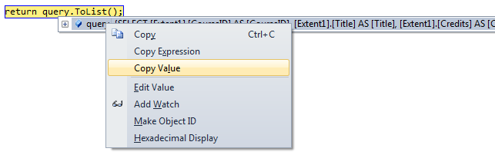

Now you'll add a drop-down list to the Course Index page so that users can filter for a particular department. You'll sort the courses by title, and you'll specify eager loading for the Department navigation property. In CourseController.cs, replace the Index method with the following code:

public ActionResult Index(int? SelectedDepartment)

{

var departments = unitOfWork.DepartmentRepository.Get(

orderBy: q => q.OrderBy(d => d.Name));

ViewBag.SelectedDepartment = new SelectList(departments, "DepartmentID", "Name", SelectedDepartment);

int departmentID = SelectedDepartment.GetValueOrDefault();

return View(unitOfWork.CourseRepository.Get(

filter: d => !SelectedDepartment.HasValue || d.DepartmentID == departmentID,

orderBy: q => q.OrderBy(d => d.CourseID),

includeProperties: "Department"));

}

The method receives the selected value of the drop-down list in the SelectedDepartment parameter. If nothing is selected, this parameter will be null.

A SelectList collection containing all departments is passed to the view for the drop-down list. The parameters passed to the SelectList constructor specify the value field name, the text field name, and the selected item.

For the Get method of the Course repository, the code specifies a filter expression, a sort order, and eager loading for the Department navigation property. The filter expression always returns true if nothing is selected in the drop-down list (that is, SelectedDepartment is null).

In Views\Course\Index.cshtml, immediately before the opening table tag, add the following code to create the drop-down list and a submit button:

@using (Html.BeginForm())

{

<p>Select Department: @Html.DropDownList("SelectedDepartment","All")

<input type="submit" value="Filter" /></p>

}

With the breakpoints still set in the GenericRepository class, run the Course Index page. Continue through the first two times that the code hits a breakpoint, so that the page is displayed in the browser. Select a department from the drop-down list and click **Filter**:

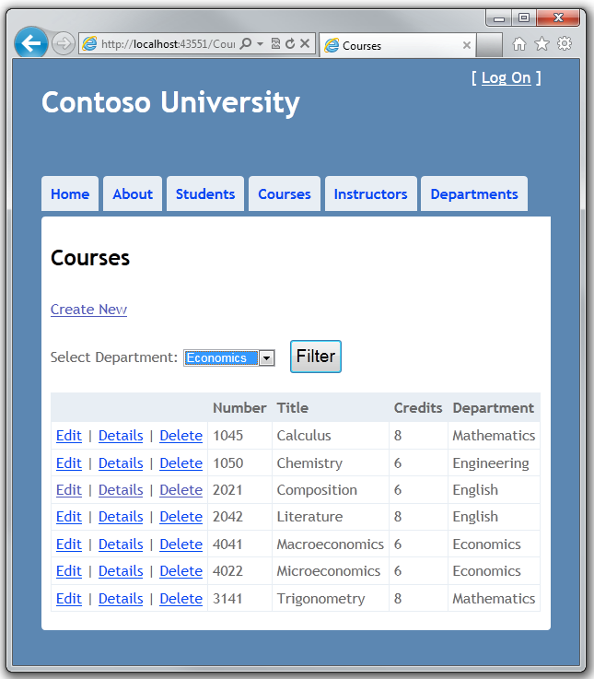

This time the first breakpoint will be for the departments query for the drop-down list. Skip that and view the query variable the next time the code reaches the breakpoint in order to see what the Course query now looks like. You'll see something like the following:

{SELECT

[Extent1].[CourseID] AS [CourseID],

[Extent1].[Title] AS [Title],

[Extent1].[Credits] AS [Credits],

[Extent1].[DepartmentID] AS [DepartmentID],

[Extent2].[DepartmentID] AS [DepartmentID1],

[Extent2].[Name] AS [Name],

[Extent2].[Budget] AS [Budget],

[Extent2].[StartDate] AS [StartDate],

[Extent2].[PersonID] AS [PersonID],

[Extent2].[Timestamp] AS [Timestamp]

FROM [Course] AS [Extent1]

INNER JOIN [Department] AS [Extent2] ON [Extent1].[DepartmentID] = [Extent2].[DepartmentID]

WHERE (@p__linq__0 IS NULL) OR ([Extent1].[DepartmentID] = @p__linq__1)}

You can see that the query is now a JOIN query that loads Department data along with the Course data, and that it includes a WHERE clause.

## Working with Proxy Classes

When the Entity Framework creates entity instances (for example, when you execute a query), it often creates them as instances of a dynamically generated derived type that acts as a proxy for the entity. This proxy overrides some virtual properties of the entity to insert hooks for performing actions automatically when the property is accessed. For example, this mechanism is used to support lazy loading of relationships.

Most of the time you don't need to be aware of this use of proxies, but there are exceptions:

* In some scenarios you might want to prevent the Entity Framework from creating proxy instances. For example, serializing non-proxy instances might be more efficient than serializing proxy instances.
* When you instantiate an entity class using the new operator, you don't get a proxy instance. This means you don't get functionality such as lazy loading and automatic change tracking. This is typically okay; you generally don't need lazy loading, because you're creating a new entity that isn't in the database, and you generally don't need change tracking if you're explicitly marking the entity as Added. However, if you do need lazy loading and you need change tracking, you can create new entity instances with proxies using the Create method of the DbSet class.
* You might want to get an actual entity type from a proxy type. You can use the GetObjectType method of the ObjectContext class to get the actual entity type of a proxy type instance.

For more information, see [Working with Proxies](http://blogs.msdn.com/b/adonet/archive/2011/02/02/using-dbcontext-in-ef-feature-ctp5-part-8-working-with-proxies.aspx) on the Entity Framework team blog.

## Disabling Automatic Detection of Changes

The Entity Framework determines how an entity has changed (and therefore which updates need to be sent to the database) by comparing the current values of an entity with the original values. The original values are stored when the entity was queried or attached. Some of the methods that cause automatic change detection are the following:

* DbSet.Find
* DbSet.Local
* DbSet.Remove
* DbSet.Add
* DbSet.Attach
* DbContext.SaveChanges
* DbContext.GetValidationErrors
* DbContext.Entry
* DbChangeTracker.Entries

If you're tracking a large number of entities and you call one of these methods many times in a loop, you might get significant performance improvements by temporarily turning off automatic change detection using the [AutoDetectChangesEnabled](http://msdn.microsoft.com/en-us/library/system.data.entity.infrastructure.dbcontextconfiguration.autodetectchangesenabled(VS.103).aspx) property. For more information, see [Automatically Detecting Changes](http://blogs.msdn.com/b/adonet/archive/2011/02/06/using-dbcontext-in-ef-feature-ctp5-part-12-automatically-detecting-changes.aspx) on the Entity Framework team blog.

## Disabling Validation When Saving Changes

When you call the SaveChanges method, by default the Entity Framework validates the data in all properties of all changed entities before updating the database. If you've updated a large number of entities and you've already validated the data, this work is unnecessary and you could make the process of saving the changes take less time by temporarily turning off validation. You can do that using the [ValidateOnSaveEnabled](http://msdn.microsoft.com/en-us/library/system.data.entity.infrastructure.dbcontextconfiguration.validateonsaveenabled(VS.103).aspx) property. For more information, see [Validation](http://blogs.msdn.com/b/adonet/archive/2010/12/15/ef-feature-ctp5-validation.aspx) on the Entity Framework team blog.

## Next Steps

This completes this series of tutorials on using the Entity Framework in an ASP.NET MVC application.

After you have built and tested a web application, the next step is to make it available to other other people to use over the Internet. To do that, you have to deploy it to a web hosting provider. Microsoft offers free web hosting for up to 10 web sites in a [free Windows Azure trial account](http://www.windowsazure.com/en-us/pricing/free-trial/?WT.mc_id=A443DD604). For information about how to deploy a Visual Studio web project to a Windows Azure Web Site, see [Create and deploy an ASP.NET web site and SQL Database with Visual Studio](http://www.windowsazure.com/en-us/develop/net/compute/). That tutorial also shows how to use Entity Framework Code First Migrations to deploy your SQL Server database to Windows Azure SQL Database (formerly SQL Azure). For more information about deployment, see [ASP.NET Web Deployment Content Map](http://go.microsoft.com/fwlink/p/?LinkId=282413).

For more information about the Entity Framework, see the [ASP.NET Data Access Content Map](http://go.microsoft.com/fwlink/p/?LinkId=282414).

For a tutorial that uses more MVC features and uses the Entity Framework, see [MVC Music Store](http://www.asp.net/mvc/tutorials/mvc-music-store-part-1).